DO NOT CONSIDER FOR TALK

10th Annual SEA Symposium Abstract

Florida International University

Miami FL

Corresponding Faculty Member: Mauricio Rodriguez-Lanetty (rodriguezlanetty@gmail.com)

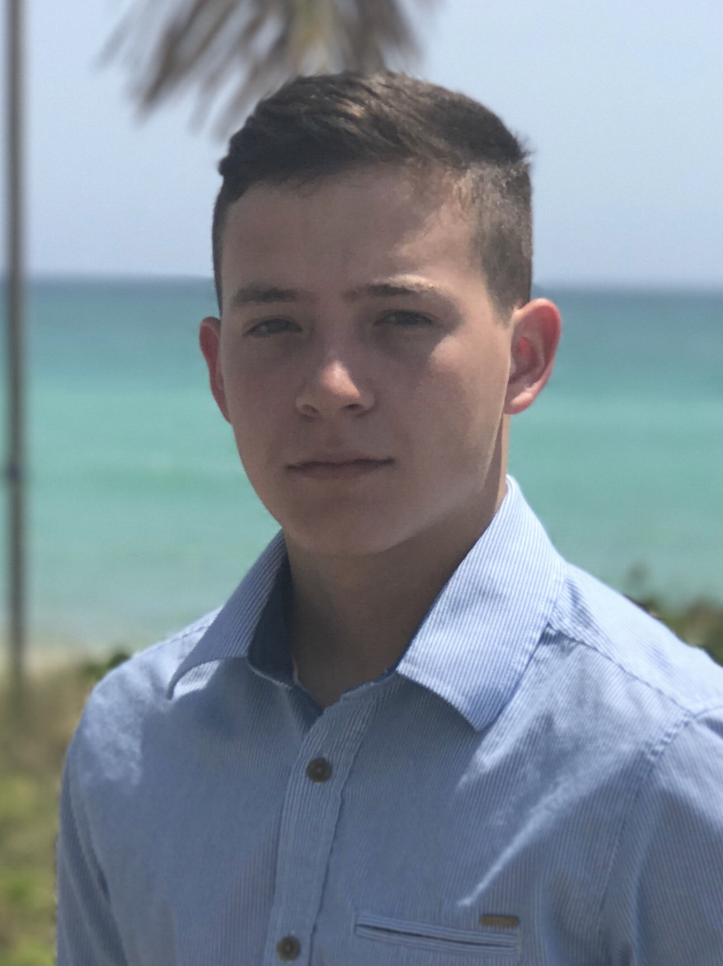

Carlos Sandoval

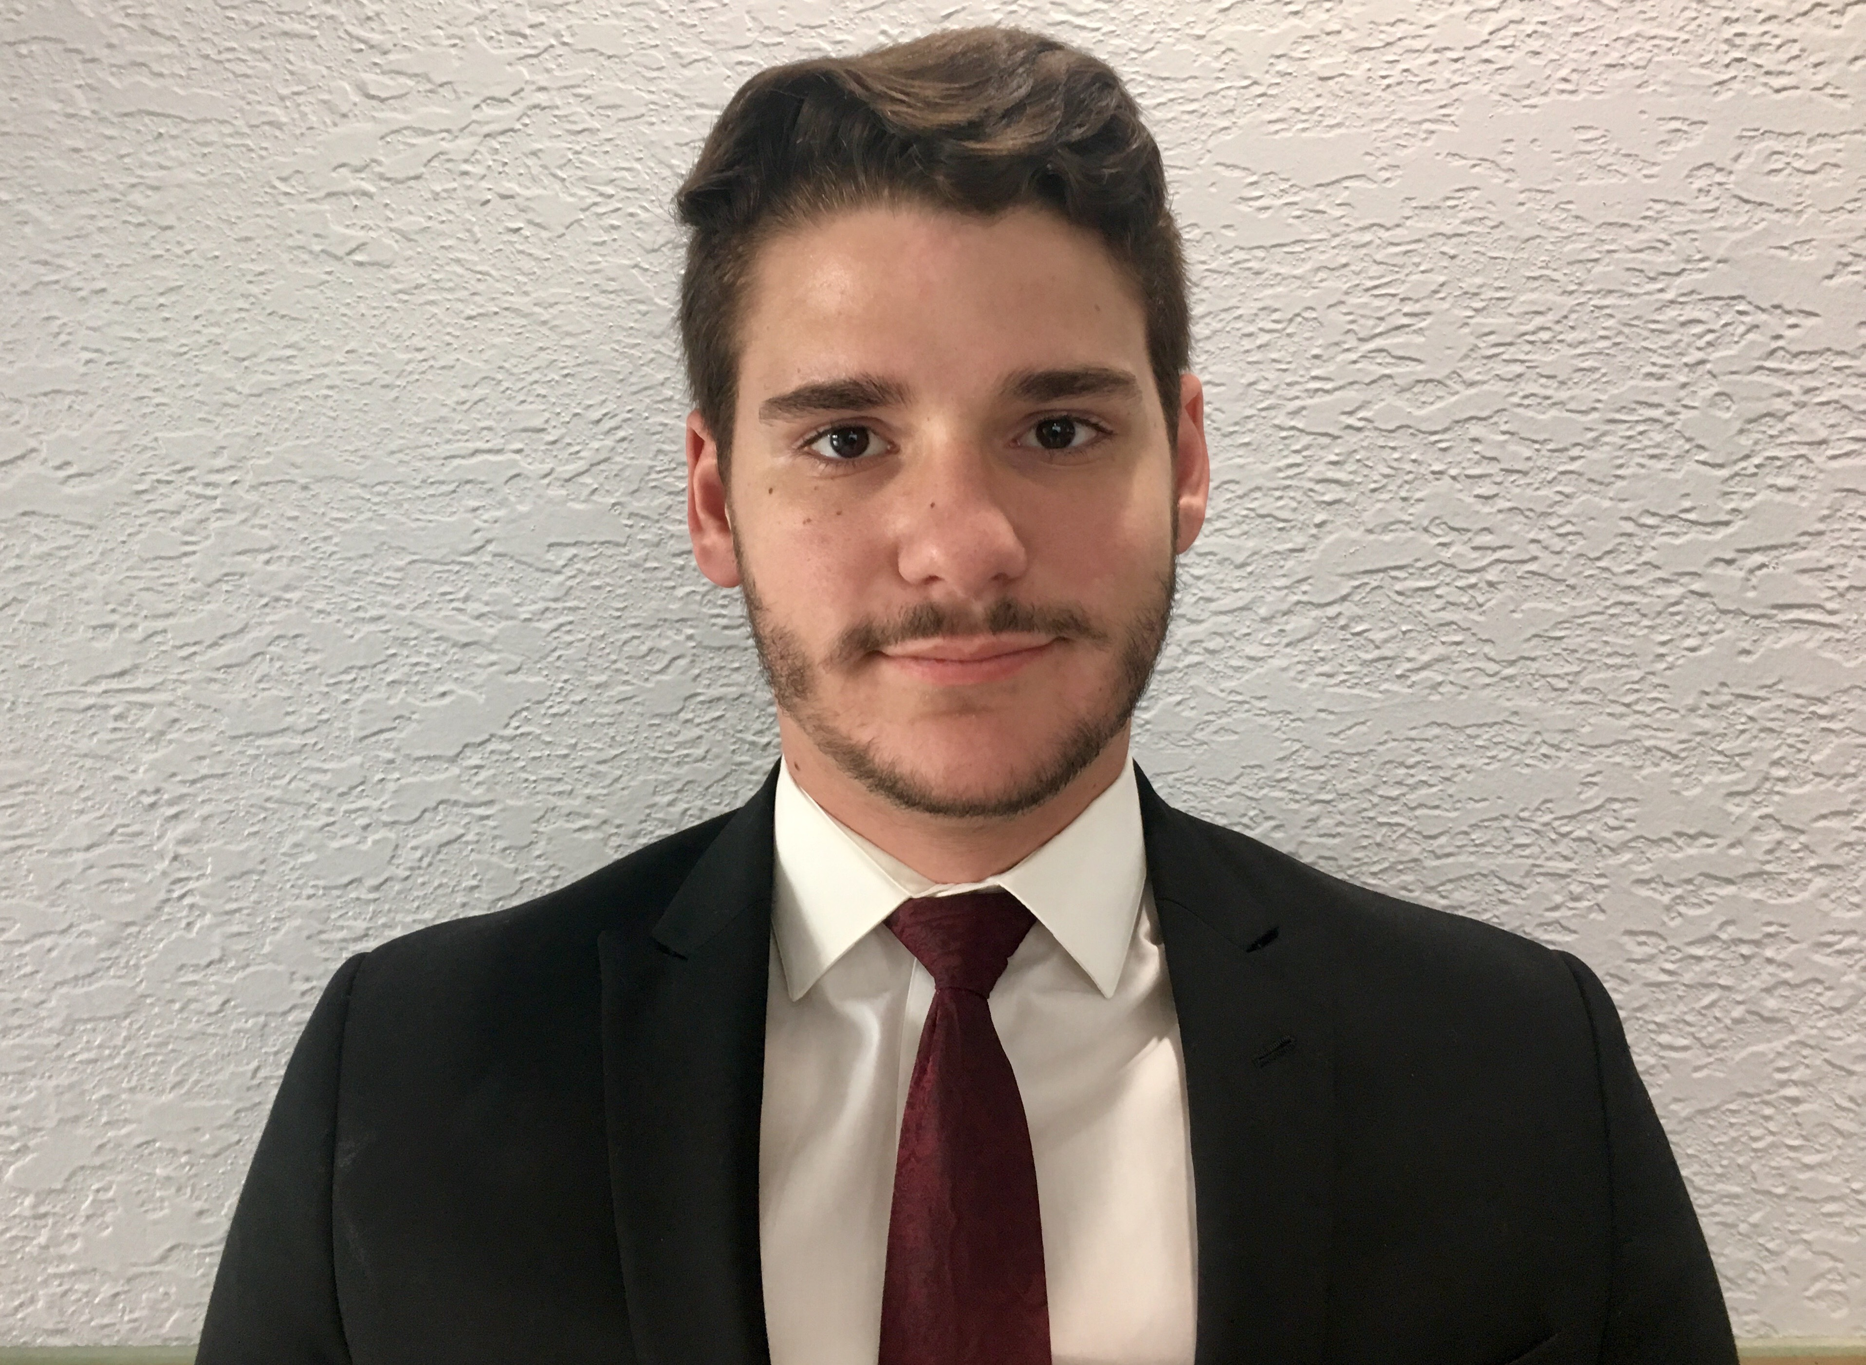

Juan Santana

Comparison of Cas4 homologs and genome architecture patterns in two Bacillus bacteriophages

Carlos Sandoval, Juan Santana, Joseph Ahrens, Katherine Dougan, Mauricio Rodriguez-Lanetty

*Bacillus cereus* is a Gram-positive soil bacterium, commonly known for causing foodborne illness in humans as well as its occasional use in probiotics for animals. Research has revealed extensive evidence of horizontal transfer among bacteriophage and host genes, mediated by mechanisms such as transduction, resulting in mosaic phage genome architectures. Here, we evaluate the architectures and specific gene content of two *Bacillus* phage genomes, Rocco and Phamous, using conventional analytical tools such as DNAMaster for functional gene annotation, PHASTER for genome architecture analyses, and MEGA for aligning homologous sequences and constructing phylogenetic trees. Comparative genomics between the two *Bacillus* phages not only reveal similarities but also differences, such as two intact prophage regions in Rocco as opposed to one region in Phamous. Additionally, open reading frame (ORF) 64 in Phamous can be classified as a putative homolog of Cas4 as demonstrated in both a Bayesian inference and maximum likelihood tree. Phylogenetic data indicates ORF 64 is more closely related to bacterial homologs than phage homologs which can be regarded as evidence of horizontal transfer. This possibility is further supported by research indicating that the Cas4 gene is mobile. Future research can focus on the expansion of phage space of firmicute hosts and further investigation of the evolution of the CRISPR-Cas complex in bacteria and phages.