DO NOT CONSIDER FOR TALK

10th Annual SEA Symposium Abstract

Mount Saint Mary College

Newburgh NY

Corresponding Faculty Member: Evan Merkhofer (evan.merkhofer@msmc.edu)

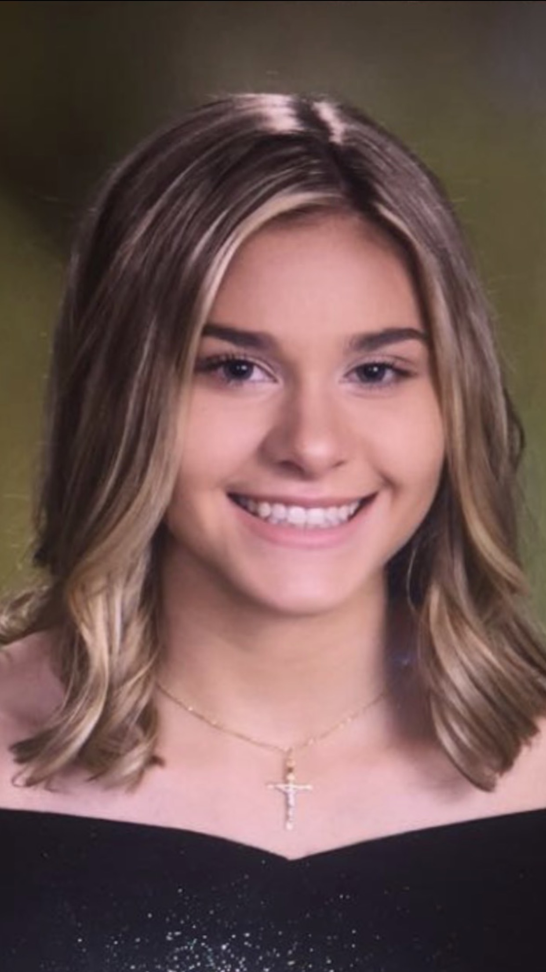

Jessica Musacchio



Sabina Zarod

The Molecular Journey: Annotation of Microbacteriophages Schnapsidee and Papafritta

Jessica Musacchio, Sabina Zarod, Kaitlyn Barber, Amanda Barnett, Destiny Bettica, Olivia Bracco, Erica Eack, Elizabeth Halpin, Camren Iorio, Nasayah Israel, Nicholas Mahoney, Chandlir Radcliffe, Andrew Velasquez, Suparna Bhalla, Evan Merkhofer

The Mount Saint Mary College Phage Hunters began isolating phages using *Mycobacterium smegmatis* mc2155 in 2016-2017 and in 2017-2018 transitioned to the host *Microbacterium foliorum* to provide more insight into the diversity of genomes across the Actinobacteriophage phylum. This year, nine Microbacteriophages were isolated from soil samples gathered in Newburgh, NY. Phages *Papafritta* and *Schnapsidee* were obtained through enriched isolation, both yielding small, cloudy plaques after 48 hours incubation at 30 degrees. Sequencing of *Papafritta* (circularly permutated, 41.9 kB length, 63.4% GC content) and *Schnapsidee* (circularly permutated, 41.6 kB length, 63.4% GC content) identified them as members of the EA cluster and EA1 subcluster. Both phages were predicted to have a lytic life cycle based on the initial analysis of the genome sequences. BLAST analysis of *Papafritta* and *Schnapsidee* showed 85% nucleotide identity between these phages. Bioinformatic programs including DNA Master, GeneMark, Phamerator and Starterator were used to successfully annotate these novel phages, and gene functions were assigned using the HHpred and NCBI BLAST programs. Upon annotation, these genomes were found to be very similar. There were however significant differences in the region of genes 28-33. Additional analysis is being performed on these phages to confirm the lytic life cycle. We are also investigating sensitivity of these phages to UV light. Finally, further bioinformatic analysis, including identification of possible regulatory elements and the presence of membrane proteins, is being performed to better understand the genome composition of these Microbacteriophages.