CONSIDER FOR TALK

7th Annual SEA-PHAGES Symposium Abstract

University of Colorado Boulder

Boulder CO

Corresponding Faculty Member: Christy Fillman (christy.fillman@Colorado.EDU)

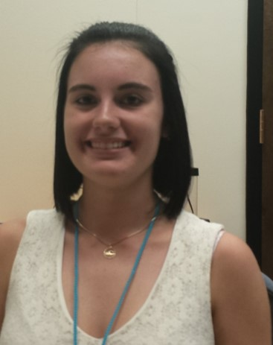

Brianna Morgan



Whitney Stanton

Comparing Codon Usage and tRNAs Present in a C1 Phage, Sprinklers, and a A6 Phage, ToneTone

Brianna Morgan, Whitney Stanton,

We compared the tRNAs and codon usage in two mycobacteriophages; ToneTone, a siphoviridae A6 cluster phage and Sprinklers, a C1 myoviridae phage. ToneTone contains three tRNAs while Sprinklers contains thirty tRNAs and one tmRNA. ToneTone’s tRNA’s are clustered at the beginning of the genome, while Sprinklers tRNA’s are distributed in several clusters localized mostly in the second half of the genome. *Mycobacterium smegmatis*, the host organism used to isolate these phages, contains 47 tRNAs. In Sprinklers’ genome we found the translational associated proteins peptidyl tRNA hydrolase type 2 and peptide chain release factor 1, which were not found in ToneTone’s genome. These tRNAs and translational factors may contribute to the fitness of these phages.