CONSIDER FOR TALK
10th Annual SEA Symposium Abstract
Queens University of Charlotte
Charlotte NC
Corresponding Faculty Member: Jennifer Easterwood (easterwj@queens.edu)
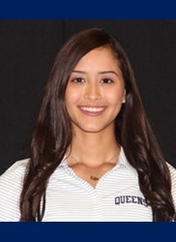
Oriana Jerez
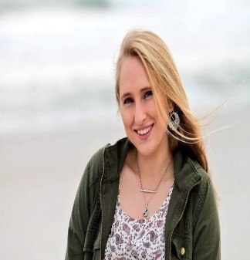
Sami Tubolino
Queens University of Charlotte performed another “Nivrat” experiment along with “Burwell21”
Oriana Jerez, Sami Tubolino, Jennifer Easterwood, Joanna Katsanos
During Queens’ second year in the SEA-PHAGES program, the discovery of two bacteriophages were made: “Burwell21” and “Nivrat.” These phages were propagated in Mycobacterium smegmatis mc^2155 then isolated and characterized by students in the biology department. Using enriched isolation, both “Burwell21” and “Nivrat” were isolated from two different soil sample at Queens University of Charlotte. Bacteriophage “Burwell21” was extracted from a soil sample outside of Burwell Hall and bacteriophage “Nivrat” was extracted from a soil sample behind Wireman Building. The plaques from both phages appeared small and cloudy. Transmission Electron Microscopy revealed that “Burwell21” and “Nivrat” were both a part of the siphoviridae morphotype. After the isolation of the two bacteriophages, both “Burwell21” and “Nivrat” were sent to the Pittsburgh Bacteriophage Institute for further analysis and DNA sequencing. Both are a part of the F cluster and the F1 subcluster. By using the shock sequencing method of Illumina Sequencing, it was found that “Burwell21” contained 58,098 base pairs and a 61.5% Guanine-Cytosine (GC) content while “Nivrat” contained 58,009 base pairs and a 61.5% Guanine-Cytosine (GC) content. Annotations were conducted using a bioinformatics program, DNAMaster and 104 genes were predicted for both genomes.

