DO NOT CONSIDER FOR TALK
10th Annual SEA Symposium Abstract
North Carolina A&T State University
Greensboro NC
Corresponding Faculty Member: Roy Coomans (coomansr@ncat.edu)
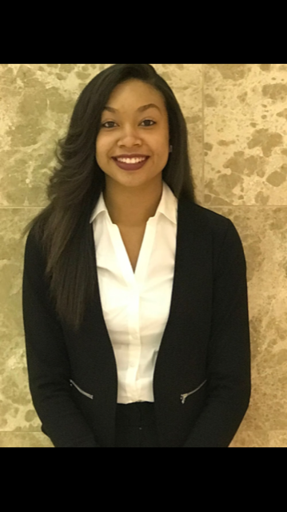
Brianna Wiggins
Aggie Phamily Adopts Brylie
Brianna Wiggins, Ashley Addison, Myana Banks, Daja Bizzell, Ayana Byrd, Rixon Campbell, N'Dea Celious, Chyna Fisher, Adrinna Freeman, Arianna Grant, Najee' Green, Camille Harrison, Courtney Holt, Rebekah Jones, Nahndi Kirk-Bradley, Alexis Matias, Shayla McCray, Zipporah Melton, Adrianne Mitchell, Malek Mitchell, Nia Nickerson, Kaisi Peele, Tyra Penn, Chi Smalls, Vaniya Tisdale, Sydney Wheeler, Supriya Patwardhan, Anthony Postiglione, Robert Newman, Roy Coomans
SEA-PHAGES students at North Carolina A&T State University isolated 13 bacteriophages in the fall of 2017 using Gordonia terrae CAG3 as the host organism. Seven were isolated by direct plating, the other six were isolated from enrichment cultures. DNA extracted from three of the thirteen phages was sequenced at Pittsburgh Bacteriophage Institute. Two of the sequenced phages, Ali17 and Bizzy, are in Cluster DE; the third, Brylie, is one of eight sequenced Cluster DI phages in the Phagesdb databank. Brylie’s genome is 49,870 base pairs and has a GC content of 67.3%. Annotation identified 73 genes. Brylie has a high degree of sequence homology with BetterKatz, the only Cluster DI phage previously annotated and entered in GenBank. Brylie and BetterKatz have a gene content similarity of 93.96% and share 70 phams. Phylogeny.fr was used to generate single gene phylogenetic trees of the eight Cluster DI phages. Trees for four different shared genes all grouped Brylie with Mulch, Nadeem, Parada, and WheatThin. Catenating the sequences for the four genes gave the same result. We also investigated protein structure prediction for selected gene products using I-TASSER.

