CONSIDER FOR TALK
10th Annual SEA Symposium Abstract
University of Wisconsin-River Falls
River Falls WI
Corresponding Faculty Member: Karen Klyczek (karen.k.klyczek@uwrf.edu)
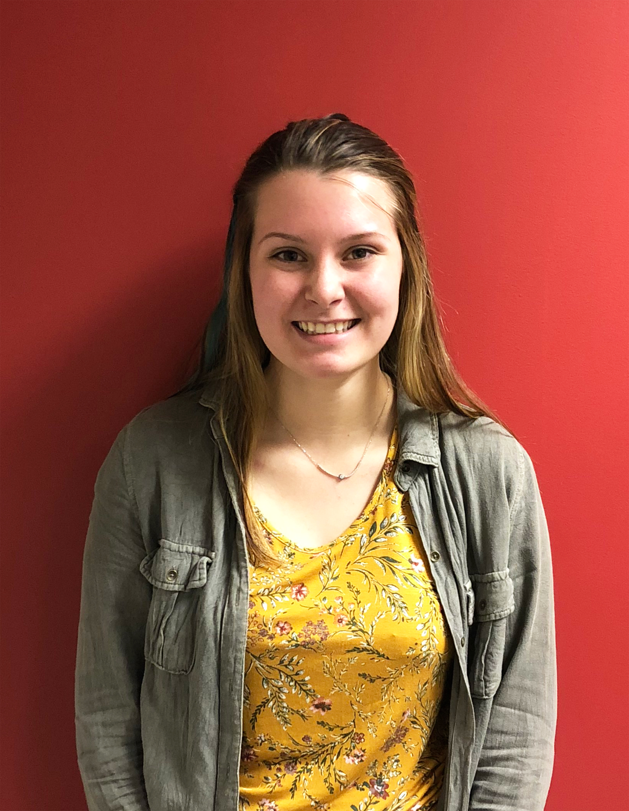
Serena K Jacob
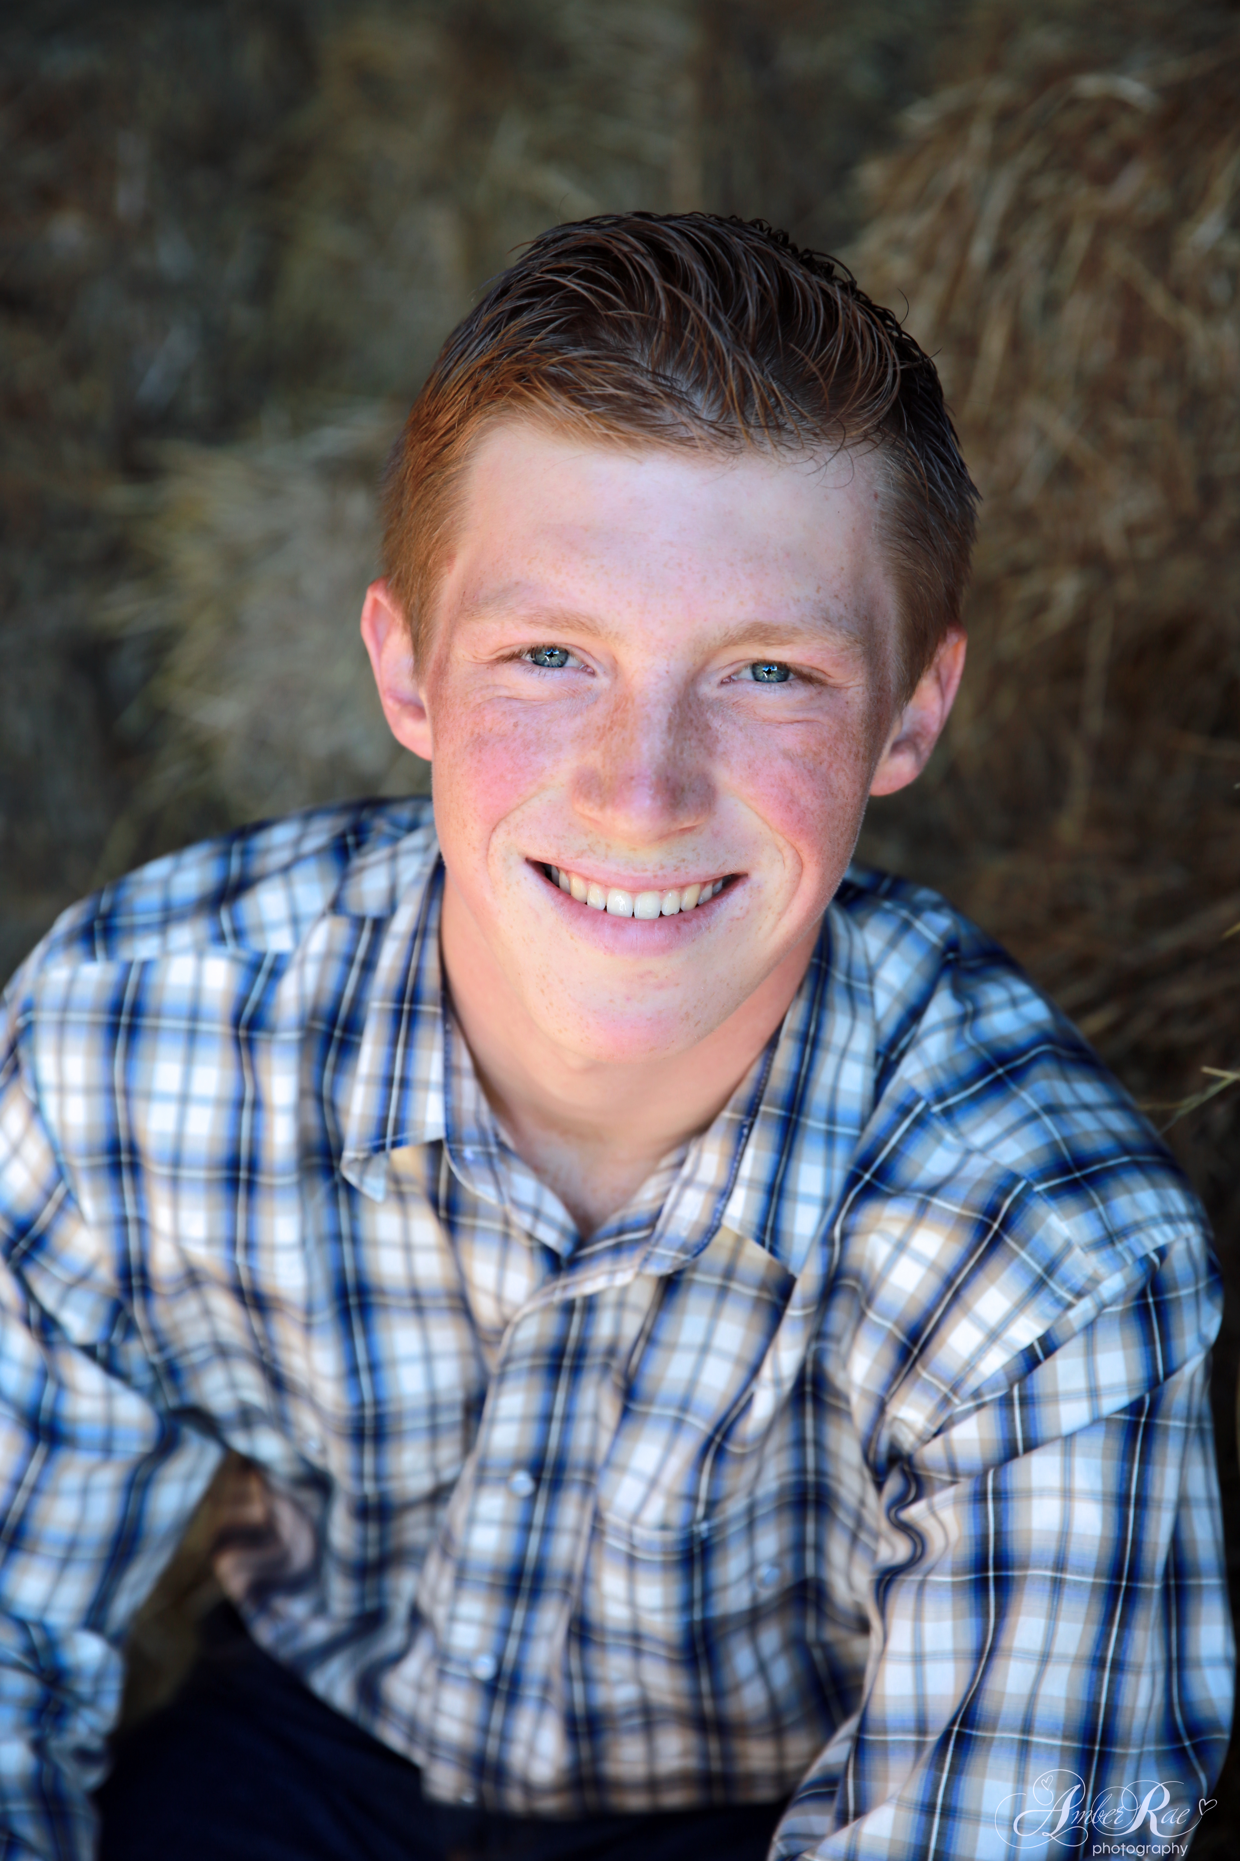
Evan P Ruesch
Adventures in phage hunting on new Actinobacteria hosts: Risks and Rewards
Serena K Jacob, Evan P Ruesch, Sidique F Bachelani, Alix Bookler, Byrgen S Buetow, Courtney A Carlson, Keysha H Carlson, Beau D Clemmensen, Emily M Dailey, Dakota C DeWindt, Kayla N Doucette, Jonathan A Duclos, Amanda R Edstrom, Samantha Flandrick, Rachael B Furey, Timothy A Gelatt, Cassie Glynn, Blake R Hansen, Alyssa M Hass, David H Hensley, Eric W Hoffstatter, Kiley K Jones, Pamela J Lisowski, Dawson P Luttrell, Baily K Paulus, Morgan A Pliszka, Hannah Preder, Cassandra O Pugh, Jared M Ricchio, Katie S Seif, Lisbeth A Servin-Meza, Courtney E Solberg, Paul H Timm, Sam P Wang, Michelle M Weinberg, Ryan S Wright, Madison A Zobrist, J Alfred Bonilla, Karen K Klyczek
UWRF phage hunters have used several alternate hosts during our participation in the SEA-PHAGES program. While the success rate of students finding phages may be lower with these hosts, the phages isolated are often very interesting and yield new information about phage genomics. To increase the chances of students finding a phage, we have tested each soil sample on three different hosts. For 2017-18, we used Arthrobacter sp. 21022 and Microbacterium foliorum, as well as Kocuria kristinae NRRL B-14383, a new host not previously used for phage hunting. We selected K. kristinae because it grows well and we found phage in a pilot experiment. It is also related to Arthrobacter and Microbacterium, and we hypothesized that phages isolated on these hosts might exhibit interesting genomic relationships. We isolated five phages on K. kristinae, 17 on M. foliorum and 23 on Arthrobacter. Of the five M. foliorum phages sequenced, two (Fork and Lyell) formed subcluster ED2 with Musetta. The ED2 phages share 82-86% gene content similarity with each other and 37-40% with subcluster ED1 phages. Phages Quaker, KayPaulus, and VitulaEligans are all in cluster EE. These phages have small genomes (17,450-17,534 bp), consisting mostly of structural genes, but share no nucleotide or protein similarity with phages in other clusters with similar sized genomes. After four Kocuria phages were sequenced, it was determined that this host is actually Microbacterium paraoxydans. However, these phages are quite interesting. Jacko is in subcluster ED1, with phages infecting M. Paraoxydans strain NWU1, and Efeko is in cluster EE. Efeko and Jacko do not infect M. foliorum, and our cluster ED and EE phages isolated on M. foliorum do not infect this M. paraoxydans host. ValentiniPuff is a singleton distantly related to Arthrobacter cluster AL phages, sharing 3% gene content similarity. Burro is a unique singleton, with little similarity to any other phage; 48 of its 49 orfs are orphams. Burro appears to be a podovirus, and its genome contains the longest gene found in Actinobacteriophages, 13,476 bp. We hypothesize that this gene consists of fused structural genes, and we are carrying out protein analyses to better identify Burro’s gene products. In preliminary host range testing, each of our M. paraoxydans phages exhibited a different pattern of infection on other strains of M. paraoxydans and M. aerolatum, and may yield new information about host range mechanisms. The one Arthrobacter phage sequenced, Tatanka, is in subcluster AU1. Cluster AU appears to be part of a supercluster that includes clusters AM, AW, BI, CC, DJ, and singleton Camille. These phages have 22-40% gene content similarity and share other genome features such as many membrane proteins (21-24), low GC content (51-59%) and repeats in intergenic regions. These new phages exhibit a range of genomic relationships and will enhance our understanding of phage biology and evolution.

