CONSIDER FOR TALK
10th Annual SEA Symposium Abstract
University of Lagos
Lagos
Corresponding Faculty Member: Imade Nsa (insa@unilag.edu.ng)
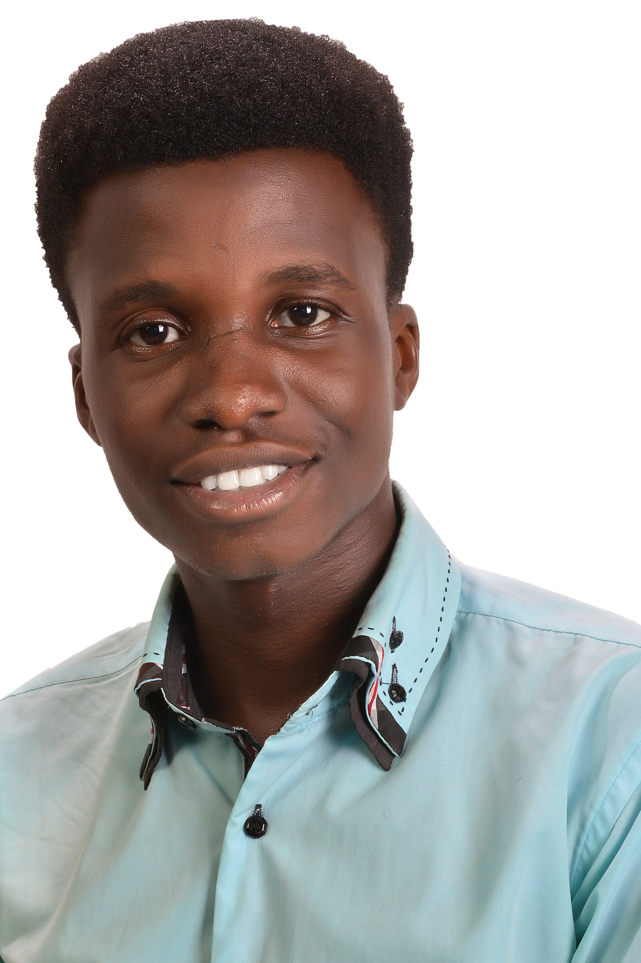
Seun D Bamisaye
Cluster A Mycobacteriophage Arcanine with a Shorter Tape Measure Protein
Seun D Bamisaye, Oluwatola E Femi-Olatunji, Oluwatobi E Oladele, Ayodeji A Odunsi, Imade Y Nsa, Ganiyu O Oyetibo, Matthew O Ilori
Cluster A is the largest group of Actinobacteriophages and has 141 mycobacteriophage members in its A1 subcluster. Arcanine, a Subcluster A1 temperate phage was found by Jeff Bonin of Washington University, Saint Louis, MO in 2012 from an enriched soil sample. Its genome size is 5227 bp and has 96 ORFS with a GC content of 63.7%, few genes overlap. About 50% of the genes are in the reverse orientation and ~ 30% of the start sites begin with the codon GTG. The genome contains genes of unknown functions. Arcanine differs from the other A1 cluster phages in its possession of a hypothetical protein similar to that of Mycobacterium SargentShorty 9. The protein products of Gene 2 shows weak similarity to hypothetical proteins from non-Mycobacterium host species. As expected, tail assembly chaperone is near tape measure and Arcanine has multiple copies of minor tail proteins but one of the minor tail proteins is longer than tape measure. It has two copies of tail assembly chaperone and primase, characteristic of Cluster A and Cluster A1 respectively. Its mosaic commonalities with other A1 phages include structural, replication and regulation genes like. HNH Endonuclease domain proteins, tail protein, Lysin A, Lysin B, terminase, portal protein, capsid maturation protease, scaffolding protein, major capsid protein, head-to-tail connector protein complex. major tail subunit, tail assembly chaperone, tape measure, many copies of minor tail subunits, integrase, membrane proteins, DNA polymerase I, DNA B-like helicase, RecB like protein, immunity repressor, and DNA methylase No tRNA genes are present in this genome.

