CONSIDER FOR TALK
10th Annual SEA Symposium Abstract
Cabrini University
Radnor PA
Corresponding Faculty Member: Melinda Harrison (mah348@cabrini.edu)
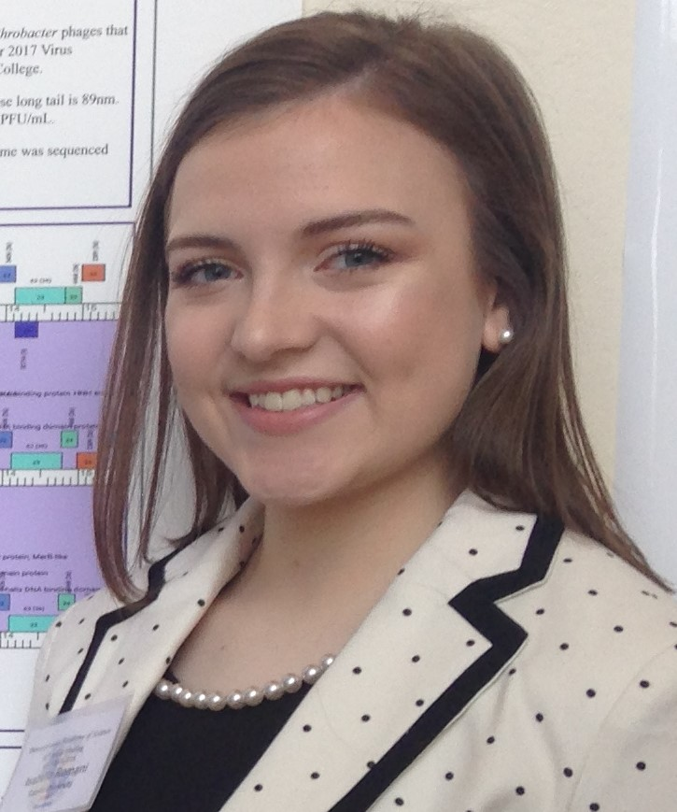
Isabella Romani
Discovery and Annotation of Cluster AN Arthrobacter Phages
Isabella Romani, Andrew Conboy, Sonia Spadafora, Bailey Babarsky, Jenna Bucca, Hunter Angle, Chris Dachowski, Alyson Marshall, Bhumi Patel, Morgan McDonough, Veronica Siko, Adriana Eiwechter, Caroline Germain, Brian Layden, Angelica Valentin, Afua Awuah, Lauren Markowitz, Bianca Santos, Sarah Grant, Alyssa Rothman, Amanda Budzilowicz, Sarah Eplett, Olivia Townshed, Danielle Ayer, Courtney Curcio, Carina Cena, Nikolai Kuchinos, Nicholas Staub, Zachary Rambo, Steve Sampura, Benjamin Giordano, Robert Schmidt, Lisa McKernan, Joseph Kulkosky, Matthew Mastropaolo*, Melinda Harrison
* Neumann University, Aston PA
Bacteriophages are viruses that infect a bacteria host, potentially leading to strategies for treating, preventing, or diagnosing bacterial infections such as tuberculosis that are resistant to conventional antibiotics. We have discovered 20 novel phages from the bacterial host Arthrobacter sp.ATCC 21022. The phages were collected from soil and water samples by students from various places around South Eastern PA and Southern NJ. and their genomic DNA isolated. After isolating the genomic DNA, they were photographed through the use of an electron microscope and then the DNA was sequenced. The Phages genomes were then annotated using various bioinformatics tools, such as DNA Master; Phamerator; HHpret and GeneMark to determine gene location and function. Using comparative genomics, unique characteristics of the phage’s genome were also explored. This study presents a comparison of seven bacteriophage genomes that were isolated from this research: CGermain, Hunnie, Inspire2; Dewayne; Azathoth; Copper and Ronnie. The genomes of these phages were annotated as a collaborative effort by many students and faculty.

