CONSIDER FOR TALK
10th Annual SEA Symposium Abstract
Southern Connecticut State University
New Haven CT
Corresponding Faculty Member: Nicholas Edgington (EdgingtonN1@SouthernCT.edu)
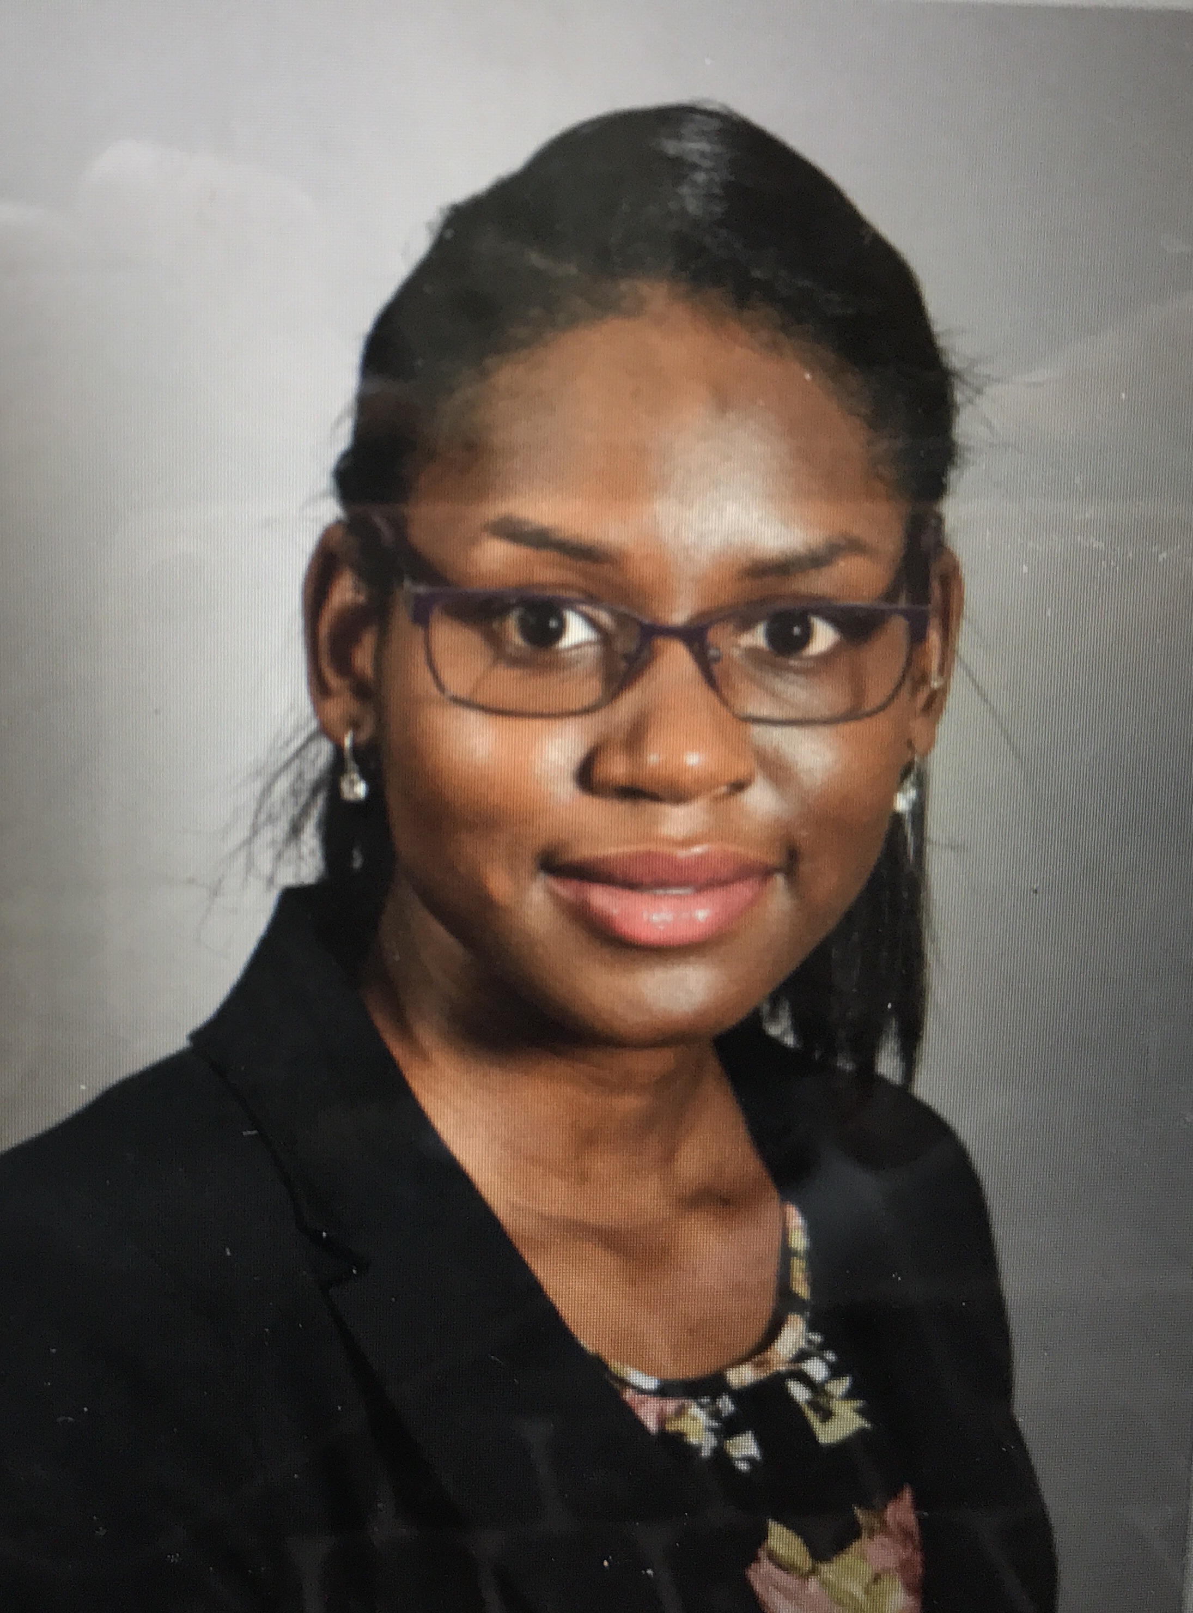
Ashley S Raymond
Maria F Lopez
Characterization of three uncommon bacteriophages, a global analysis of Actinobacteriophage predicted transmembrane domain-containing proteins, and a pan-genome analysis of Microbacteriophages.
Ashley S Raymond, Maria F Lopez, Timothy Abbot, Mallory Breban, Angela Galantini, Lucas Galster, Muhamed Khatib, Samantha Murphy, Megan Rebeschi, Dathan Stone, Nicholas P Edgington
So far approximately one hundred sequenced Microbacteria foliorum bacteriophages have been identified. We describe two new bacteriophages, 'Gilda' and 'Minima', that can infect this host, and belong to the clusters EF and EE, respectively. The EF cluster only has three members that are closely related to each other and are about 56.7kb in genome length, and the EE cluster has twelve members whose average genome size is only 17.4 kb. We present annotations and comparative genomics data on the Mycobacteriophage "S" cluster phage named 'Lilbit', which was isolated in 2014, but only recently sequenced last year by the Hatfull lab in a search for 'uncommon' mycobacteriophage lineages. Finally, we present a comprehensive examination of putative transmembrane domain-containing proteins in the Actinobacteriophages, and a pan-genome analysis of Microbacterium bacteriophages.

