DO NOT CONSIDER FOR TALK

10th Annual SEA Symposium Abstract

Virginia Western Community College

W. Roanoke VA

Corresponding Faculty Member: Heather Lindberg (hlindberg@virginiawestern.edu)

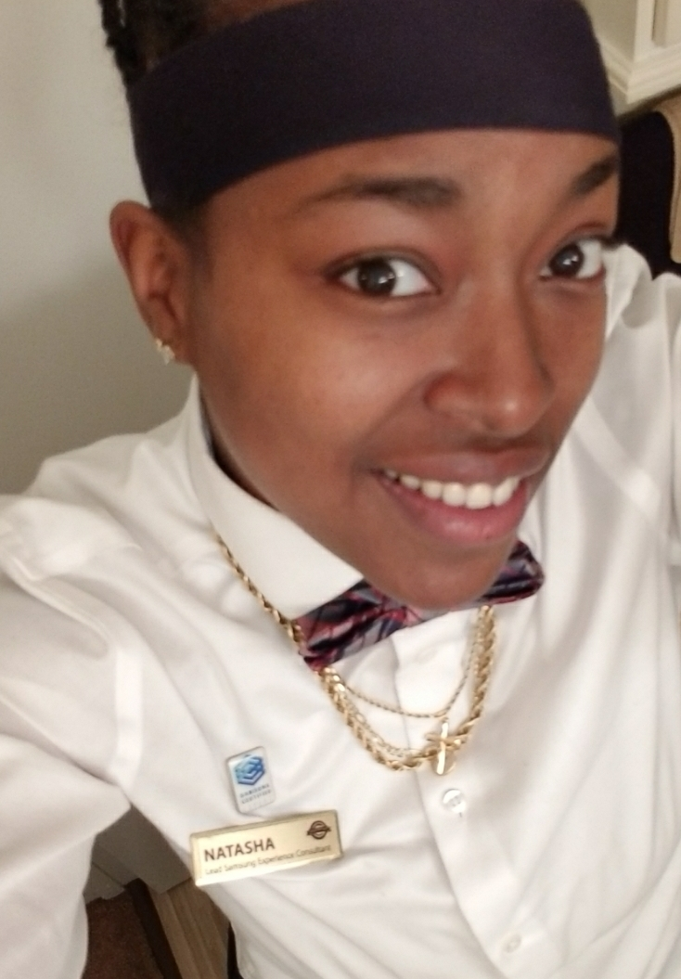

Natasha Whitaker

The discovery, characterization and annotation of DrFeelGood, an A1 cluster mycobacteriophage

Natasha Whitaker, Christopher Tice , Richard Juneau, Jacqueline Biscardi, Stacie Deaver, Heather Lindberg

At Virginia Western Community College, over the course of the 2017- 2018 academic year, we isolated, characterized and annotated the genome of a unique bacteriophage, DrFeelGood. DrFeelGood was isolated from soil collected from a compost pile comprised of potting soil mixed with clay in the Roanoke Valley using Mycobacterium smegmatis mc155 as the host bacterium. Isolation and purification of Dr.FeelGood occurred during the fall semester in Biology 101, while genome annotation took place in Cellular Biology during the spring semester. Sequencing done by the Univeristy of Pittsburgh revealed DrFeelGood to be an A1 cluster phage. For genome annotation, several databases were used to investigate the sequence of DrFeelGood’s 83 genes and their correlative functions. The overall goal is the submission to GenBank with expectations of contributing to the comprehensive knowledge of phage genetics, biodiversity, and microbial ecology.