DO NOT CONSIDER FOR TALK
10th Annual SEA Symposium Abstract
Salish Kootenai College
Pablo MT
Corresponding Faculty Member: Elizabeth Rutledge (elizabeth_rutledge@skc.edu)
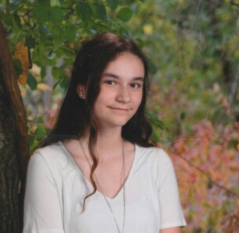
Savannah Houle
Geraldine Trahan
Bacteriophages
Savannah Houle, Geraldine Trahan
Introduction: Bacteriophages, also known simply as phages, are microscopic viruses in the soil which infect bacteria. Even though we have learned a tremendous amount about phages, there is still plenty left to learn.
Methods: In order to find the phages, we first had to collect soil. The next step was to enrich the soil so the bacteria can grow. The phage was then then spun in the centrifuge and the supernatant was collected, filtered, and M. smegmatis was added so the phage can amplify. The supernatant was then used for assay via spot test and purification. After purification, we named the phages, in our group we had Bones, Snazzy, Stulix, Walgreen, Coca, and Freyja. Several webbed plates were used to collect lysate in phage buffer to create a higher titer. When we had a high enough titer after flooding the plates and collecting the lysates, the phages were sent to the archive. With the leftover lysate, DNA from the phages was extracted, Bones and Snazzy were sent to be sequenced. When the DNA sequences came back, annotation was started.
Results: After performing multiple serial dilutions, and titers we finally received a high enough titer to be submitted to HHMI. We received the genomic sequence of Bones, and began the process of annotation. Bones has 88 genes and is in the A1 subcluster, it is in the siphoviridae family. By annotating each gene we were able to tell where each gene starts and stops, how they are related to similar phages, and what the function is if it had one, but many still have NKF (no known function) which makes the research challenging and exciting.
Conclusions: Throughout the process of isolating phages, we have become familiar with the procedures. We learned how to perform serial dilutions, plaque assays, titers, spot tests. We also learned about phage biology. Throughout the year we had 9 people working to collect a phage with a high enough titer, although only 6 of us succeeded. Of the 6 phages that were sent to HHMI, so far we have received the draft genome for Bones and Snazzy. The process of annotating genes was an entirely new and exciting process for us.

