CONSIDER FOR TALK
7th Annual SEA-PHAGES Symposium Abstract
Lincoln University
Lincoln University PA
Corresponding Faculty Member: Anna Hull (ahull@lincoln.edu)
Erin N Lockwood
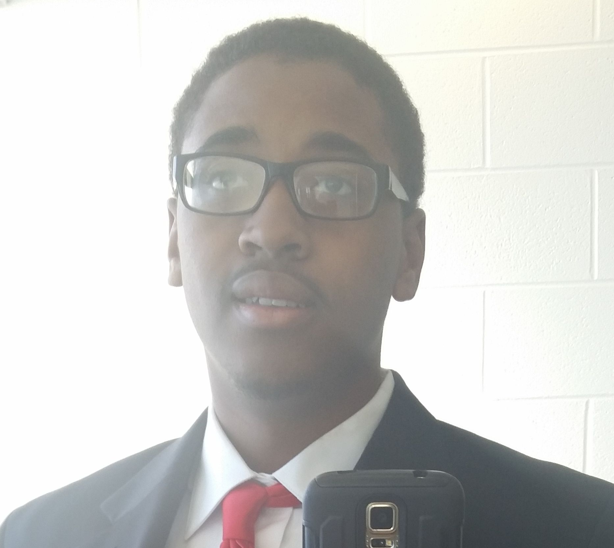
Nijewel X Holliday
Finding Panchino - a novel N-cluster Mycobacterium phage isolated at Lincoln University, Pennsylvania
Erin N Lockwood, Nijewel X Holliday, Nnamdi E Ihejirika, Tamara D Jones, Lisa R Mwanza, Prisca C Obidike, Jaqueline G Ruban, Nathaniel J Sangster, Anna K Hull, David F Royer
Panchino, an N cluster bacteriophage, was isolated from a soil sample on the campus of Lincoln University (Pennsylvania) as part of a Phage Hunters class offered for the first time during the 2014-15 academic year. Panchino is similar to other N cluster phages in genome length, GC content and number of genes. It produces clear, 1.5mm diameter plaques. It is a member of the Siphoviridae with a characteristic long tail (200 nm) and a head with a 50 nm diameter. The annotation revealed 65 genes, of which 20 were assigned a putative function based on comparisons with other N cluster phages using BLASTP on PhagesDB and on NCBI. Of the 20 assigned a function, 6 code for structural proteins and 14 code for functional proteins. Two of the more interesting genes encountered during annotation were a programmed translational frameshift involving genes 15 and 16 that encode a tail assembly chaperon and a possible type 1 restriction enzyme.

