CONSIDER FOR TALK
10th Annual SEA Symposium Abstract
University of California, San Diego
San Diego CA
Corresponding Faculty Member: Swarna Mohan (swmohan@UCSD.EDU)
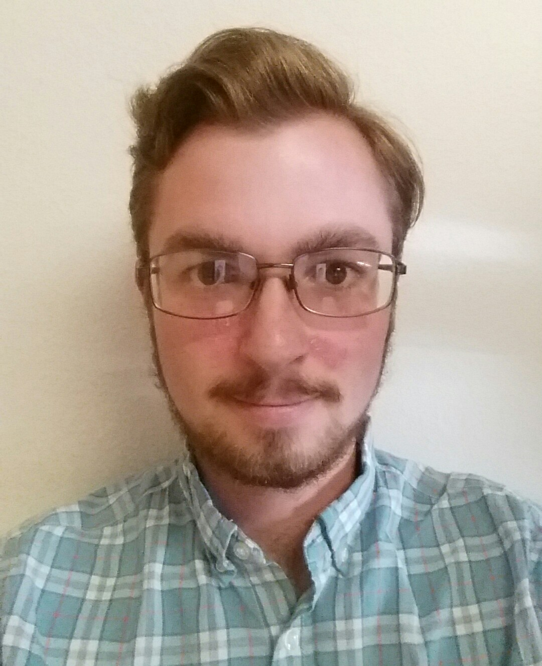
William W Bushnell
Isolation and characterization of Streptomyces and their Phages from soil samples in the San Diego County.
William W Bushnell, Noorhan Z Amani, Maya E Ambroziak, Andrea Biju, Cianna N Calia, Yi J Chen, Lindsay T Hill, Sarna Karpinska, Keeley C Martinez, James R Medwid, Caroline Nguyen, Aaron A Oliver, Jessica P Pham, Marina R Ramsey, Saisri Ravi, Jefferey R Sardina, Savanna L Senecal, Jeanna Sheen, Neil V Shende, Caroline Y Shi, Lauren C Stuart, Linda Vu, Lily Q Wang, Laine J West, Alexandra C Westgaard, Roland Liu, Emily Pierce, Swarna Mohan, Joe Pogliano
Students in the Genomics Research Initiative course at UCSD isolated 26 Streptomyces platensis strain MJ1A1 phages from soil samples from around San Diego County and 47 Streptomyces strains from the same soil samples. Genomes from two phages, Hank144 and Darolandstone, were sequenced and annotated. Phage Hank144 belongs to subcluster BD2 and phage Darolandstone is the second phage to be added to the subcluster BC2. We screened the isolated Streptomyces strains for antibiotic production and 41 out of the 47 isolated strains, were classified by 16s rRNA sequencing. Several of the isolated Streptomyces strains produced molecules capable of killing E. coli ΔtolC and Bacillus subtilis PY79. Additionally, we examined the host range of our two sequenced phages against a subset of the isolated Streptomyces strains. We used the 16s rRNA results and the sequenced phage genomes to explain any observed differences in the host ranges.

