CONSIDER FOR TALK
10th Annual SEA Symposium Abstract
Carnegie Mellon University
Pittsburgh PA
Corresponding Faculty Member: Javier Lopez (jlaa@andrew.cmu.edu)
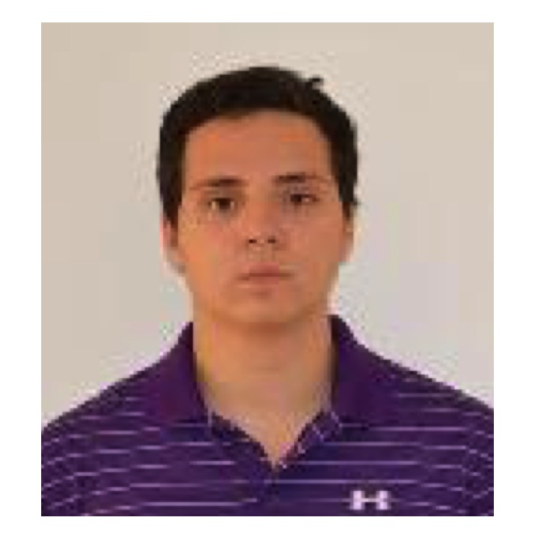
Pedro Safi
Characterization of Novel Bacteriophages that Infect Arthrobacter sp ATCC1022 or Microbacterium foliorum
Kendra Adegbesan, Mabel Bartlett, Carolyn Botz, Cali Colliver, Brooke Dresden, William Fahy, Alejandro Garces, Venkat Gella, Ziyi Guan, Camila Guerrero, Priya Guntur, Wonhee Han, David Hoyos, Meera Krishna, Sydney Lee, Iris Lu, Kiran Mirpuri, Harold Rockwell, Pedro Safi, Aria Salyapongse, Emily Schneider, Ariel Uy, Jonathan Jarvik, A. Javier Lopez, Natalie McGuier
Bacteriophages have important ecological roles and applications in medicine, food production and bioremediation. To further the understanding of bacteriophage diversity and evolution, we screened soil samples from diverse locations for bacteriophages that form plaques on lawns of Arthrobacter sp. ATCC1022 or Microbacterioum foliorum. Arthrobacter has potential uses in bioremediation and Microbacterium species can be involved in spoilage of milk products. We identified 14 Arthrobacter phages and 8 Microbacterium phages and we characterized them with respect to plaque morphology and temperature sensitivity, virus morphology, and ability to lysogenize. We purified genomic DNA from 9 Arthrobacter phages and 8 Microbacterium phages and we sequenced the DNA on the Illumina Miseq platform, followed by assembly of the genomes using GS DeNovo Assembler. We obtained complete assemblies for 8Arthrobacter phages (1 singleton, 2 cluster AK, 1 AN, 1 AR, 2 AU1, 1 FG) and 5 Microbacterium phages (2 EA, 1 EB, 2 EE). We generated finalized annotations for Guntur (Arthrobacter, cluster AN) and Dongwon (Microbacterium, cluster EE), as well as draft genome annotations for all other assembled genomes.
We found evidence in the Dongwon genome sequence for a programmed translational frameshift to produce a full-length tail assembly chaperone. Two tRNAs were predicted by Aragorn, but they are located in regions of strong coding potential within the tapemeasure protein ORF, suggesting that they are not expressed tRNAs. They are also predicted, in different combinations, within some but not all EE phages. To investigate whether these sequences represent ancestral insertions of tRNA genes that were modified by mutation and coopted to encode portions of the tapemeasure gene, we performed a comparative phylogenetic analysis of the tapemeasure gene and flanking genes, including a minor tail protein gene that is represented by different Phams within the EE phages.
We also analyzed in detail the sequence and conservation of Guntur gene 23 ORF, more than half of which exhibits very poor coding potential. The N-terminal portion (strong coding potential) encodes an HTH domain with similarity to Bacillus DNA-D, an origin recognition protein (HHPred analysis). The poor-coding potential region contains a series of inverted and direct repeats that are more highly conserved than the HTH region, as well a relatively AT-rich region. We suggest that Gene 23 may contain an origin of replication and also encodes a protein that recognizes it.
We isolated an interesting derivative of Arthrobacter sp ATCC1022 that is partially resistant to bacteriophage Wyth and exhibits different phage-specific modifications in plaque morphology with a range of our Arthrobacter phages. Although this strain was initially isolated as a survivor or Wyth infection, we have not been able to purify and sequence Wyth DNA so we cannot yet determine whether it is a lysogen or a bacterial mutant.

