DO NOT CONSIDER FOR TALK

10th Annual SEA Symposium Abstract

St. Louis Community College

St. Louis MO

Corresponding Faculty Member: Bob Harms (rharms@stlcc.edu)

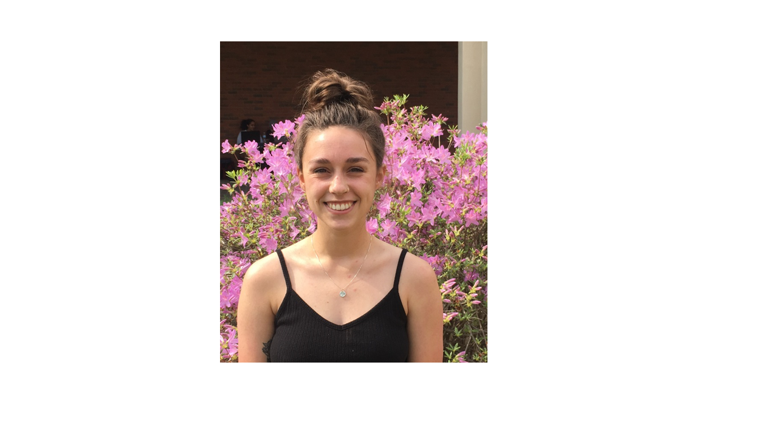

Taylor Gray

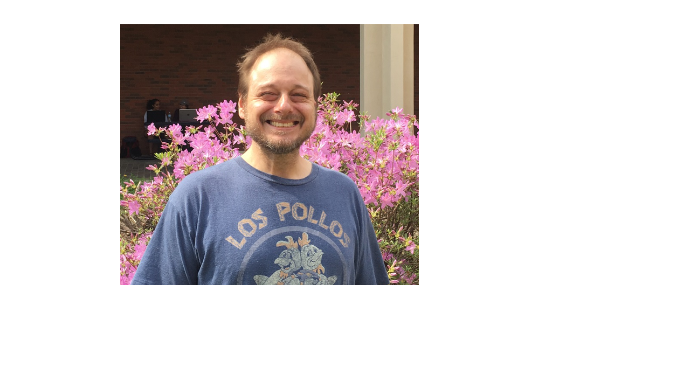

Fredrick Wuliger

Isolation and Annotation of a Unique B1 Mycobacterium Phage - PinheadLarry

Taylor Gray, Fredrick Wuliger, Robert C Harms, Thomas J Peters

Mycobacteriophage are pathogens known to attack mycobacterium. Eradicating a pathogen with a pathogen seems poetically just. They could be the key to revealing the secrets behind the mechanisms of human pathogens like Mycobacterium tuberculosis and Mycobacterium leprae. Since phage can be grown in abundance in a laboratory setting, unlike M. tuberculosis, they can also be used as a potential model. Working backwards by understanding how phage “work,” we can begin to understand the potential phage therapy of human pathogens like M. tuberculosis and M. leprae.   
Since August of 2017, the students of St. Louis Community College have been working diligently to isolate, purify, amplify, and extract DNA from phage samples collected from soil found in numerous locations in the St. Louis area using Mycobacterium smegmatis as the phage’s bacteria host. PinheadLarry was the phage that was successfully extracted; therefore, it was sent off to the University of Pittsburgh for genome sequencing.   
At Pittsburgh, the DNA sample was cleaved into small, manageable fragments, hybridized to special adapters designed to anneal to oligonucleotides adhered to a channeled glass slide. The target DNA was amplified and sequenced during synthesis by observation of unique fluorescent signals emitted by the synthesized strand. By this method, many strands are sequenced simultaneously and indexed according to a specific, shorter sequence that is also catalogued. Pooled sequence libraries were divided according to index and subdivided according to similarity. Reverse and forward sequences were matched creating a whole contiguous genome sequence.  
 Gene annotation began after mapping with a computer program analyzing the genetic sequence, and defining all the open reading frames based on conditions determining their likelihood. However, the program is imperfect, particularly with a dearth of comparative data as is the case with phage, and thus the draft genome required a second, human annotation. During the 2018 Spring semester, eleven students worked together to annotate PinheadLarry using bioinformatic tools to guide their way to a fully annotated genome. DNA Master was the genome annotation program used along with coding potential algorithms, Glimmer and GeneMark, for gene start locations. NCBI Blast, PhagesDB, and HHPred were utilized for possible known functions for each gene, while the database Phamerator was examined for synteny among similar phage in the B1 cluster. After having to revise start locations, make ORF deletions, and adding new uncalled ORFs, PinheadLarry’s genome sequence annotation was finalized. With the annotation complete, hopefully the genome will provide insight to how phage function, which in turn provide insight to how mycobacterium function.