CONSIDER FOR TALK

10th Annual SEA Symposium Abstract

The Ohio State University

Columbus OH

Corresponding Faculty Member: Sarah Ball (ball.1766@osu.edu)

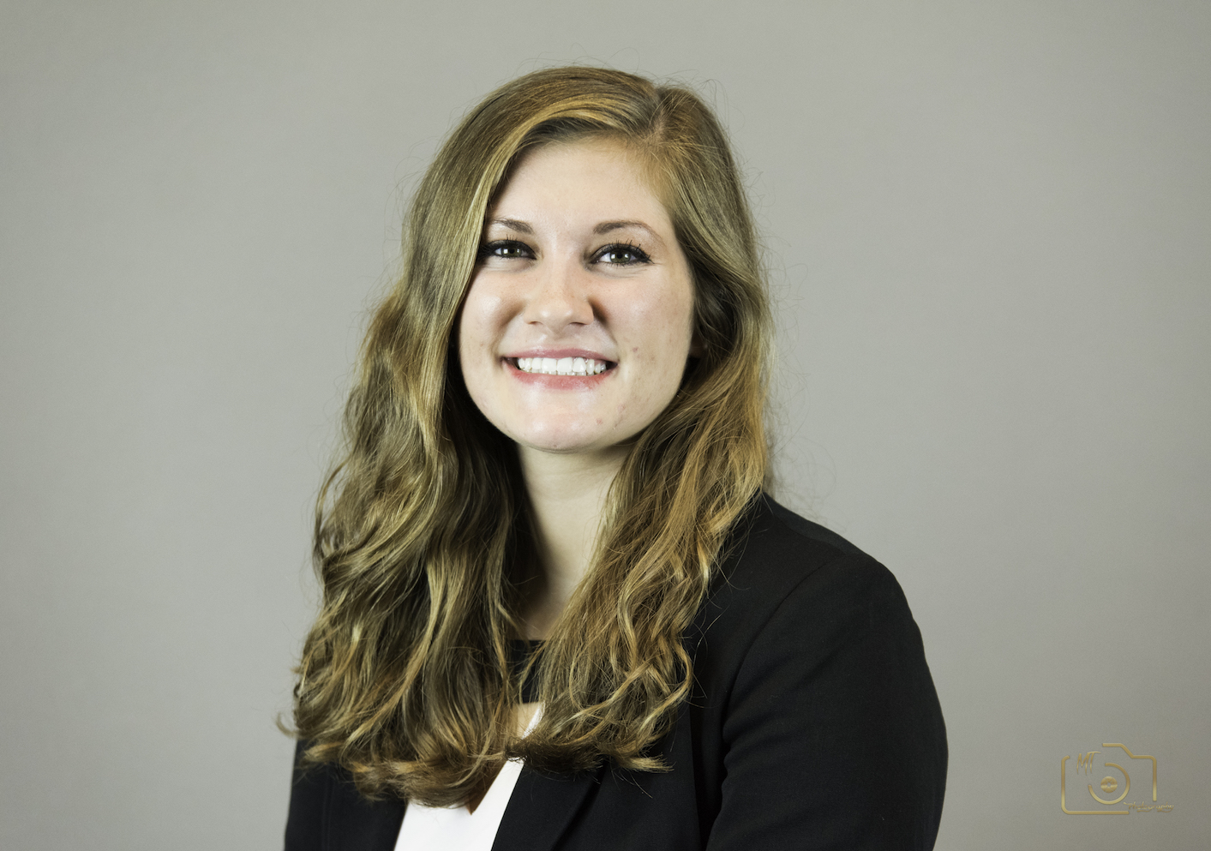

Natalie Cervelli

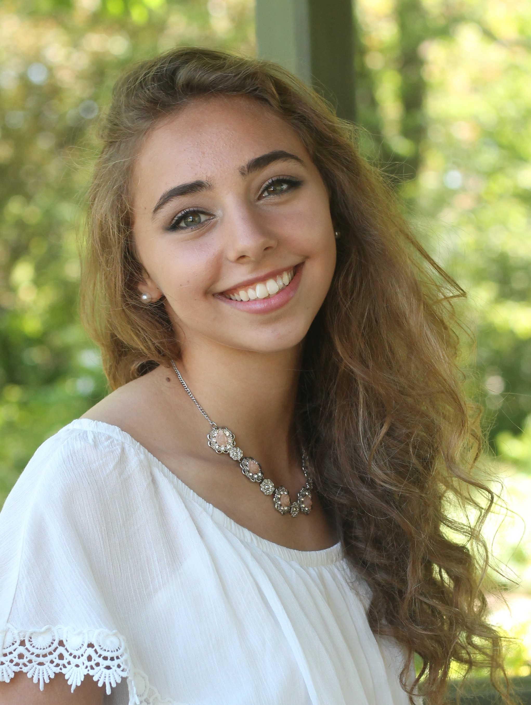

Dahlia Najjar

Genomic Analysis of Arthrobacteriophage MargaretKali, a singleton

Natalie Cervelli, Dahlia Najjar, Sarah Ball, Caroline Breitenberger, Charles Daniels

Students at The Ohio State University have been participating in SEA-PHAGES since 2011. During fall semester 2017, we isolated our first singleton, MargaretKali, using Arthrobacter sp. ATCC21022 as the host. The 39,448 base-pair MargaretKali genome has a 61.1 % GC content, which is slightly lower than that of the host’s genome (63.4 %), and 69 predicted open reading frames, of which 29.5 % are orphams. A putative tyrosine-integrase was identified, suggesting MargaretKali may be a temperate phage. This is further supported by the fact that many predicted gene products had BLASTP hits corresponding to open reading frames in several different Actinobacteria genera, some of which could represent prophages.