CONSIDER FOR TALK
10th Annual SEA Symposium Abstract
Doane University
Crete NE
Corresponding Faculty Member: Dane Bowder (dane.bowder@doane.edu)
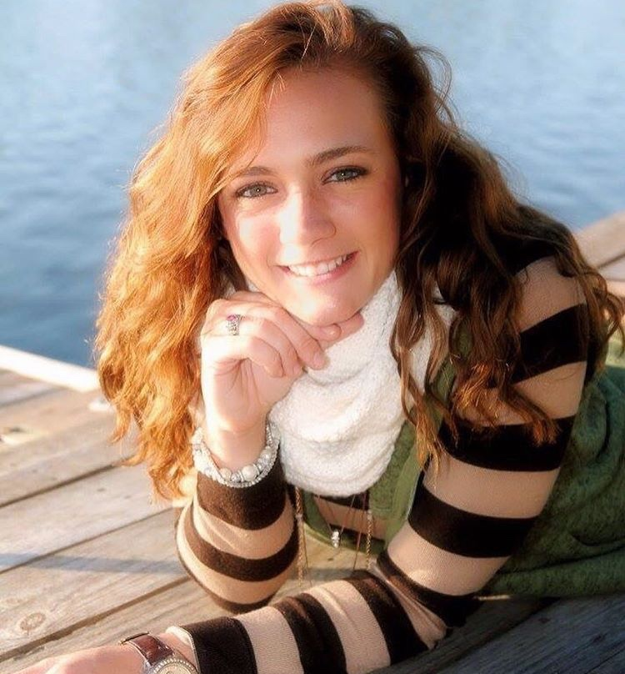
Danielle Schreiber
Discovery and genome annotation of Bread and Fudgetart, two cluster C1 Mycobacteriophages
Danielle Schreiber, Grace Su, Brea D Murnan, Kaitlyn Mahnke, Jason T Iltz, Alexandria M Osborn, Teryn M Koch, Kate J Grint, William M Herron, Jaime G Troester, Brandon W Gannon, Dane M Bowder, Erin L Doyle
Many mycobacteriophages were isolated from soil samples collected around the Doane University Crete campus in August of 2017 using Mycobacterium smegmatis as the host bacteria. The phages were isolated from enriched soil samples. Harvested lysates were used for TEM imaging and DNA extraction. TEM imaging showed a high percentage of myoviridae. Two phages, Bread and FudgeTart, were selected for DNA sequencing based on morphology. Sequencing confirmed that both Bread and Fudgetart were lytic phages belonging to the C1 subcluster.
Bread’s genome is 153,796 bp in length with 225 ORFs, 79 of which have identified functions, and 32 tRNAs. Fudgetart’s genome is 154,658 bp in length with 228 ORFs, 78 of which have identified functions, and 30 tRNAs. Both genomes also contained a single tmRNA.

