DO NOT CONSIDER FOR TALK
10th Annual SEA Symposium Abstract
Coastal Carolina University
Conway SC
Corresponding Faculty Member: Daniel Williams (dwilliams@coastal.edu)
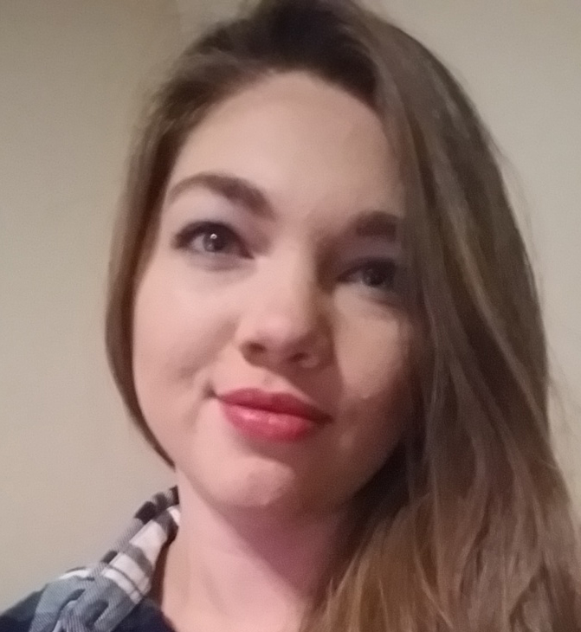
Mary Akers
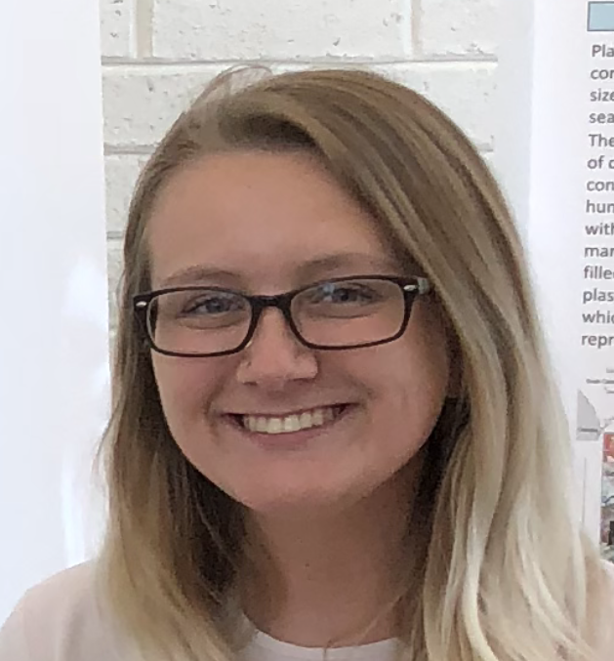
Kelsey Largen
Comparative Analysis to Assess Hangman’s Potential for Phage Therapy
Mary Akers, Kelsey Largen, Megan Cevasco, Daniel Williams
Phage therapy can be used to combat bacterial diseases by treating patients with phages that lyse infectious bacteria. Because antibiotic resistant bacteria are on the rise, phage therapy is currently being explored as an alternative to antibiotics. Comparative analysis can be used to identify phages or genes within phages that have therapeutic potential. Using Mycobacterium smegmatis as a host, Hangman was isolated at Coastal Carolina University, South Carolina in the fall of 2017 and belongs to subcluster B4. During annotation of Hangman, we discovered lysin A belongs to a pham that includes lysin A genes from cluster K phages, some of which infect Mycobacterium tuberculosis. We performed comparative and phylogenetic analysis of Hangman with other phages that show broad host specificity. Our results will be used to assess the potential of Hangman for phage therapy.

