CONSIDER FOR TALK
10th Annual SEA Symposium Abstract
Drexel University
Philadelphia PA
Corresponding Faculty Member: Alison Moyer (aem442@drexel.edu)
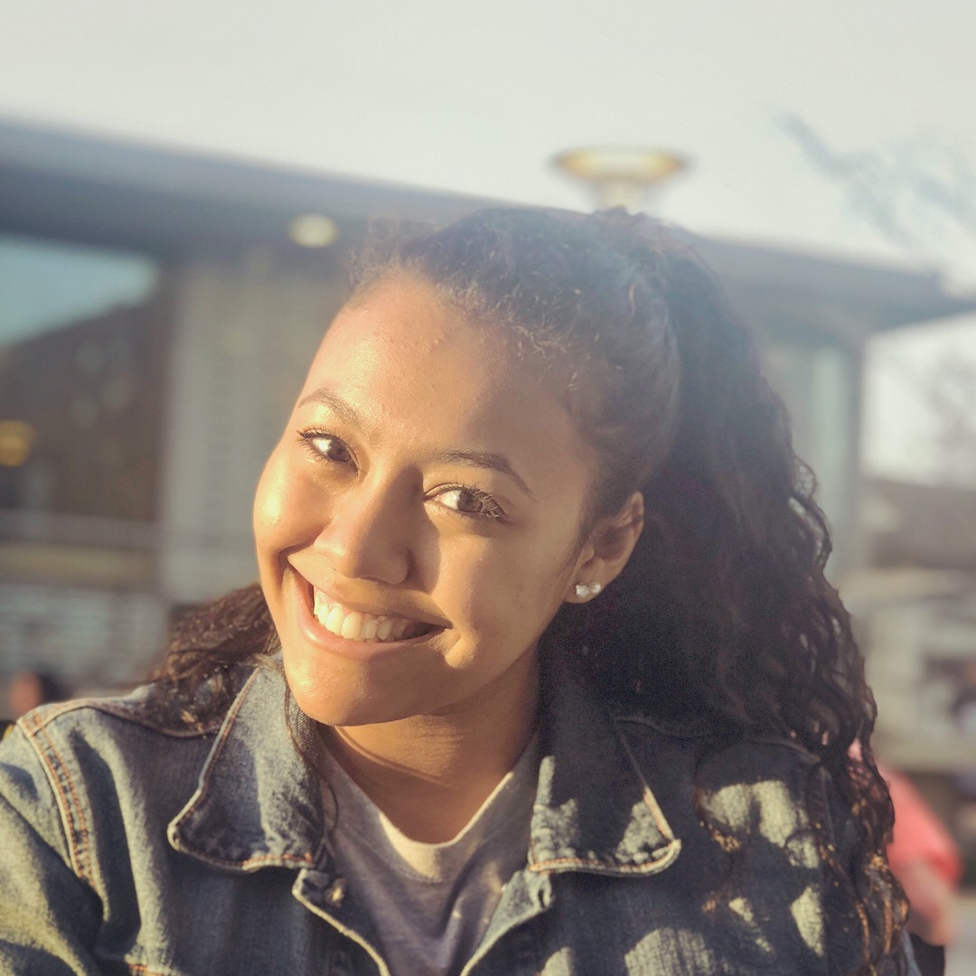
Apollonia Quiros
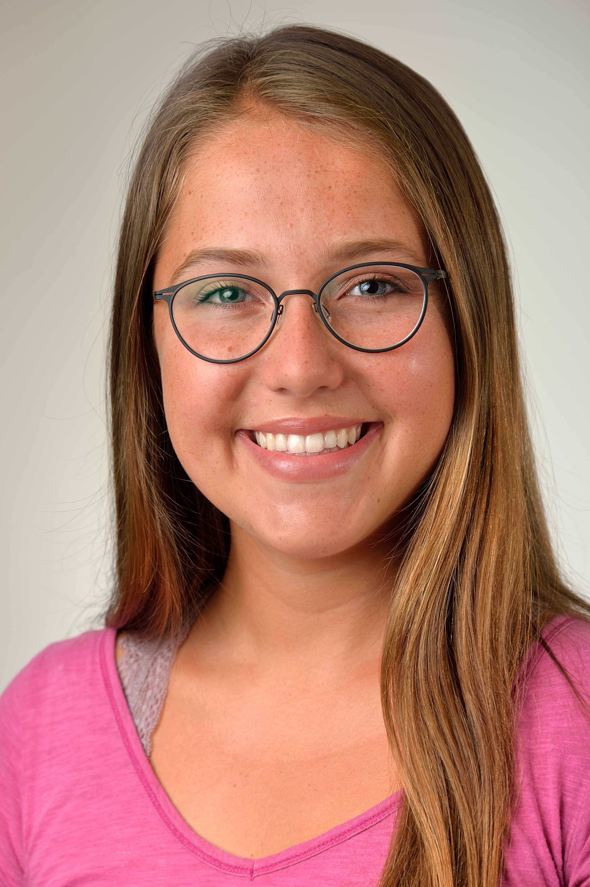
Gabriella Macera
Analysis of Four F1 Cluster Mycobacteriophages: A True Phage Phrenzy!
Apollonia Quiros, Gabriella Macera, Matan Ben Abou, Abhinaya Bharath, Akash Bhat, Praneetha Bheemarasetty, Madison Bockol, Ishaan Bhatt, Meredith Anne Capuli, Zachary Cataline, Upoma Chakraborty, Patrick Chang, Jessica Chase, Amanda Chen, Jackie Chen, Nina Cheng, Hannah Cherusseril, Justin Cicarelli, Caitlin Clifford, Cara DePiano, Nihar Desai, Leah Dobossy, Skylar Driscoll, Jinie Eom, Rahul Gandhi, Jakub Gocal, Saksham Goel, Alvin Guan, Zachary Gulgule, Natalie Gundling, Selam Haile, Ashley Harkins, Lucy Helgren, Samir Jambhekar, Hannah Johnson, Rohan Joshi, Shraddha Kamat, Akriti Keswani, Jonathan Khoo, Un Bi Kim, Victoria Koa, Merlin Kochunilathil, Hannah Kostan, Kaylee Krapp, Prem Krishnaprasad, Zhuo Kuang, Sophie Lawrence, Hannah Lee, Katherine Li, Angelo Lodato, Richard Lu, My Mai, Shreya Mandloi, Rohil Mediratta, Sreya Muchivolu, Tania Mulherkar, Mekha Nair, Emily Navarreto, Chandler Olson, Angele Oye-Mba, Victoria Palochik, Chanyeong Park, Dhwanil Patel, Radhika Patel, Riya Patel, Kenil Patel, Uyen Phan, Neha Puttagunta, Natasha Reddy, Joy Rosenberg, Megha Sangam, Mitali Shah, Saloni Shah, Alexandra Silvestri, Maria Sims, Shannon Smith, Allison Tran, Alyssa Truxon, Najia Uddin, Serin Varughese, Shannon Smith, Allison Tran, Alyssa Truxon, Najia Uddin, Serin Varughese, Kanyinsola Yoloye, Nari Yoon, Eleanor Young, Justin Yuen, Nathan Zhang, Arden Edgerton, Christine Tang, Ritu Dalia, Susan Gurney, Alison Moyer
Drexel University undergraduates isolated and purified 89 unique bacteriophages that infect Mycobacterium smegmatis mc² 155 in the Fall of 2017; and have successfully completed a third year in the SEA PHAGES program. From these, eight phage genomes were sequenced, and represent three different clusters and subclusters, including four F1 phages: JoeyJr, Nimbo, Phappiness, and QuickMath. These sequenced genomes were annotated throughout the Winter quarter. Genomic comparisons with other F1 phages indicate that QuickMath has the highest level of diversity compared to JoeyJr, Nimbo and PHappiness. The highest sequence similarity observed for QuickMath is 83% coverage with phage Kimberlium. In the Spring quarter students conducted independent wet lab research projects to characterize the growth patterns of these F1 phages under varying conditions. Experimentation involved testing differing growth variables such as incubation temperature, pH, ion source in phage buffer, exposure to different proteins during infection, and growth in the presence of various sugars. In addition, because F1 cluster phages contain the gene encoding for integrase, they can potentially form stable lysogens. Therefore, creating and testing lysogens was explored.

