CONSIDER FOR TALK
10th Annual SEA Symposium Abstract
University of Detroit Mercy
Detroit MI
Corresponding Faculty Member: Stephanie Conant (conantsb@udmercy.edu)
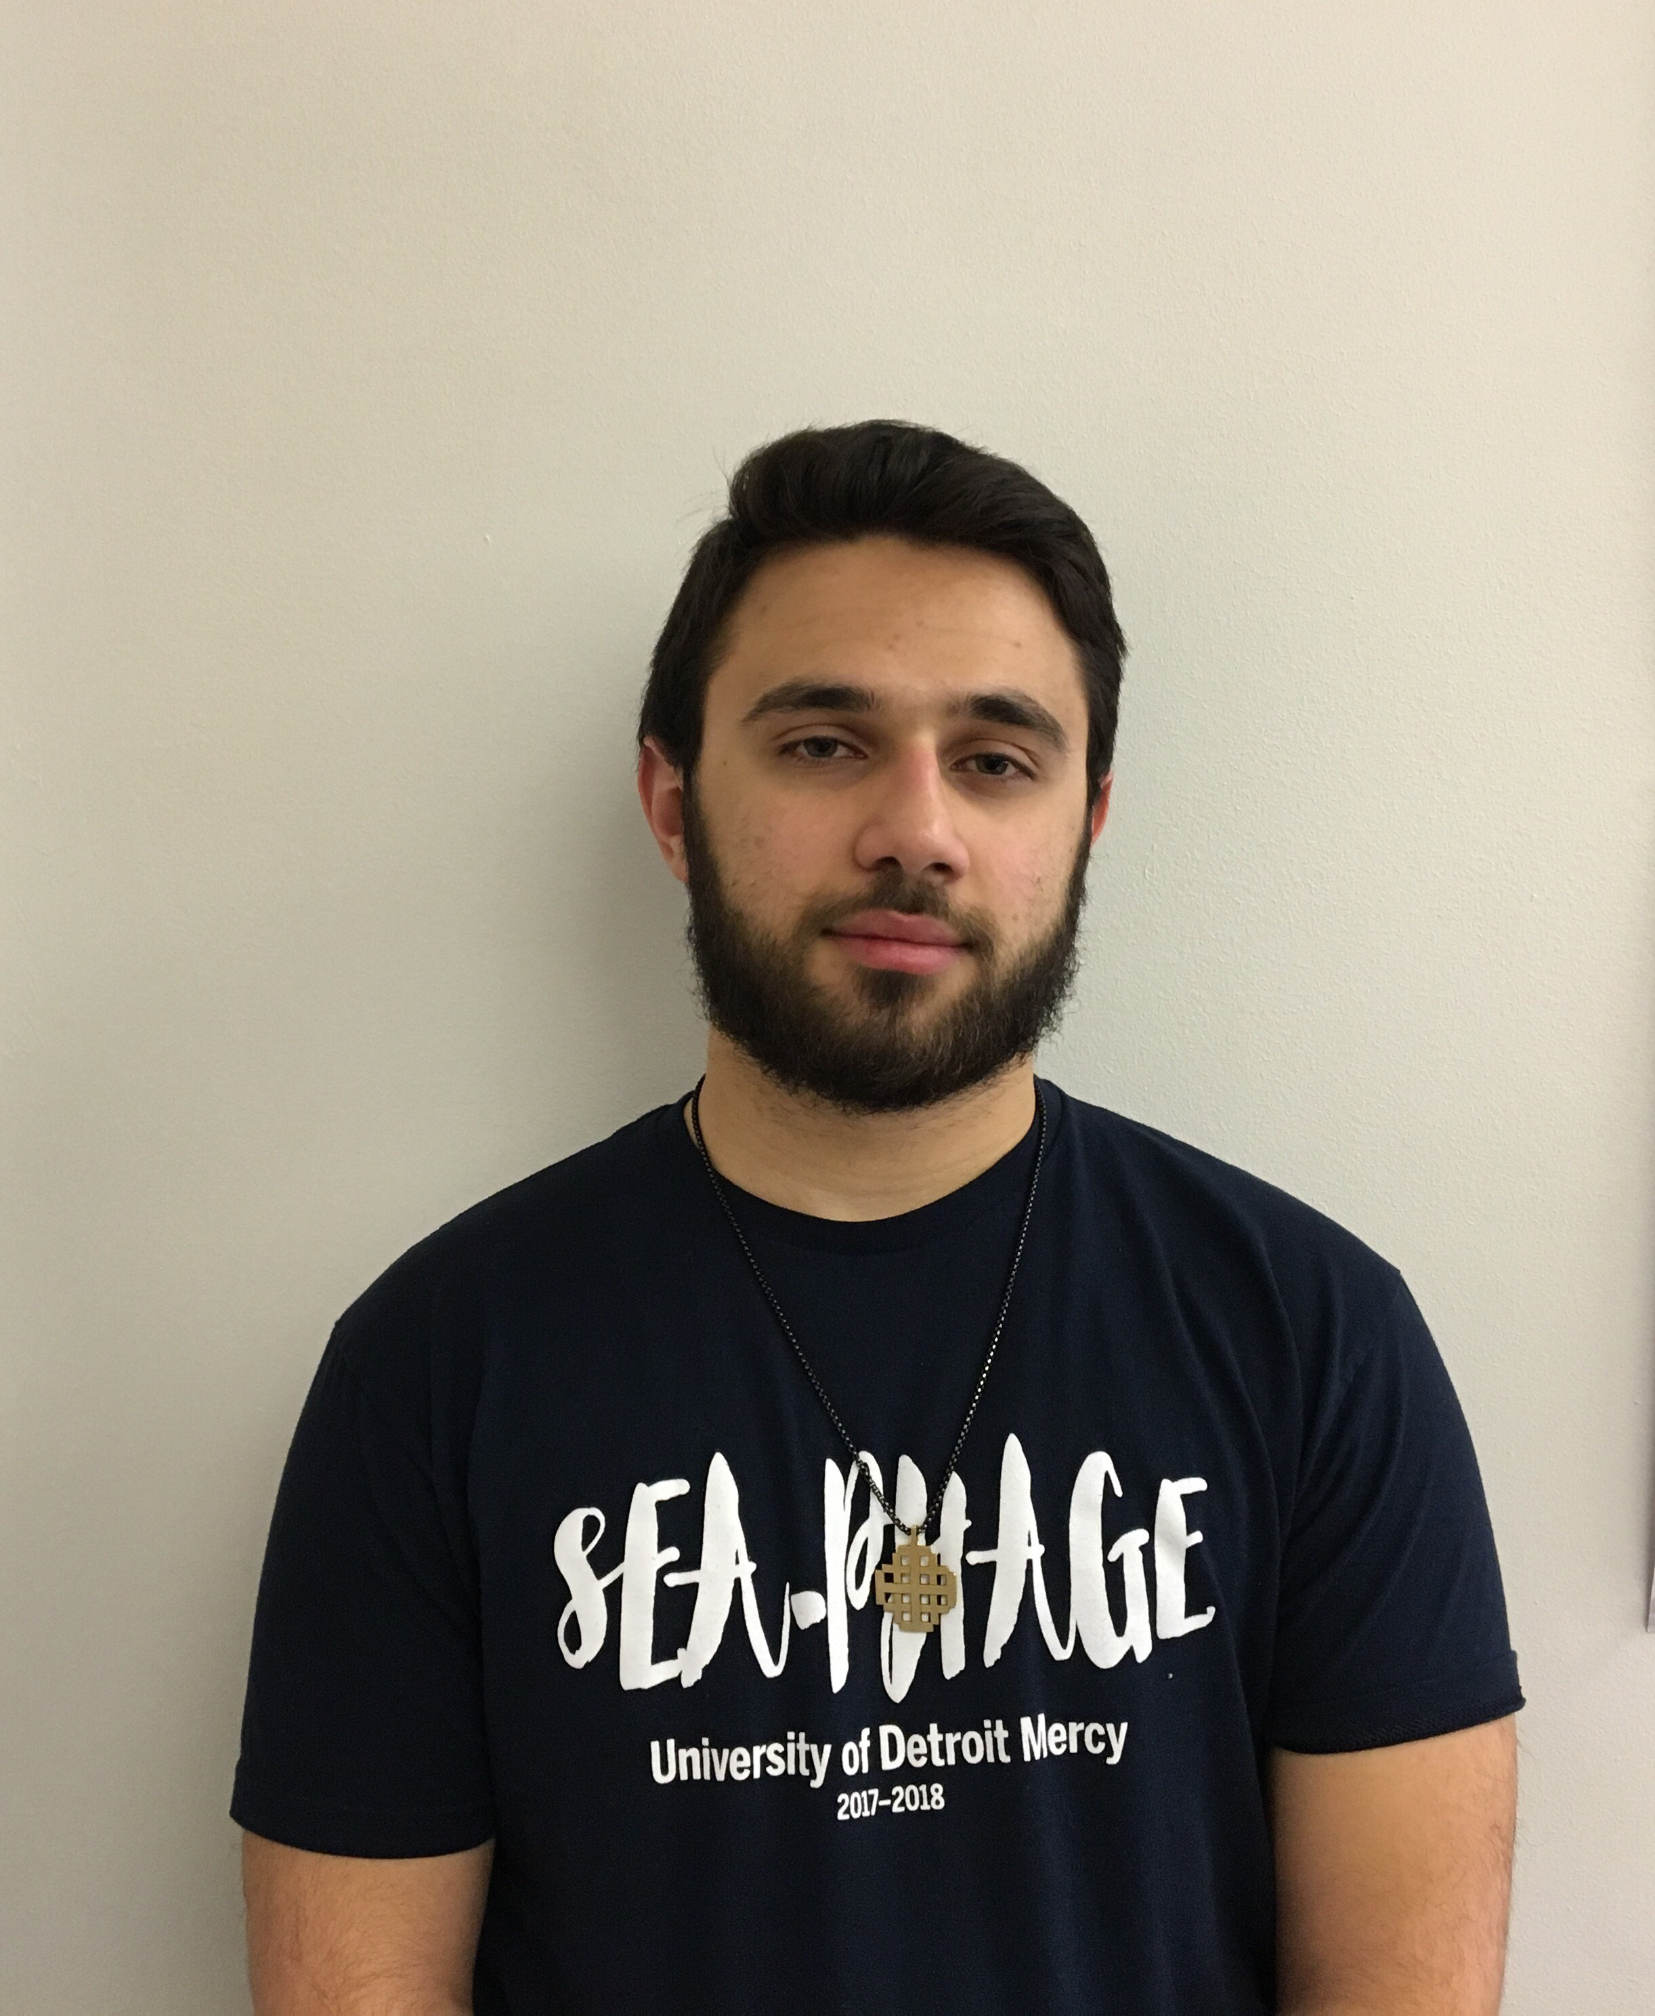
Marcelio Shammami
Analysis of the Annotation of Salz (A11) and Darionha (G1) Bacteriophage
Amber Abram, Zahraa Alhabib, Ivan Barraza-Duran, Karen Crile, Victoria Krajcz, Yamiya Lloyd, DeAvion Logan, Tulsi Patel, Yashodhara Patil, Sabriyyah Ricketts, Leonardo Romero-Barajas, Marisa Rowland, Laila Sareini, Marcelio Shammami, Erin Sheardy, Nikol Shllaku, Racha Tiba, Jonathan Finkel, Jacob Kagey, Stephanie Conant
Two Mycobacterium smegmatis specific phage were extracted from soil and were then purified. DNA was extracted and sent to the University of Pittsburg for sequencing, followed by annotation by the 2017/2018 UDM SeaPhage class. The two phages annotated were Salz and Darionha, which belong to cluster A11 and G1 respectively. Cluster A has 19 sub clusters and 556 members, members of cluster A on average have a length 51,604 base pairs, 90.5 genes, 1.2 t-RNA, and are usually siphoviridae. Salz is a siphoviridae phage in cluster A sub cluster 11, it has 50,146 base pairs, and 95 predicted genes, genes 1-34 read forward, and genes 35-95 read reverse. Salz also has one t-RNA, one confirmed deletion, and seven confirmed changed starts. Cluster G has 4 sub-clusters and 46 members. On average cluster G phage have 42,274 base pairs, 62 genes, 0 t-RNA, and are specific to Mycobacterium. Darionha is a siphoviridae phage cluster G sub cluster 1 phage, it has 41,451 base pairs, and 62 predicted genes, there were three confirmed reverse genes, 32, 33, and 61, and the rest were all forward. Darionha has three confirmed added genes, one confirmed deletion and eight confirmed changed starts.

