DO NOT CONSIDER FOR TALK
10th Annual SEA Symposium Abstract
Lincoln University
Lincoln University PA
Corresponding Faculty Member: David Royer (royer@lincoln.edu)
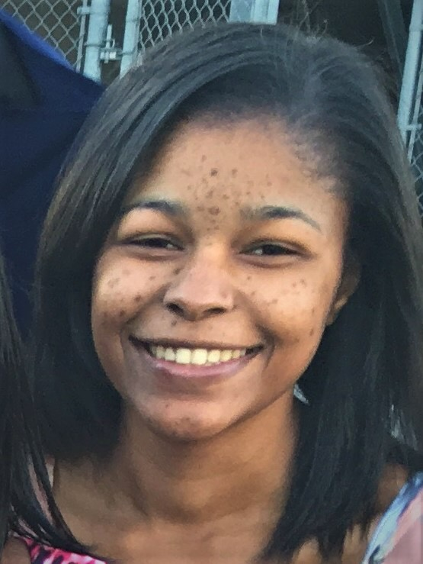
Davisha A Brown
Ohfah, a newly annotated A4 subcluster mycobacteriophage
Davisha A Brown, Charlene L Combs, Seth Donnelley, Saran A Hendrickson, Chiamaka A Ihejirika, Ramona A Plummer, David F Royer
Ohfah, an A4 subcluster temperate bacteriophage, was isolated from a soil sample collected on the campus of Lincoln University as part of a Phage Hunters class offered during the 2017-18 academic year. Ohfah is similar to other A4 subcluster phages in genome length, GC content and number of genes. Genome wide comparisons using the Phamerator program and BLAST revealed that Ohfah is most closely related to members of the A4 subcluster of mycobacteriophages. The greatest similarity is to A4 phages BellusTerra (Gettysburg, PA), Peaches (Monroe. LA), Maverick (Richmond, VA) and Kampy (Williamsburg, VA). It is a member of the Siphoviridae with a characteristic long tail. The annotation revealed 83 genes, of which 51 were assigned a putative function based on comparisons with other A4 mycobacteriophages using BLASTP assignments from both phagesdb.org and GenBank. Of the 51 genes assigned a function, 17 coded for structural proteins and 34 coded for functional proteins. A programmed translational frameshift involving genes 23 and 24, tail assembly chaperones, was identified.

