CONSIDER FOR TALK

10th Annual SEA Symposium Abstract

Dominican University New York

Orangeburg NY

Corresponding Faculty Member: Bernadette Connors (bjconnor60@gmail.com)

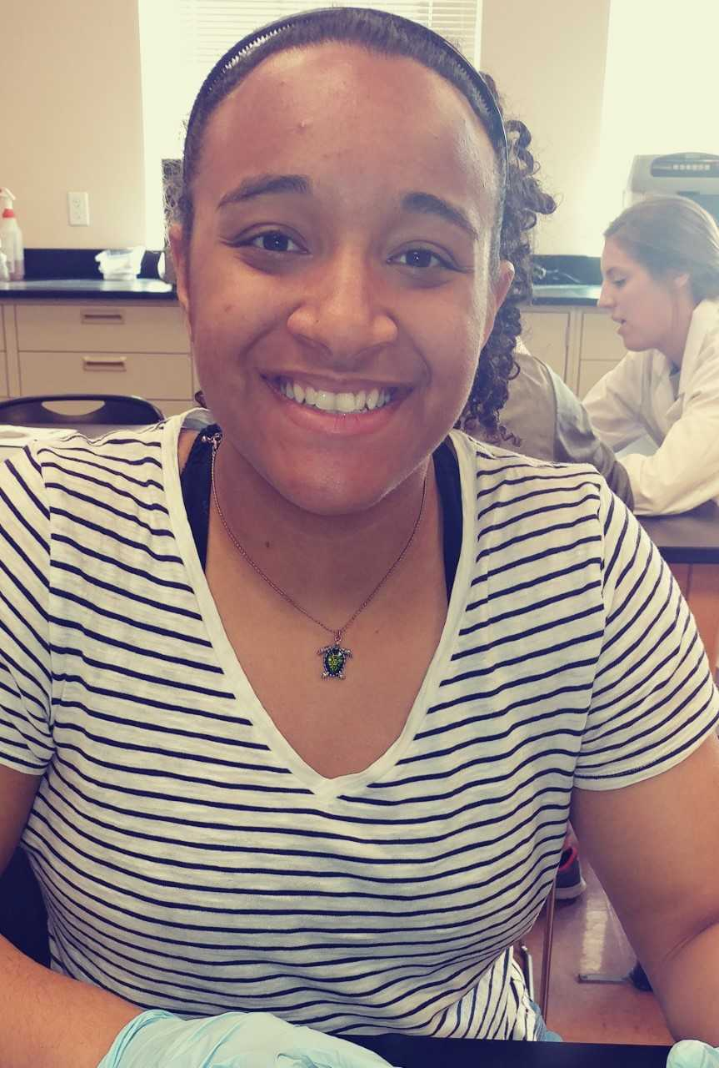

Katherine Clarke



Stefanie Moncayo

Biodiversity of Mycobacteriophages Isolated From Soil

Katherine Clarke, Stefanie Moncayo, Bernadette Connors, Regina Alvarez

In the current study, five mycobacteriophages from the soil were isolated and their genomes were sequenced, and subsequently annotated. Mycobacteriophage are viruses that infect members of the genus Mycobacterium, and are commonly found in soil from myriad environments. Soil samples from Rockland and Bergen Counties were used as the source for these isolations, and all bacteriophage were obtained through direct isolation. The isolated phages were characterized using restriction endonuclease digestion followed by gel electrophoresis. Six genomic DNA samples were submitted for sequencing to the Pittsburgh Bacteriophage Institute for sequencing. The phages discovered by students at Dominican College included cluster J (Zelink) and subclusters B1 (Gophee), B3 (Tydolla), F1 (Spikelee), and K4 (Patt) phages. Genome annotations were completed for all of the five isolates using DNA Master, Glimmer, GeneMark, BLAST, HHPred, Starterator, and Phamerator to identify start sites and assign putative functions. The proportion of the genes with function was determined, and the gene content similarity was analyzed. For Spikelee, 28.83% of the genes were found to have a function. Gophee and Tydolla, on the contrary, had 96.12% and 92.16% of genes with no known function. Gophee (B1) and Tydolla (B3) displayed a significant amount of similarity in terms of gene content (29.3%), while gene content similarities between F1 phage found by students from 2016-2018 at Dominican College (EleanorGeorge, Mattes, Spikelee) ranged from 42-50%. This is a relatively narrow range of similarities compared with that of a random sample of 10 phages on the Actinobacteriophage Database (29-64%). Immunity testing with the Xeno lysogen and experimental analysis of infectivity in various concentrations of CaCl2 (0.1-10mM) and incubation in a range of temperatures (22-42ºC) revealed a variety of phenotypes related to these environmental factors, which may be related to these genetic differences. As a result of researching bacteriophages, we have been able to make observations about the biodiversity of acellular life, including variations in life cycle and speed of reproduction amongst bacteriophages, genomic architecture, and phenotypes. In addition to this, we studied the practical qualities of bacteriophages, which included adaptations and the ability to infect bacteria. We also found that the successful development of bacteriophages required ideal temperature and CaCl2. Further research continues to be conducted on these bacteriophage, including an analysis of their ability to migrate antibiotic resistance genes between host cells.