CONSIDER FOR TALK
10th Annual SEA Symposium Abstract
University of Maine, Farmington
Farmington ME
Corresponding Faculty Member: Jean Doty (jeandoty@maine.edu)
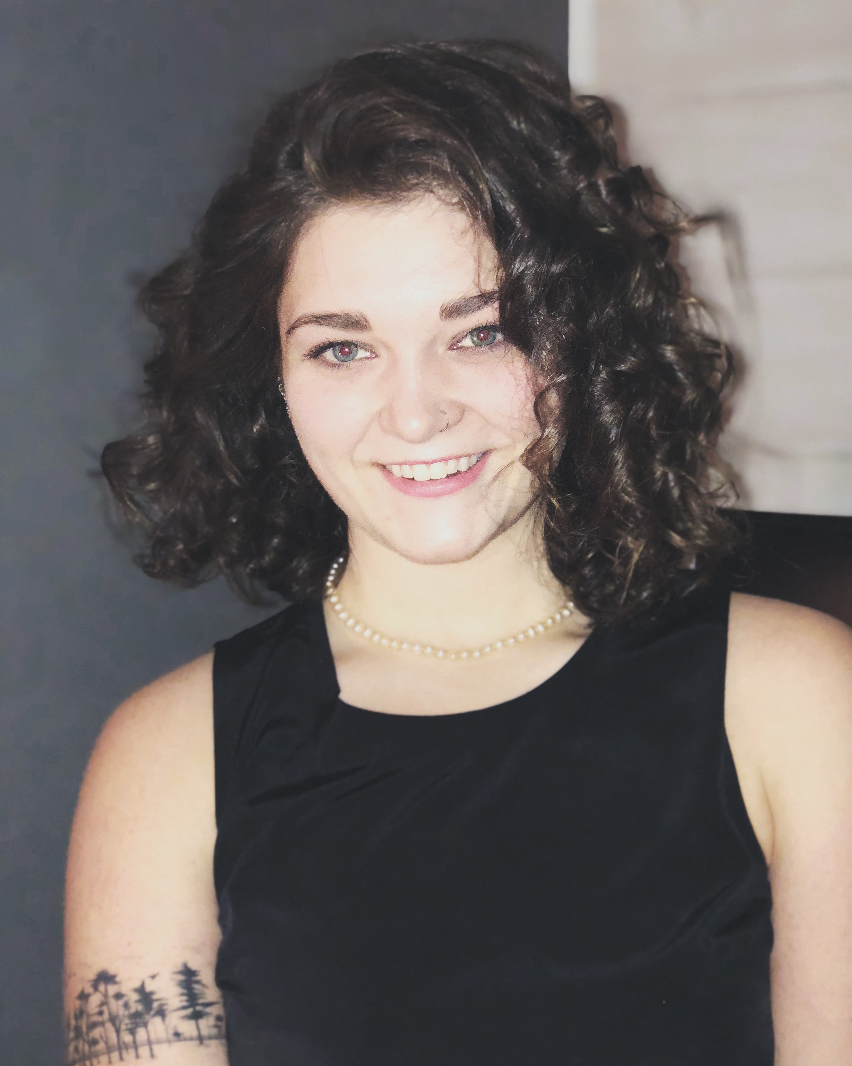
Abigail Moreau
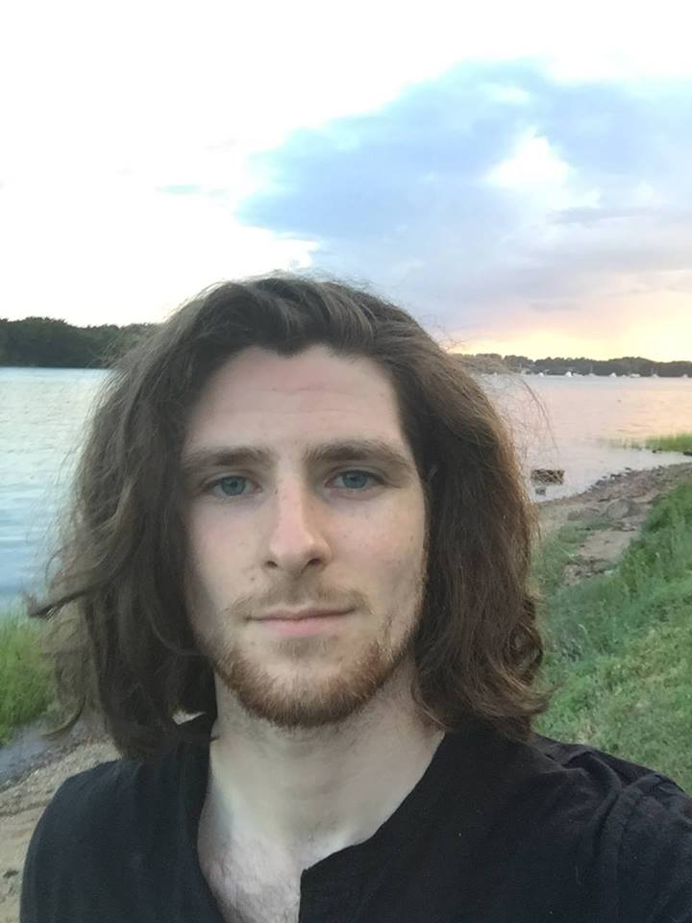
Andrew Wilcox
The isolation and genome annotation of Cluster CV phage, Frokostdame
Abigail Moreau, Andrew Wilcox, Kesuma Laizer, Sitey Muktar, Kevin Smith, Jean Doty, Timothy Breton
Bacteriophages are useful for studying evolutionary questions and in medical applications, such as phage therapies. A novel bacteriophage capable of infecting the host Gordonia terrae was isolated from a wastewater treatment facility in Farmington, Maine, named Frokostdame, and its genome was sequenced, assembled and annotated. Frokostdame is a Cluster CV siphoviridae phage that produces small, clear plaques and consists of 52,531 bp and 84 genes. A translational frameshift was found in a tail assembly chaperone sequence, and gene with likely S-integrase and antirepressor functions were identified. No genes corresponding to an immunity repressor or excise, however, were found, and more information is needed to confirm Frokostdame’s ability to produce lysogens. This adds to a growing database of actinobacteriophage research that may be useful in future research to understand gene evolution and combat antibiotic resistance.

