DO NOT CONSIDER FOR TALK
10th Annual SEA Symposium Abstract
Montclair State University
Montclair NJ
Corresponding Faculty Member: Sandra D. Adams (adamssa@mail.montclair.edu)
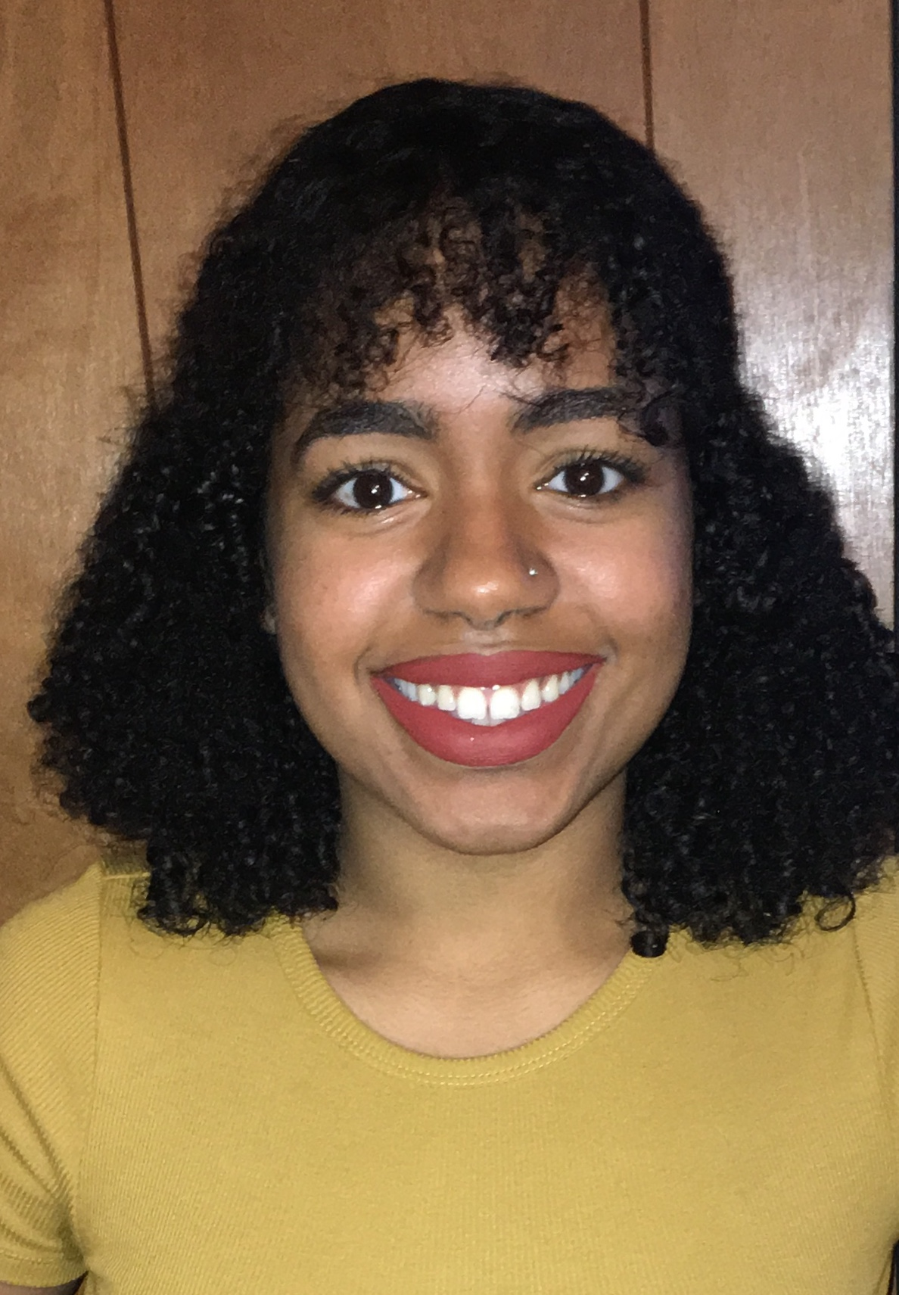
Ashly Reyes
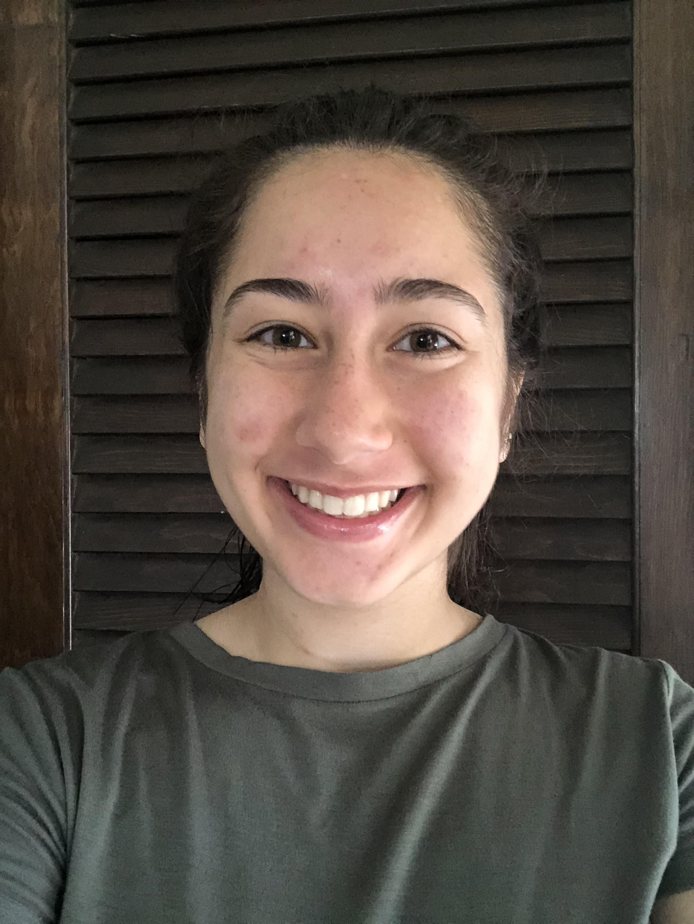
Leen Khashashina
Isolation and Characterization of Novel Mycobacterium smegmatis and Arthrobacter sp. Bacteriophage from New Jersey Soil
Ashly Reyes, Leen Khashashina
The goal of this study was to isolate and characterize novel bacteriophages from New Jersey soil samples that infect Mycobacterium smegmatis and Arthrobacter sp. hosts. In 2017, 29 lytic phages that infect M. smegmatis and two that successfully infect Arthrobacter sp. were successfully isolated and further characterized through plaque morphology and scanning electron microscopy. Of the phages isolated in 2017, one M. smegmatis phage (BreSam8) and one Arthrobacter sp. phage (Tenno) were sequenced and annotated. BreSam8 is a subcluster A3 phage with a putative 90 genes (including three tRNA genes). Tenno is a subcluster AU1 phage with a putative 80 genes. Like other AU1 phages, all of Tenno’s 80 genes are transcribed
using the top strand of DNA, and none of Tenno’s genes appear to be transcribed using the bottom strand.

