CONSIDER FOR TALK

10th Annual SEA Symposium Abstract

Ouachita Baptist University

Arkadelphia AR

Corresponding Faculty Member: Ruth Plymale (plymaler@obu.edu)

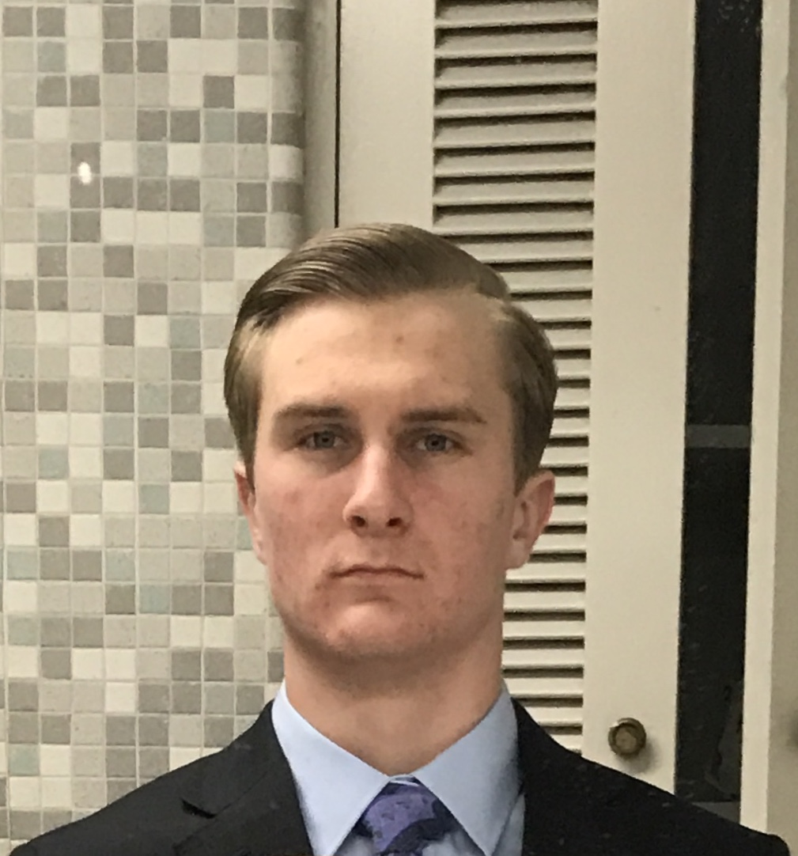

Cameron M Brownlee

RFLP-Guided DOGEMS and a Class Genome Announcement--Bioinformatics at OBU

Cameron M Brownlee, Hayden H Bowman, Haley K Davis, Emme M Edmondson, Savannah L Edwards, Jordan R Gills, Katlin R Jacobs, Gracie C Jones, Luke W Livingston, Morgan E Masengale, Madi Morrison, Austin M Mullins, Mariah D Pate, Beau T Pennington, Kenzie N Pickard, David R Rainwater, Allie C Studdard, Abby L Walker, Liam C Wooten, Nathan Reyna, Ruth Plymale

Students at Ouachita Baptist University isolated ten bacteriophage infecting Gordonia terrae 3612 from enrichment of seventy-five soil samples. Four bacteriophage were identified as candidates for DNA sequencing—DelRio, Ribeye, Ruthy, and SketchMex. In an effort to distinguish and prioritize these four phage for sequencing, the DNA of each phage was digested with the restriction enzymes BamH1, Cla1, EcoR1, HaeIII, and HindIII. The restriction fragment length polymorphism (RFLP) patterns were used simplify the DOGEMS (Deconvolution of Genomes after En Mass Sequencing) process. In traditional DOGEMS, multiple unknown phage are combined and unique phage are separated out as individuals during the sequencing assembly step. In our RFLP-guided DOGEMS, we combined two phage (Ruthy/Ribeye and DelRio/SketchMex) with dissimilar RFLP patterns into a tube, allowing effective sequencing and straightforward separation of multiple phage. Ruthy was found to be a singleton phage, DelRio to be in cluster DI, Ribeye in cluster DE, and SketchMex in cluster CT. All four phage genomes were annotated by the Bioinformatics class. DelRio was annotated as part of our Genome Hack-A-Thon, a regional high school outreach program where OBU students served as facilitators. After annotation, OBU student groups conducted additionally bioinformatic analyses. This data is currently being compiled and will be used to write a class genome announcement. Results will be presented.