CONSIDER FOR TALK
10th Annual SEA Symposium Abstract
La Sierra University
Riverside CA
Corresponding Faculty Member: Arturo Diaz (adiaz@lasierra.edu)
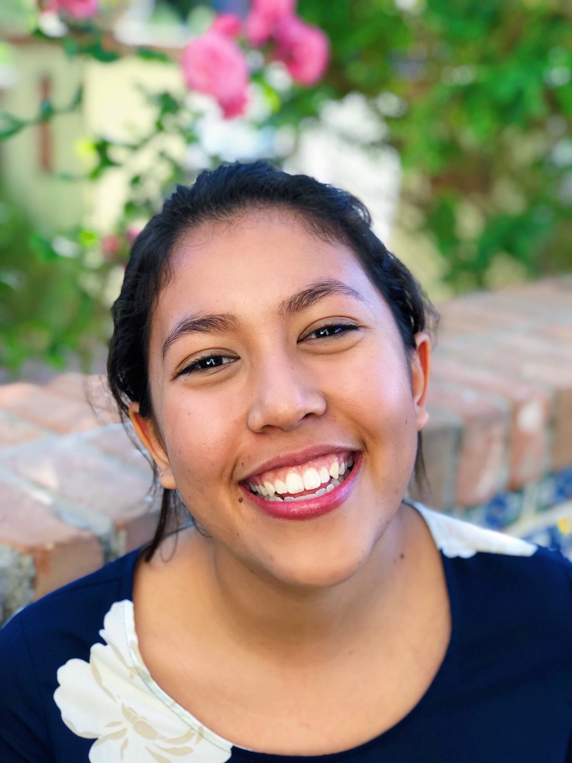
Rhiannon Abrahams
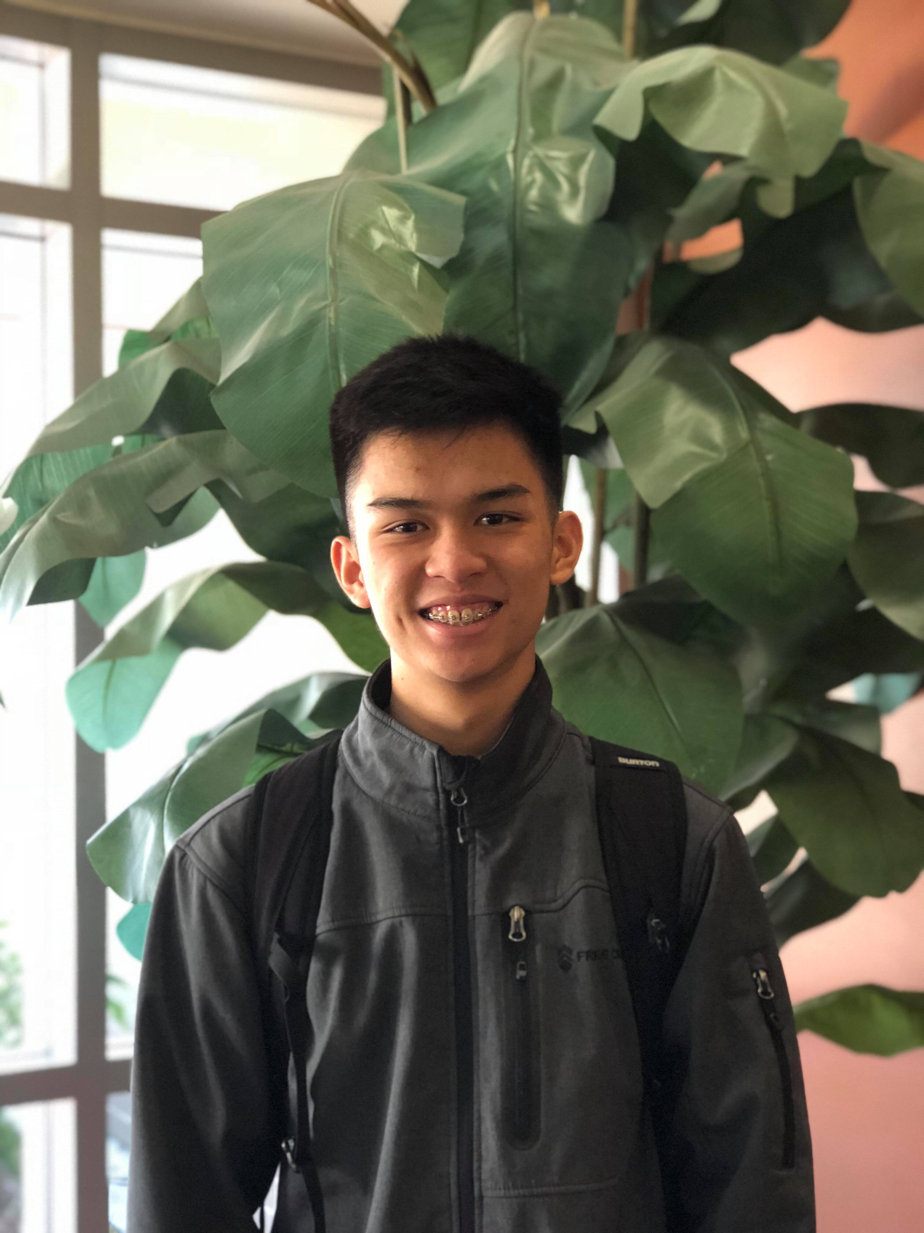
Steven Tran
Orphams find a home in OneinaGillian while KaiHaiDragon continues moving forward
Rhiannon Abrahams, Steven Tran, Daniel Bazan, Bryceson Beglau, Ethan Blaylock, Jessica Choi, Shannon Grewal, Elmira Hernandez, Daniel Kim, Kay Kim, Yumin Lee, Michael Linde, Meagan Lopez, Gillian Miller, Emily Pangalila, Markell Parker, Rachel Specht, Ming Chung Teng, Benjamin Toledo, Houting Yu, Natasha Dean, Arun Muthiah, Arturo Diaz
Undergraduates enrolled in the SEA-PHAGES program at La Sierra University obtained a total of twenty bacteriophages infecting Microbacterium foliorum; sixteen phages were found from direct isolation and four were found through enriched isolation. Two direct isolates, KaiHaiDragon and OneinaGillian, were sequenced and annotated.
KaiHaiDragon has a capsid diameter and tail length of 72.2 nm and 124.4 nm, respectively. It was assigned to cluster EC and was experimentally found to be lytic as are all other phages in that cluster. The plaques were clear and 0.1mm in diameter and no integrases were identified during the annotation.The genome is 52,992 base pairs long and 90 genes were indentified. The GC content is 68.9%, which is similar to the GC content of the other phages in that cluster. Of note, all 90 ORFs are transcribed in the forward direction.
OneinaGillian was assigned to cluster EG. Interestingly, OneinaGillian is only one of three phages assigned to that cluster. It has a capsid diameter of 57 nm and tail length of 143 nm. OneinaGillian is 61,703 base pairs long and 101 genes were identified, including a Tyrosine tRNA. 66 genes are transcribed in the reverse direction while the remaining 34 are in the forward direction. 42 genes were orphams, while 58 genes were assigned to a pham when compared to similar genomes.
None of the twenty phages were able to infect Mycobacterium smegmatis. A host range assay is currently being done with three other Actinobacteria species. Moreover, attempts to isolate lysogens were unsuccessful.

