DO NOT CONSIDER FOR TALK
10th Annual SEA Symposium Abstract
SUNY Old Westbury
Old Westbury NY
Corresponding Faculty Member: Fernando Nieto (nietof@oldwestbury.edu)
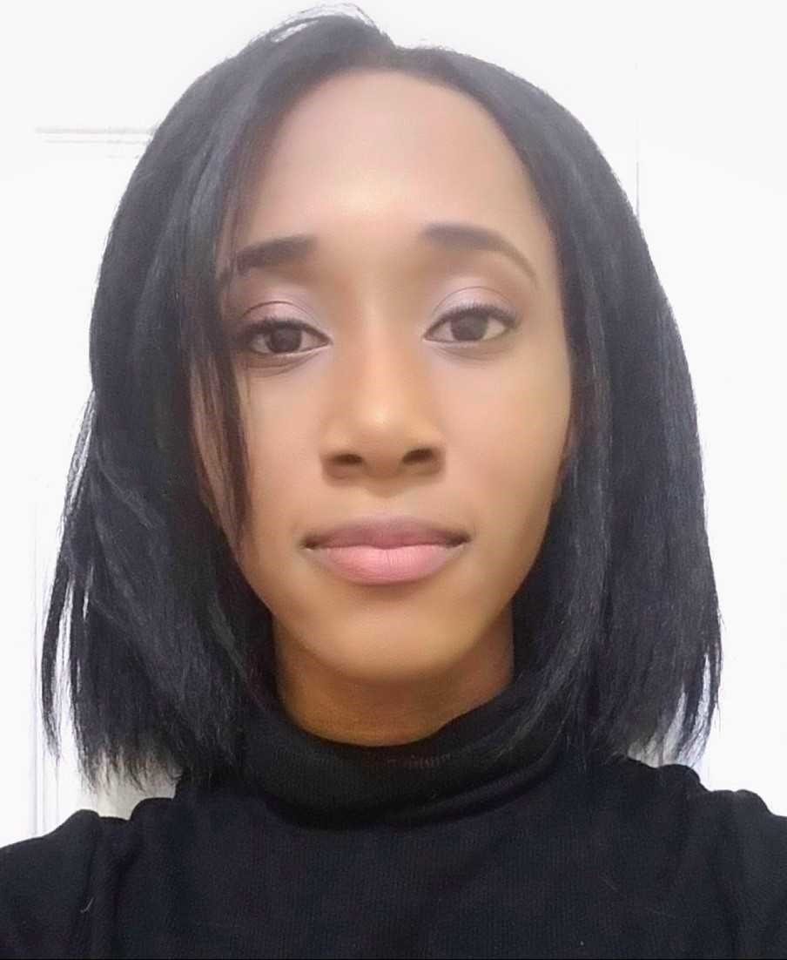
Adwoa Lewis
Karthik Madhira
Characterization of Actinobacteriophages isolated at SUNY Old Westbury and annotation of Rahel, a C1 cluster Genome
Yara Abdelsalam, Jessica Ackloo, Navpreet Banger, Hason Chan, Tarana Chittineedi, Isabel Duplessy, Mark Dyce, Daesha Garrison, Ashley Gayle, Jaime Gonzalez, Sandra John, Imanjot Kahlon, Tania Kumar, Adwoa Lewis, Karthik Madhira, Rivka Mullokandova, Fernando Nieto, Christos Noutsos, Whitney Phair, Nellie Pirzadeh, Iman Raja, Kevin Ram, Ravi Ramdhari, Rita Reddy, Briana Saed, Phalan Smith, Stevee Sproul, Jane Thomas, Avia Yossefi
SUNY Old Westbury joined the 10th Cohort of HHMI SEA-PHAGES last fall 2017 semester. The Phage Discovery component was integrated into the General Biology I laboratory (23 students) in the Fall 2017 semester and the Bioinformatics component into the General Biology II laboratory in the Spring 2018 semester (25 students). During the Phage Discovery semester twenty-three viruses were isolated, only two using direct isolation. All of them were isolated from soils in Nassau or Suffolk counties in an 18 miles radius using Mycobacterium smegmatis mc2155 as a host. Eleven of them were siphoviridae and twelve myoviridae. Rahel, a myoviridae Mycobateriophage was sent for sequencing to the University of Pittsburgh. Rahel forms plaques of approximately 1 mm in diameter and its titer was 3.07 x 10¹² PFU/ml. During sequencing the genome was covered 471x. A C1 cluster member, Rahel has 155,955 base pairs and 64.7% GC content. As reported by DNA master Rahel has 266 genes of which 9 are in the reverse strand, 155 in the forward strand and 32 are tRNAs. Its closest C1 cluster relative ArcherS7 has 269 genes 43 for which the function is known, 37 are tRNAs and 1 is tmRNA. Using comparative genomics we manually validated the starting codons of Rahel. Out of the 266 genes we changed the starting codon for 30 genes using Starterator and HHPred. Gene density in Rahel is 1.7 genes/kb indicating high gene density. ArcherS7 has 4 more genes and is around 1kb longer than Rahel indicating that genome expansion is due to gene content.

