DO NOT CONSIDER FOR TALK

10th Annual SEA Symposium Abstract

Tarleton State University

Stephensville TX

Corresponding Faculty Member: Dustin Edwards (dcedwards@tarleton.edu)

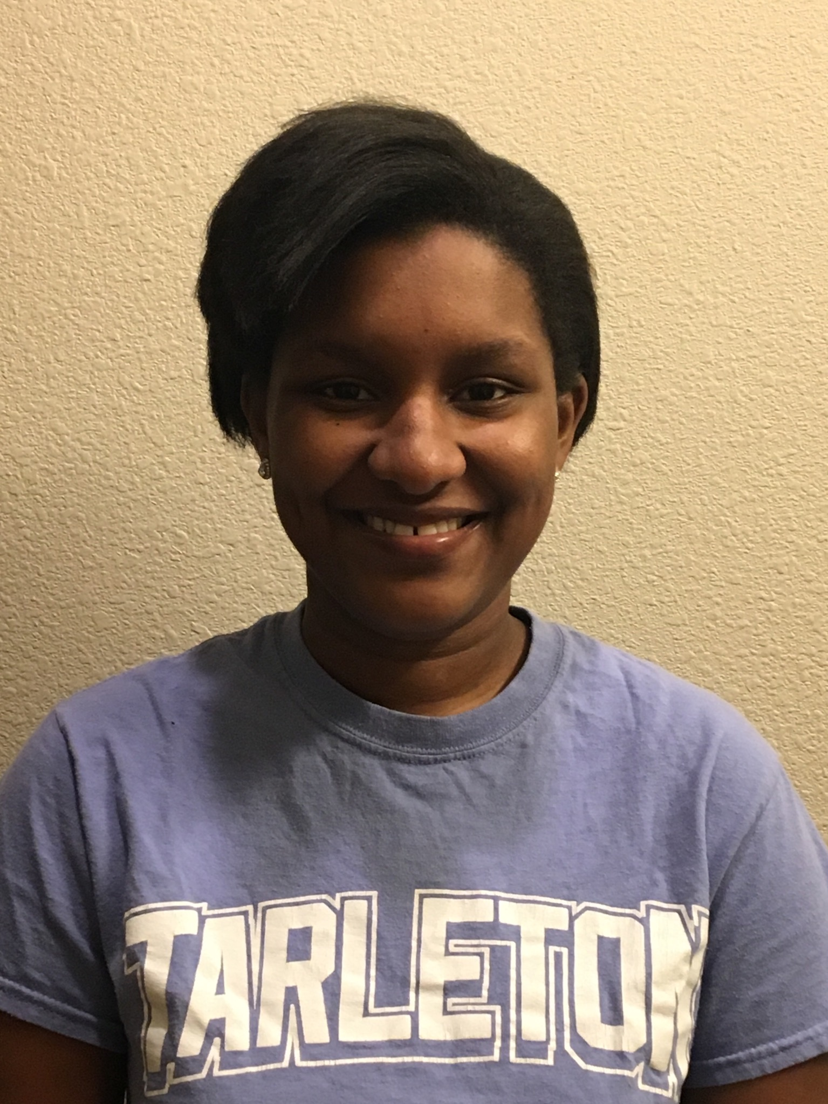

Megan Adams

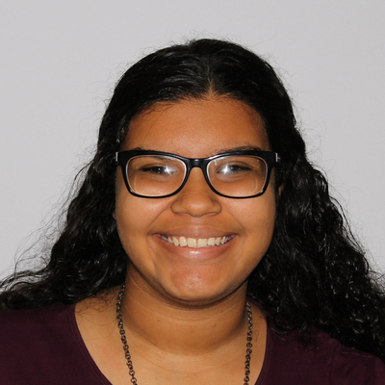

Esperanza Sandoval

Discovery of Cluster A1 and O Bacteriophages, Arlo and Ryadel

Megan Adams, Esperanza Sandoval, Travis Miller, Brittany Stewart, Danielle Bachhofer, Ashleigh Cooper, Jessica Doty, Miranda Fuentes, Morgan Gaitan, Leeila Hanson, Josh Katuri, Brandi McElroy, Jonathon Musgrave, Aleksey Palumbo, Heidi Spann, Amanda Stone, Mario Tovar, Camille Trautman, Bianca Willis, Jesse Meik, James Pierce, Dustin Edwards

We isolated 16 bacteriophages that infect *M. smegmatis* mc2155 from soil samples in north Texas. DNA was extracted and whole genomes of mycobacterophages Arlo and Ryadel were sequenced at the Pittsburgh Bactriophage Institute. Arlo is a temperate cluster A1 bacteriophage with medium plaque size and Ryadel is a lytic cluster O bacteriophage. Transmission electron microscopy identified both Arlo and Ryadel to have siphoviridae morphology, however Ryadel has a prolate capsid which is characteristic of Cluster O bacteriophages. Arlo genome is 52,069 base pairs in size and contains a 10 base overlap of CGGATGGTAA, while Ryadel genome is 72,658 base pairs in size with a 4 base overlap of GTGT. Analysis of potential viral open reading frames indicate that Arlo could encode for a Cas4 protein, a component of CRISPR genome editing systems. These phages could provide further insights into bacterial immune functions and function of elongated capsid structures.