DO NOT CONSIDER FOR TALK
10th Annual SEA Symposium Abstract
Howard University
Washington DC
Corresponding Faculty Member: Mary A Ayuk (mary.ayuk@howard.edu)
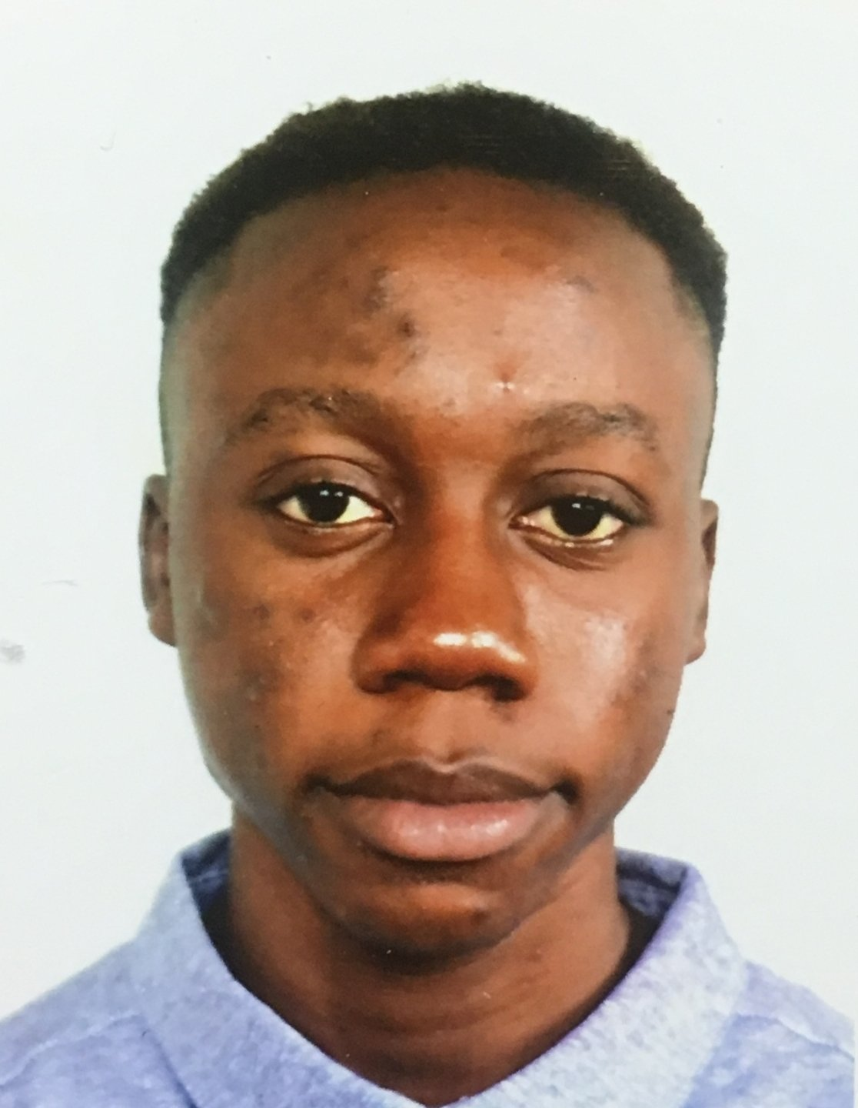
Boluwatito Oladeinde
Isolation and Characterization of Fourteen Siphoviridae and Myoviridae Isolated from The Campus of Howard University
Boluwatito Oladeinde, Jalen Jean -Baptist , Kennis Booker, Naji Cameron, Adaora Ekwunife, Ehab Elhag, Kiana Fludd, SeighViance Givens, Quinlyn Highsmith, NyAsia Kelley , Camryn Lam, Briana Louis, Chidera Nwude-Jacobs, Ebonee Major, Charity Onwuchekwa, Students of HU- PHAGES 2017-2018, Kristodea Boadum, Michelle Lourds Fernando, Madison Moore, Jerome Oliver, Adebiyi Sobitan, Michael Smith, Roy Swagota, Adrian Allen, Mary Ayuk, Leon Dickson, Somiranjan Ghosh, Ayele Gugssa, , Hemayet Ullah, Winston Anderson, Courtney Robinson
Bacteriophages, or phages, may be utilized to study viral ecology, epidemiology, and enhance the development of therapeutics. In the current study, enrichment and direct culturing methods, in conjunction with host Mycobacterium smegmatis MC²155, were used to elucidate phage diversity in soil samples collected from the campus of Howard University. Over 100 phages were purified using standard isolation protocols. Subsequently, lysates were generated, and DNA was extracted. Fourteen genomes were sequenced (Pittsburgh Bacteriophage Institute), using Illumina Sequencing. This revealed that the sample phages belong to four clusters: A (phage Naji); B (phages Bishoperium, CamL, Mecca, Samaymay, Omniscient, QueenBeane and West99); C (Basquiat, Chargie21, Fludd, JustHall and Naija), and Q (DeepSoil15). The genome sizes range from 53,746 to 154,456 bp with G+C contents ranging from 63.5 to 68.9%. Morphotypes were identified as Siphoviridae and Myoviridae. Annotation of the genomes is currently underway. Additionally, all of phages in the 2017-2018 collection are undergoing assays to determine patterns of phage sensitivity/insensitivity—immunity using wildtype M. smegmatis MC²155 and lysogens generated from the collection.
Key words: Mycobacteriophages, Soil, Mycobacterium smegmatis, Siphoviridae and Myoviridae

