DO NOT CONSIDER FOR TALK

10th Annual SEA Symposium Abstract

University of West Alabama

Livingston AL

Corresponding Faculty Member: Kayla Fast (kaylafast0@gmail.com)

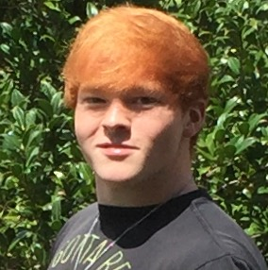

Nicholas C Pritchett

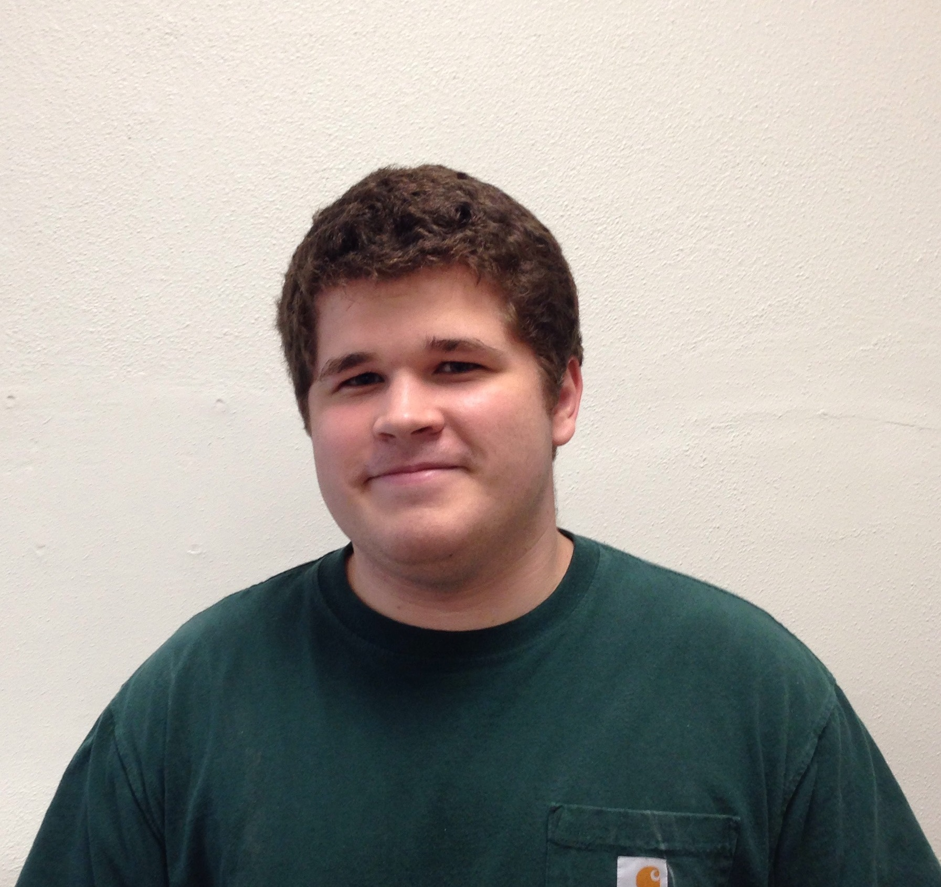

John D Larrimore

Ecological niche modeling and phylogenomic analysis of the C1 mycobacteriophage subcluster

Nicholas C Pritchett, John D Larrimore, Shane Castleberry, Kenny D Jones II, Caitlin A Long , Kayla M Fast, Tracy Keener, Michael W Sandel

Cane17, a novel mycobacteriophage, was discovered in a soil sample collected from a farm in Emelle, Alabama. The phage was isolated using the host bacterium *Mycobacterium smegmatis* mc2155. Cane17 (Myoviridae) forms small, lytic plaques and possesses a large head and short tail. It was chosen for genome sequencing because of its plaque morphology and high DNA concentration relative to other phages collected by the class. Cane17 was then assigned to the C1 subcluster and is 160,330 base pairs long. We annotated the genome using DNA Master and other supplemental programs. We discovered that Cane17 has 223 protein coding genes, 33 tRNAs, 1 tmRNA, a programmed translational frameshift, and a wraparound gene. There are 120 C1 subcluster phages, and we sought to understand the phylogenomic relationships within this subcluster. To accomplish this goal, we performed a Principle Coordinate Analysis and generated a Bayesian phylogenomic tree. Tonenili is the most basal taxon of the C1s and all other phages fall into one large cluster. Although all phages except Tonenili group together, there is high support making each phage unique. Given the atypical genome identity of Cane17 and its sisters, we wanted to see where else C1 phages are found and predict their distribution. We conducted ecological niche modeling using bioclimatic variables and present a map which indicates where C1 phages are likely to be found and where they should be scarce. Given the predicted distribution of C1 phages, we then performed a DOGEMS experiment to see if we had isolated any other C1 phages which weren’t immediately chosen for genome sequencing. We found that our pool of phages did in fact include an additional C1 phage as well as A1, A7, B1, B4, B5, and F2 phages.