DO NOT CONSIDER FOR TALK
10th Annual SEA Symposium Abstract
Southern Maine Community College
South Portland ME
Corresponding Faculty Member: Brian Tarbox (btarbox@smccme.edu)
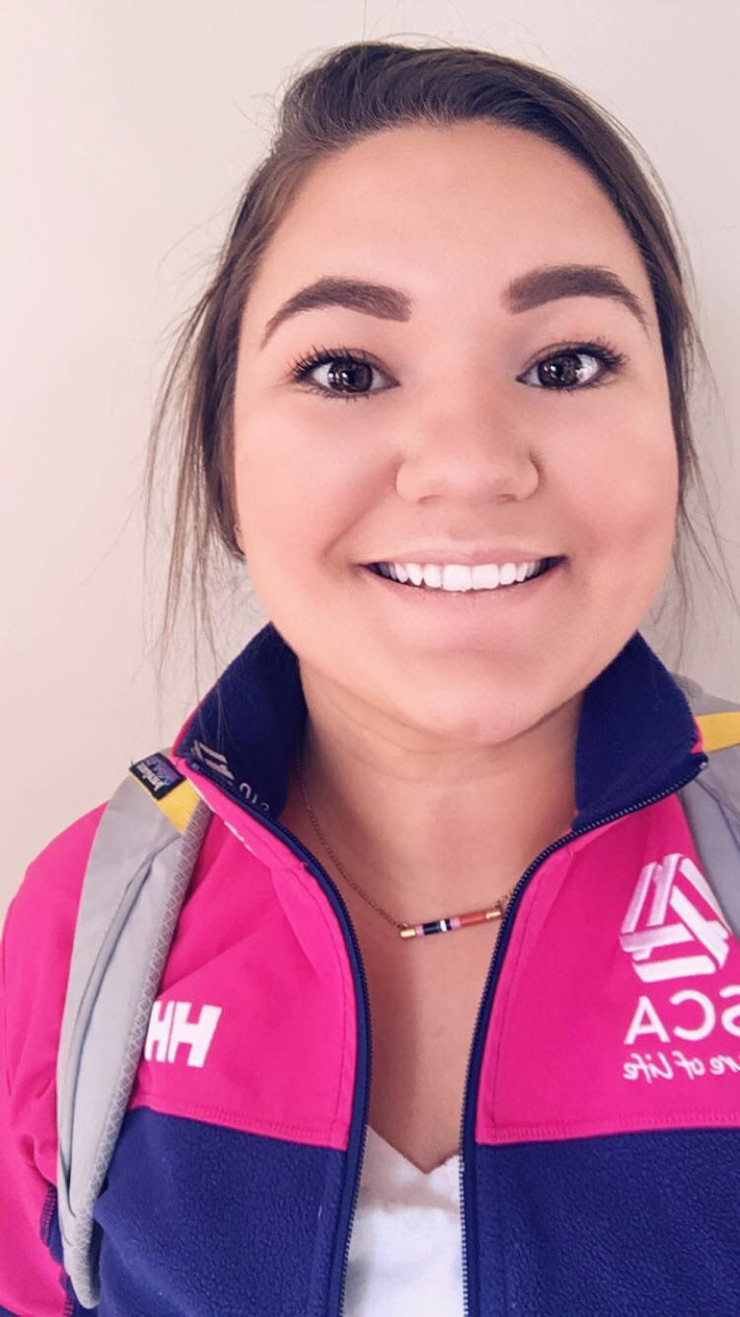
Isabelle I Russell
A Diversity of Marine Phage
Isabelle I Russell, Emily F Haggett, John F Onesti, Ornelly N Yanga, Megan Greenwood, Kathleen Pyburn
Marine phage have been associated with algal blooms either as a limiting factor on blooming species through infection or by infecting bacteria that in turn infect algal species. In 2018 we isolated bacterial hosts and phage from the water column and marine mud from the northwest Southern Maine Community College (SMCC) cove (43°38'48.74"N, 70°13'35.45"W). We isolated three hosts and four phage using enrichment techniques. Hosts were identified to genus level through barcoding of the 16S rRNA gene. One phage genome was sequenced, annotated and submitted to GenBank (NCBI Acc. # MG675557), this phage forms a putative lysogen with its host, Pseudoalteromonas. Electron Micrographs were taken of all phage, portions of their genomes cloned and sequenced and PCR primers were designed. We used the primers to look for the presence of phage in various parts of the marine ecosystem in Casco Bay. We hypothesize that as the waters warm in the spring, host populations will increase with a concomitant increase of phage.

