DO NOT CONSIDER FOR TALK
9th Annual SEA-PHAGES Symposium Abstract
Howard Hughes Medical Institute
Chevy Chase MD
Corresponding Faculty Member: Viknesh Sivanathan (sivanathanv@hhmi.org)
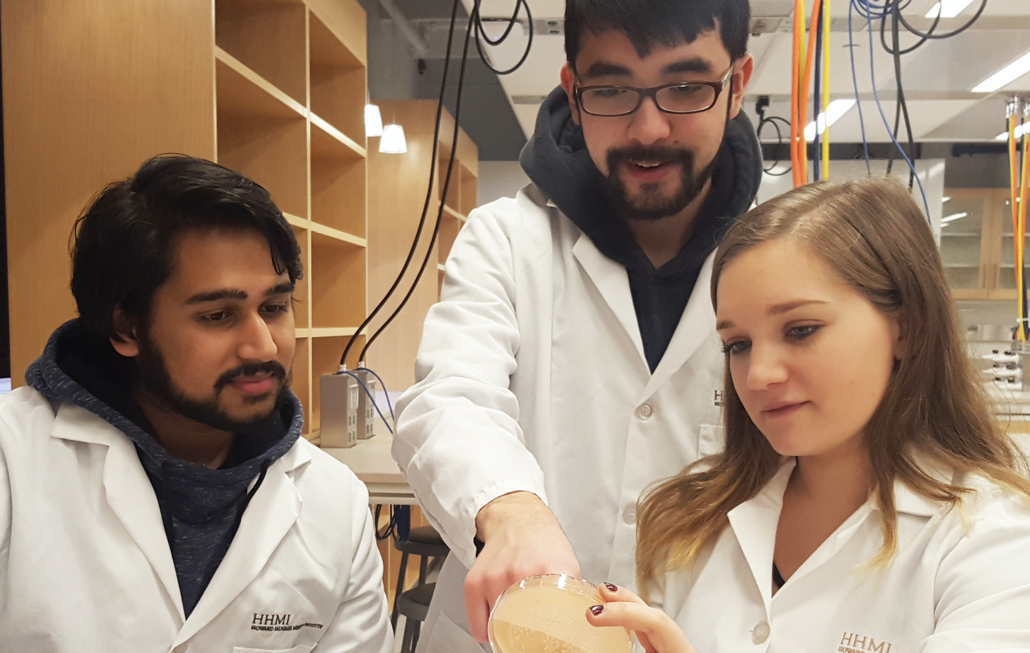
Ilzat Ali
Characterization of Actinobacterial Hosts for Phage Isolation
Ilzat Ali*, Emily Davis*, Aleem Mohamed*, Priscilla Kobi, William Biederman, Vic Sivanathan
* University of Maryland, Baltimore County, Baltimore MD
The scientific goal of SEA-PHAGES is to explore the biodiversity amongst bacteriophages. As we expand from isolating and studying mycobacteriophages to actinobacteriophages, the careful “piloting” of new actinobacterial hosts can facilitate this process. Here, we present data from piloting 3 actinobacterial hosts, Arthrobacter sp., Gordonia terrae, and Microbacterium foliorum. This data is presented in the context of other Actinobacteria, namely Microbacterium smegmatis and Streptomyces griseus, the latter with data provided by Lee Hughes of the University of North Texas. It is our hope that the data presented will encourage and facilitate the adoption of these Actinobacteria as hosts on which to isolate and study actinobacteriophages.

