DO NOT CONSIDER FOR TALK
9th Annual SEA-PHAGES Symposium Abstract
Nebraska Wesleyan University
Lincoln NE
Corresponding Faculty Member: Angela McKinney (amckinne@nebrwesleyan.edu)
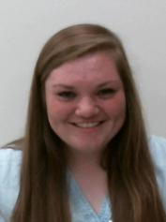
Dayton Dolincheck
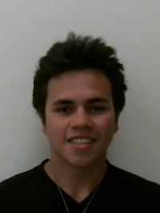
Johan Vizoso
Comparison of Bacteriophage OlinDD and RobsFeet to other isolated Microbacterium paraoxydans bacteriophages
Dayton Dolincheck, Johan Vizoso
The SEA-PHAGES program allows undergraduates the opportunity to isolate novel bacteriophages from the environment. The DNA from each isolated bacteriophage is sequenced and the genome annotated using a variety of computer software and online tools. Bacteriophages OlinDD and RobsFeet were isolated from the host bacterium Microbacterium paraoxydans NWU1. These two bacteriophages were compared to one another. OlinDD is a Siphoviridae, classified in cluster ED, and has 114 putative genes. RobsFeet is a Myoviridae, classified in Cluster EC, and has 101 putative genes. Since Microbacterium paraoxydans NWU1 is a new host, information regarding the genome arrangement, genes obtained, in addition to determining commonalities between these two bacteriophages and other bacteriophages isolated from Microbacterium paraoxydans will be discussed.

