CONSIDER FOR TALK
9th Annual SEA-PHAGES Symposium Abstract
Montclair State University
Montclair NJ
Corresponding Faculty Member: Sandra D. Adams (adamssa@mail.montclair.edu)
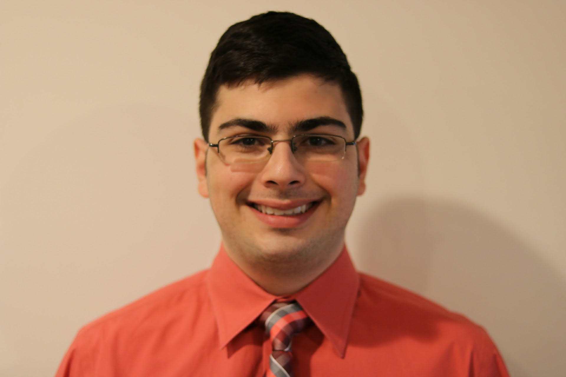
Gerard Nasser
Adam Zadeh
Isolation and Characterization of Novel Mycobacterium smegmatis Bacteriophage from New Jersey Soil Over the Past Six Years
Gerard Nasser, Adam Zadeh
In 2016, 35 lytic phages that infect M. smegmatis were successfully isolated and further characterized through plaque morphology and scanning electron microscopy. Genome sequencing of two of these phages (MoneyMay and Tarynearal) revealed both were novel, previously undescribed phage. MoneyMay is a subcluster A3 phage with a putative 91 genes (including one tRNA gene). Tarynearal is a subcluster A5 phage with a putative 93 genes (including three tRNA genes). Students from the MSU Howard Hughes SEA-PHAGES Genomics course have isolated 94 bacteriophages since 2011. Of these phage, 10 have been sequenced, five have been published in GenBank, three are in review for deposition in GenBank, and two are currently being annotated. The MSU SEA-PHAGES team has also been developing cluster and subcluster-specific PCR primers. Current methods of identifying a phage’s cluster include morphological analysis using electron scanning microscopy and whole genome sequencing. Microscopy does not always positively identify cluster (or sub-cluster) since some clusters are morphologically similar and genome sequencing is prohibitively expensive for large numbers of samples. An alternative approach is to develop a PCR-based technique using cluster-specific primers based on unique genes in each cluster. To identify candidate genes Phamerator was used to align each cluster of phages to find 4 pieces of data: (1) E-value and percent similarity between the phages in the cluster, (2) location of the candidate gene in relation to each phage in the cluster, (3) gene length, and (4) cluster specificity (whether or not the gene in question is in any other phage outside the cluster). From there, primers are to be made for each unique gene. To date, clusters A1, A7, and A10-18 have had 91 unique genes found, from which 33 candidate genes have been identified and work continues to identify candidate genes in the other clusters as well as test primers for each cluster.

