CONSIDER FOR TALK
9th Annual SEA-PHAGES Symposium Abstract
Southern Connecticut State University
New Haven CT
Corresponding Faculty Member: Nicholas Edgington (EdgingtonN1@SouthernCT.edu)
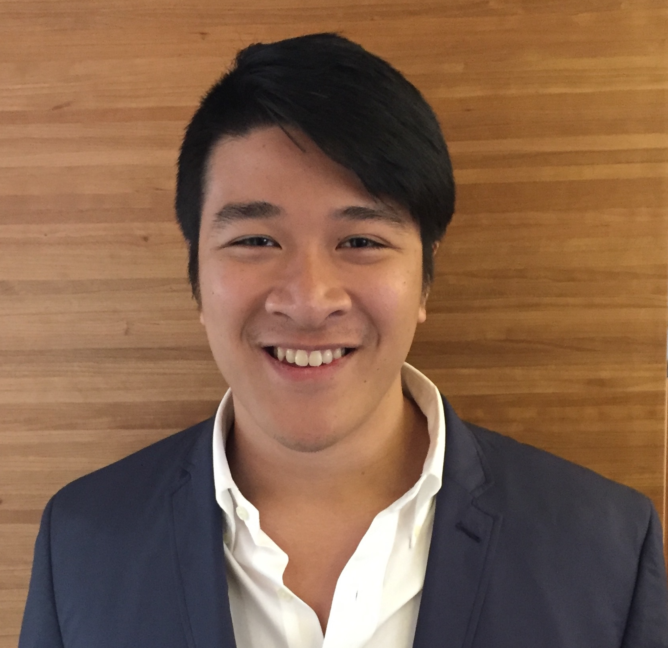
Thomas S Hoang
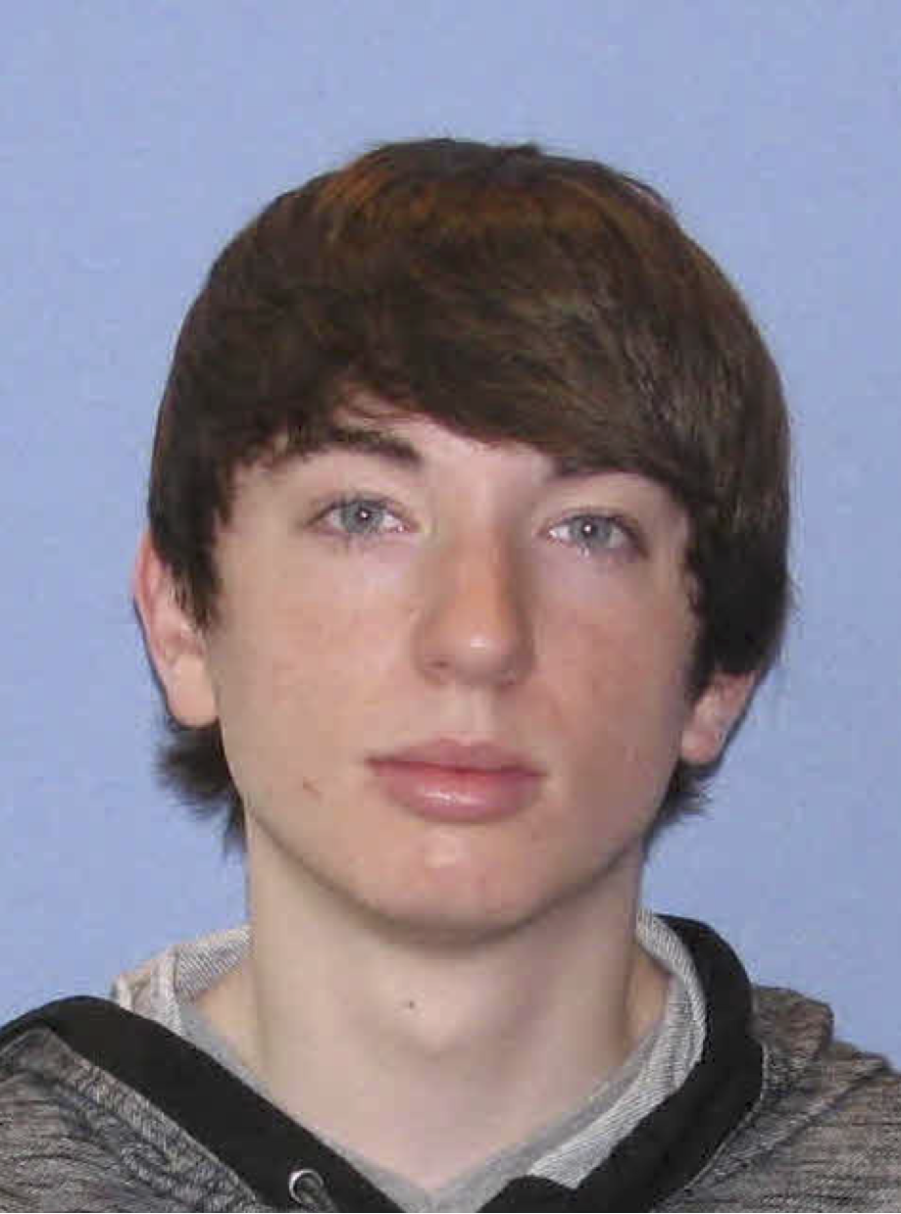
Dathan D Stone
Maybe A11 phages are odd: Genome annotation and comparative genomic analysis of subcluster A11 mycobacteriophages
Thomas S Hoang, Dathan D Stone, Edward J Martinez, Bridget R Sharnick, Michael J Squires, Maurice Newton, Kara Jones, Andrea G Rizzo, Meagan M Harris, Carolynn A Keal, Edward J Martinez , Christopher P Wojtas, Zachary C Wright , Bryan Pasqualucci, Nicholas P Edgington
The “A cluster” comprises the largest cluster of discovered actinobacteriophages, consisting of almost 500 members and 18 subclusters. Since 2012, twelve subcluster A11 actinobacteriophages have been discovered, surprisingly with one-third of its members having been discovered by SCSU students. Phages have been included in a particular ‘cluster’ based on evident sequence similarity in a dot plot that spans more than 50% of the smaller of the two genomes. So this begs the question, what characteristics of the subcluster A11’s actually distinguishes them from the other A subclusters? To investigate the novelty of A11’s, we identified, studied and present data on those phams that were not only unique to A11 phages, but also were present in all A11 phages. The A11 phages also exhibit pseudolysogeny, in which their genomes are predicted to persist extrachromosomally rather than integrating into the hosts genome. ParABS systems that are present in subcluster A11 phages are responsible for this extrachromosomal maintenance, and we present a comparative genomics analysis of this system in the actinobacteriophages. Furthermore, a comparative genomic analysis of immunity repressor binding sites called ‘stoperators’ within the A cluster is presented. Finally, we present computational evidence that the A11 phages may have a novel toxin-antitoxin system.

