CONSIDER FOR TALK
9th Annual SEA-PHAGES Symposium Abstract
Western Carolina University
Cullowhee NC
Corresponding Faculty Member: Jamie Wallen (jamiewallen@email.wcu.edu)
Dylan Rood
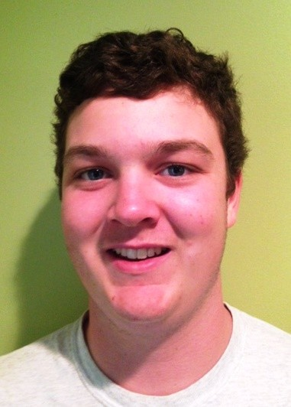
Henry Salvo
Preliminary Cluster Typing of 38 Mycobacteriophages Discovered at Western Carolina University and Surprisingly High Sequence Identity of a Rare Cluster M Bacteriophage
Dylan Rood, Henry Salvo, Megan Eckardt, Jamie R Wallen, Maria D Gainey
Western Carolina University (WCU) is a member of cohort 8 and has completed two years in the SEA-PHAGES program. Over the course of two years WCU students have isolated and archived 38 mycobacteriophages. In the fall of 2016 bacteriophages Crispicous1 (A1), Galactic (F1), and IPhane7 (M1) were selected for full genome sequencing. Through bioinformatic analysis we have observed some exciting trends regarding nucleotide conservation amongst these three subclusters. Currently there are 123 A1, 119 F1, and 5 M1 genomes that have been sequenced. Blast analyses reveal that Crispicous1 and Galactic show high sequence identity (97-98%) with their top genome hits. Surprisingly, however, analysis of rare subcluster M1 bacteriophage IPhane7 has revealed that the five members of cluster M1 share higher nucleotide identity (99%) than the more frequently isolated A1 and F1 bacteriophages. In 2015 we discovered and sequenced another rarely isolate B5 mycobacteriophage (phage Serendipitous, one of only 7 that have been sequenced), and Serendipitous shares only ~90% sequence identity to other phages in the B5 subcluster. The results of the sequenced A1, F1, and B5 phages suggest that cluster M1 phages are unique in their high sequence conservation. Cluster M phages were recently described in detail by Pope et al. (2014). We will describe results of a comparative analysis of the IPhane7 genome architecture with the other four sequenced M1 genomes.
While we have been able to clearly determine the subclusters for the 6 bacteriophages that have been selected for whole genome sequencing over the past two years, we do not have whole genome sequencing data for the other 32 archived bacteriophages discovered at WCU. By combining three different methods (the Phage Enzyme Tool 2.0, tapemeasure gene PCR, and shotgun cloning) we have been able to putatively type 31 out of 32 of these bacteriophages. Currently, the most common bacteriophages discovered at WCU belong to sub-clusters A1 (37%) and F1 (24%); however, bacteriophages belonging to sub-clusters A2, A3, B1, B3, B5, E, G1, K5, and L2 have also been isolated by our students. These additional tools have allowed us to incorporate mycobacteriophage research into more advanced laboratory classes, and WCU students whose phages were not selected for sequencing get to learn to which subcluster their bacteriophage belongs. The preliminary typing of our additional 32 bacteriophages has provided a framework for understanding the diversity of phages we are discovering here at WCU.

