DO NOT CONSIDER FOR TALK
9th Annual SEA-PHAGES Symposium Abstract
Austin Community College
Austin TX
Corresponding Faculty Member: Ana Maria Valle-Rivera (anamaria.valle-rivera@austincc.edu)
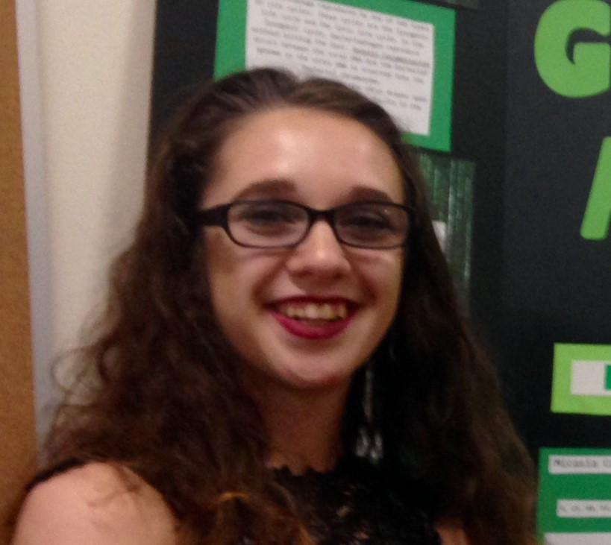
Micasia Cash
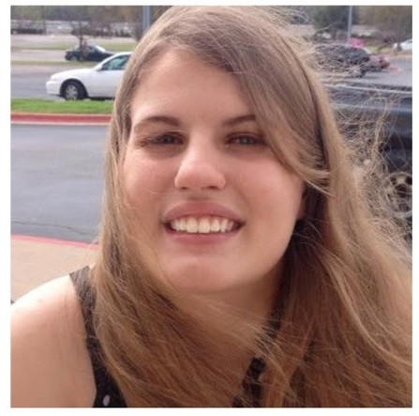
Cassandra L Woliver
Isolation and Genome Annotation of mycobacteriophage "ArcusAngelus", a Siphoviridae Group F Cluster F1 from Austin Community College
Micasia Cash, Cassandra L Woliver, Kevin Britt, Michelle Vang, Patricia Bal, Kennedy M Blanton, Tyler Busk, Tram Dang, Arianne E Dillard, Austin B Eickhoff, Jennifer Gallardo, Carissa L Gragg, Stephanie D Gunkel, Ara M Hunt, Jessica M Kohanek, Bryce C LaChance, Kristine M Laqui, Nihitha Nukala, Mary K O'Malley, Zarae R Pena, Francisca Porras, Christopher G Riggs, Yu Syuan T Yeh, Martha Aguilera, Luis Argaez-Licea, Tara Belles-Elsea, Christina Bennett, Daisy Gutierrez, Luke Lindsay, Davalynn Quiroz, Joshua Rollins, Ana Maria Valle-Rivera
It was the first year for submissions of mycobacteriophages to the SEA PHAGE program from the Central Texas area. We were able to discover a novel phage ‘ArcusAngelus’ isolated from the host bacteria Mycobacterium smegmatis, mc2155. The isolation method was enrichment. The plaques produced were small and clear. Electron microscopy was performed by the facility at the Universiti of North Dallas. The electron micrographs showed that the virus morphology was consistent with the Siphoviridae. The genome of ‘ArcusAngelus’ was sequenced by the Pittsburgh Bacteriophage Institute using Illumina Sequencing. The genome was annotated using bioinformatics software including DNA Master, NCBI's Blastp,Phamerator and Starterator. The genome had 113 predicted genes. We found protein functions that match functions for bacteriophages in the national database as well as unknown function proteins by comparing the phage ‘ArcusAngelus’ with other phages isolated from the same host.

