CONSIDER FOR TALK
9th Annual SEA-PHAGES Symposium Abstract
University of Colorado Boulder
Boulder CO
Corresponding Faculty Member: Christy Fillman (christy.fillman@Colorado.EDU)
Jack Johnson
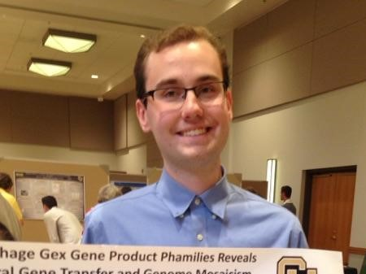
Austin Hammermeister Suger
C1 Cluster Mycobacteriophage Iota Structural and DNA Metabolism Genes Show Homology to Gordonia and Rhodococcus Phages, which Suggests a Broader Host Range for Iota
Jack Johnson, Austin Hammermeister Suger, Erin Char, Gavin Chiem, Nathan Do, Scott Ho, Suchita Lulla, Ian McAdams, Manasa Ponnapalli
Comparative genomic analysis of mycobacteriophage Iota and Gordonia and Rhodococcus phages shows nucleotide similarity among phages infecting these diverse hosts. Using several bioinformatics tools, including Phamerator, MUSCLE alignment software, and Dot Plot analysis, we found homology in the tail tube, baseplate assembly, and DNA polymerase genes between C1 cluster mycobacteriophage Iota and two Rhodococcus phages, Finch and E3, one Gordonia phage: Pupper, and one AA cluster mycobacteriophage Phrappucinio. All five of these phages are myoviridae. During the initial steps of phage infection, the recognition of a specific bacterial host is accomplished through the docking of phage’s tail fiber and base plate proteins with host cell surface receptors, and the similarity between these proteins in Iota and the Gordonia and Rhodococcus phages suggests that Iota may be able to also infect Gordonia and Rhodococcus bacteria. A broader host range in phages can impact their effectiveness in targeting specific bacteria for phage therapy and for biosensor assays.

