DO NOT CONSIDER FOR TALK
9th Annual SEA-PHAGES Symposium Abstract
Lincoln University
Lincoln University PA
Corresponding Faculty Member: David Royer (royer@lincoln.edu)
Shekinah L Vann
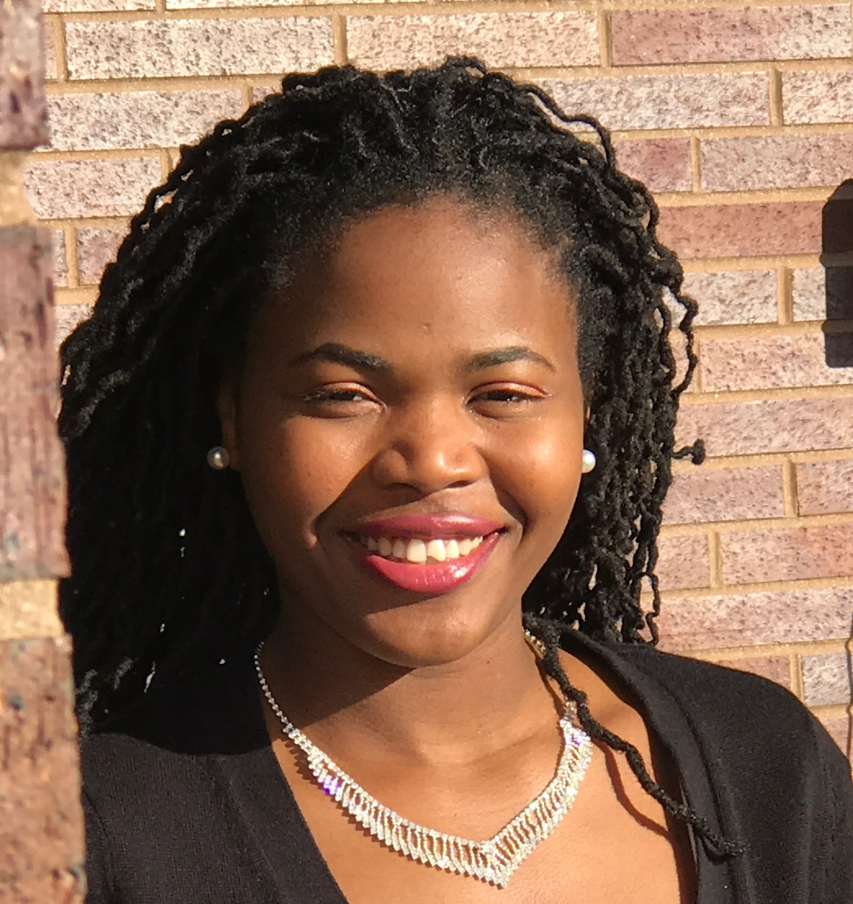
Joy Yakie
Kasen3, a newly annotated G1 subcluster mycobacteriophage
Shekinah L Vann, Joy Yakie, Deanee N Love, Dashawn N Asegbola, David F Royer
Kasen3, a G1 subcluster bacteriophage, was isolated from a soil sample collected on the campus of Lincoln University as part of a Phage Hunters class offered during the 2016-17 academic year. Kasen3 is similar to other G1 subcluster phages in genome length, GC content and number of genes. The greatest similarity is to G1 phages Angel (western PA), Halo (Pittsburgh), Taheera (South Africa) and Sneeze (Costa Rica). It is a member of the Siphoviridae with a characteristic long tail. The annotation revealed 61 genes, of which 32 were assigned a putative function based on comparisons with other G1 mycobacteriophages using BLASTP assignments from both phagesdb.org and GenBank. Of the 32 genes assigned a function, 18 coded for structural proteins and 14 coded for functional proteins. A programmed translational frameshift involving genes 14 and 15, tail assembly chaperones, was identified.

