CONSIDER FOR TALK
9th Annual SEA-PHAGES Symposium Abstract
Virginia Commonwealth University
Richmond VA
Corresponding Faculty Member: Allison Johnson (aajohnson@vcu.edu)
Alexa Crow
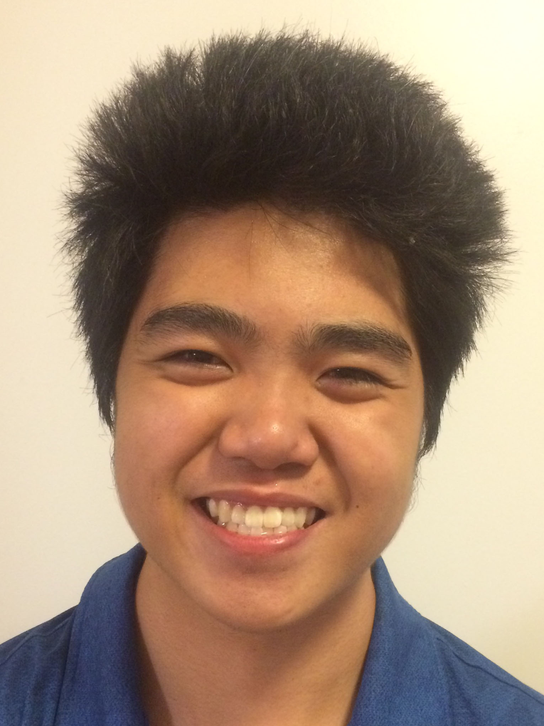
Dalton Huey
Comparative genomics and functional annotation of six Bacillus phages
Alexa Crow, Dalton Huey, Allison Johnson
As part of the 2016-2017 Phage Lab at VCU, students discovered and characterized six new bacteria-infecting viruses, or bacteriophages. Four phages were isolated using Bacillus thuringiensis kurstaki as the host bacteria (Janet, OTooleKemple52, Zainny, and PPisBest), and two phages were isolated using Bacillus thuringiensis 350 (AaronPhadgers and Bubs). These viruses are all myoviruses with a lytic lifestyle. Sequencing of the phage DNA revealed that the six genomes had lengths ranging from 159149 bp to 162692 bp with a mean GC content of 38.5%. The Spring 2017 Phage Lab focused on the computational analysis of gene sequences and functional predictions of the proteins in these phages to better understand the genetic relationships between the viruses. Students annotated the open reading frames of each genome for the best starting position and predicted function with supported database results. Comparative analysis of these six phages reveal that Janet and OTooleKemple52 can be categorized under cluster and the other four, AaronPhadgers, Bubs, Zainny, and Janet, can be grouped in another cluster. Phamerator genome comparisons, ClustalOmega protein sequence phylogeny, Splitstree protein content comparisons, and Gepard dotplot comparison support these groupings. The annotation and comparative genomics results of these six phages will be shared in further detail at the conference. For the second half of the semester, students participated in the CACAO functional annotation competition. We focused on submitting ‘standard annotations’ for proteins with published experimental results supporting endolysin, capsid and holin function, and then submitted ‘transfer annotations’ for phage protein sequences in Genbank with sufficient homology to experimentally published proteins. Combined, our work will be submitted to Genbank and Gene Ontology databases for access by other scientists.

