CONSIDER FOR TALK
9th Annual SEA-PHAGES Symposium Abstract
La Sierra University
Riverside CA
Corresponding Faculty Member: Arturo Diaz (adiaz@lasierra.edu)
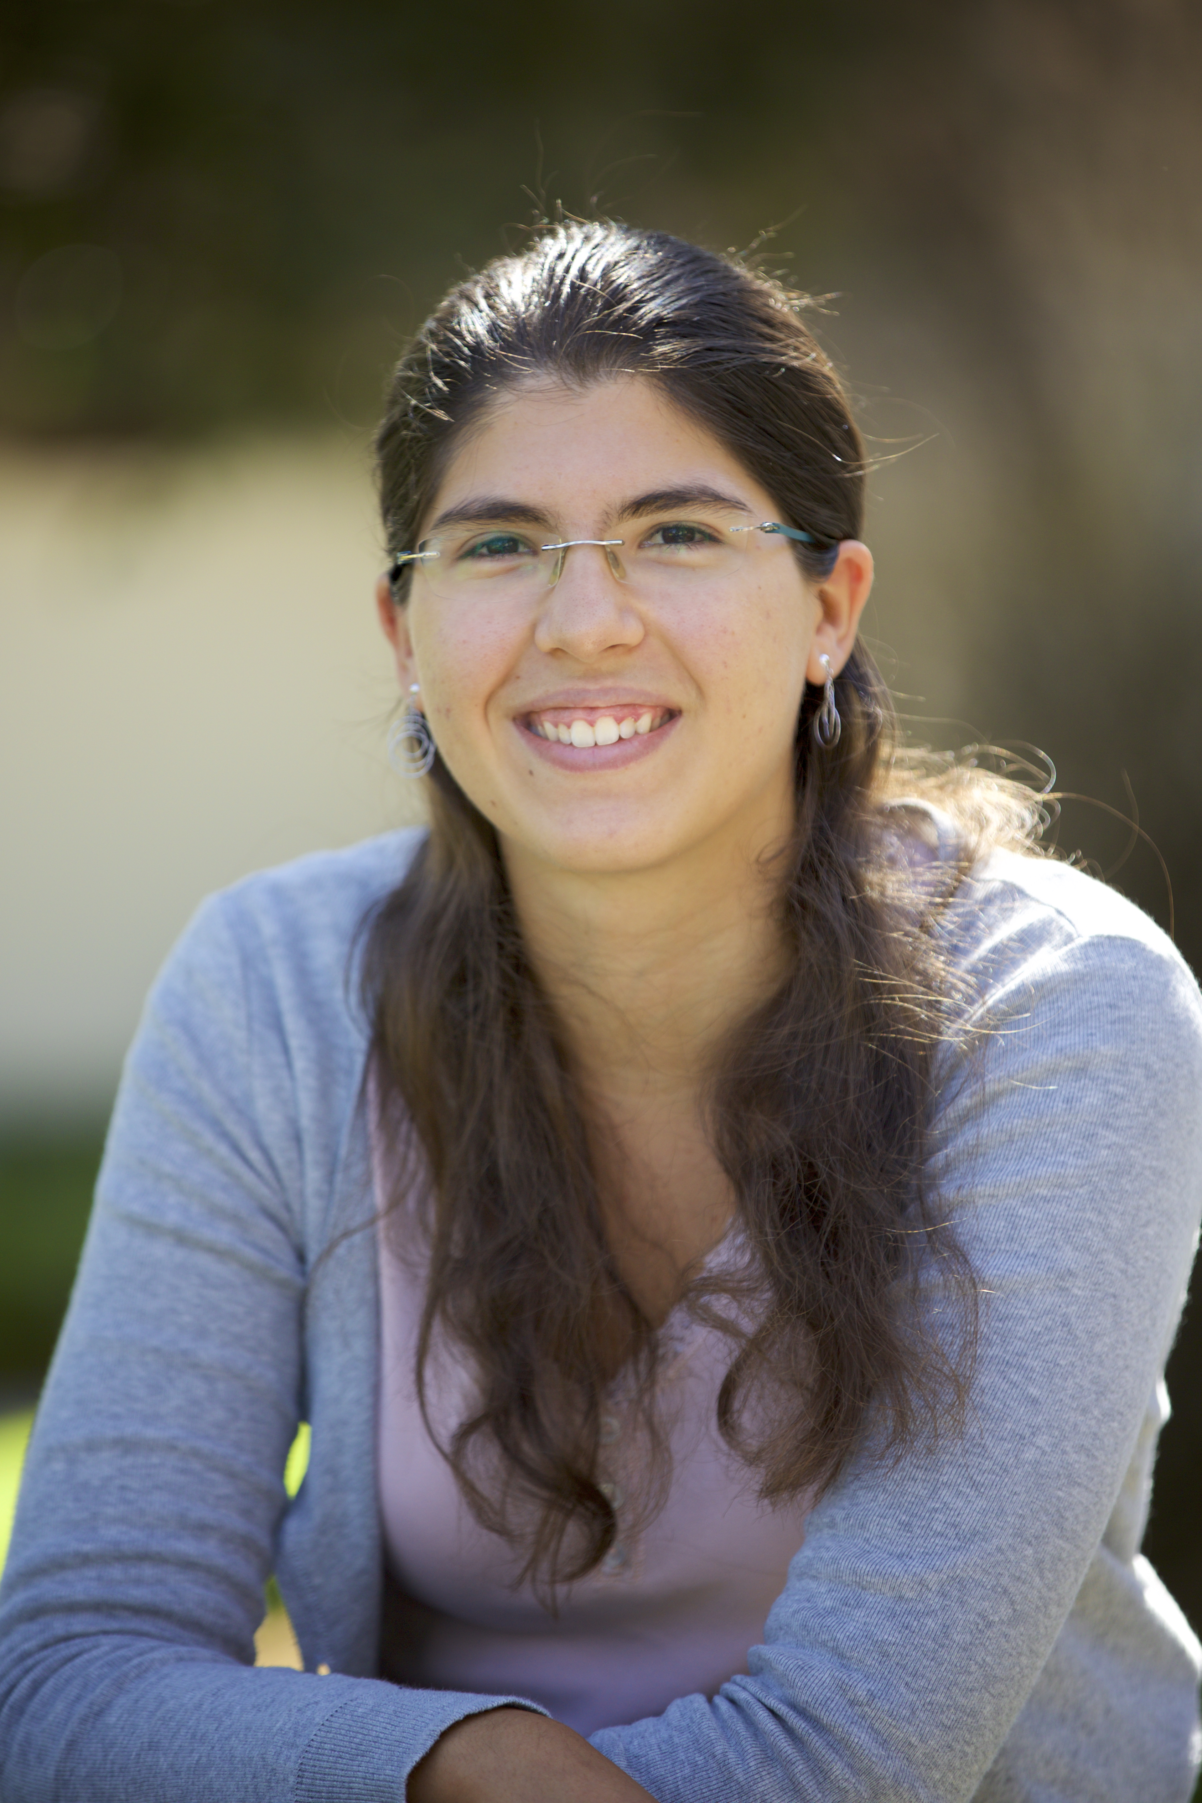
Nancy Kalaj
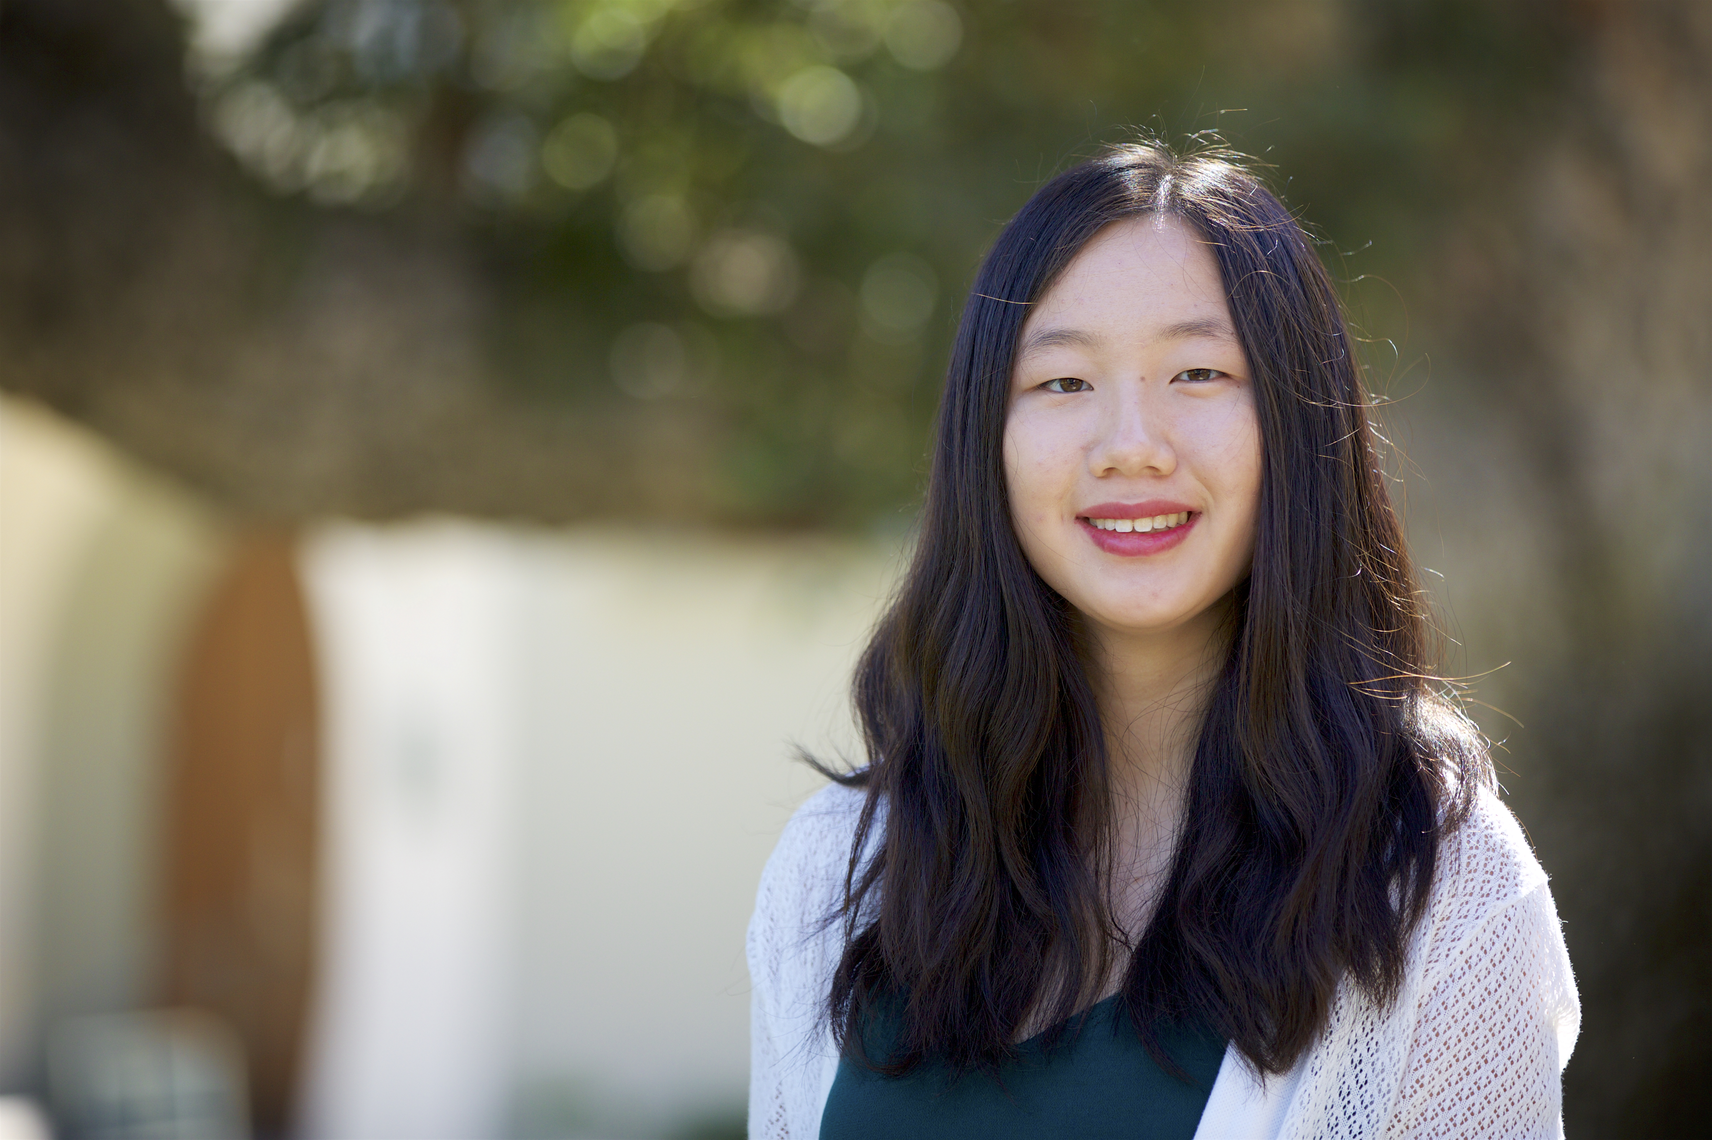
Casey Jang
Crouching prolate, Hidden icosahedron: JangDynasty ends the corndog era
Nancy Kalaj, Casey Jang, Brian Hwang, Shaquille Fyfe, Lorelei Hughes, Katarina Brankov, Thomas Pak, Jennifer Gallao, John Kim, Jason Tedjakusnadi, Emily Poon, Cecilia Saucedo, Connie Yang, Dong Yoon Han, Nicholas Fernandez, Truc Nguyen, Arun Muthiah, Natasha Dean, Nathaniel Sutter, Arturo Diaz
Sixteen Mycobacteriophages that infect Mycobacterium smegmatis mc2 155 were isolated from environmental samples and analyzed using SEA-PHAGES techniques at La Sierra University. Eleven of the phages were found via direct isolation while five were found via enriched isolation. The phages JangDynasty, Roliet, and Shaqnato were selected for Illumina sequencing and assigned to clusters O, B (B1), and C (C1) respectively. The full nucleotide sequence of JangDynasty was then further analyzed using DNA Master and related bioinformatic tools, which revealed a more detailed genetic profile of the phage. Mycobacteriophage JangDynasty is 70883 bp long with a 65.4% GC content and, according to the conjugate analysis of Glimmer and GeneMark, it contains 124 ORFs (67 of which are reverse transcribed) but no tRNAs, which is also the case for the other phages belonging to cluster O. The possible functions (not listed on NCBI Blast, PhagesDB Blast, or Phamerator) of two ORFs present in all Cluster O phages were determined based on HHpred evidence. Specifically, gene 98 was found to be highly similar to the ip1 gene (HHPred probability: 95.4%, e-value: 0.035), whose protein product is used by phage T4 to protect its DNA from the enzymatic activity of the two-gene-encoded gmrS/gmrD type IV dependent endonuclease discovered in pathogenic Escherichia coli CT596 (Rifat, Dalin, et al., 2008). Gene 90 was also found to have a 92.5% probability alignment to the CRISPR-associated protein Cse2 on HHPred. This protein was originally discovered in E. coli and seems to be most prevalent in bacteria. It may play a role in crRNA targeting of invading dsDNA and help stabilize the R-loop structures (Liu, Yuan, & Yuan, Journal of Structural Biology 2015) (Hayes, Xiao, et al., 2016). In addition, Mycobacteriophage JangDynasty displays a very evident structural difference with all phages belonging to cluster O. While cluster O phages have unusual prolate capsids, JangDynasty has an icosahedral capsid, which is the prevalent shape among mycobacteriophages. Since no specific gene products determining the length of the capsid and thus the abnormal shape of prolate heads have been discovered studying cluster O phages (Cresawn et al., 2015), future genomic and proteomic analyses of JangDynasty could help identify the source of this peculiarity.

