CONSIDER FOR TALK
9th Annual SEA-PHAGES Symposium Abstract
Worcester Polytechnic Institute
Worcester MA
Corresponding Faculty Member: JoAnn Whitefleet-Smith (jaws@wpi.edu)
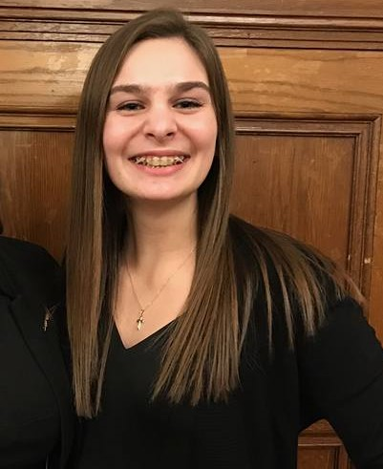
Madeline G Manfra-Levitt
Eoin J O'Connell
“We are Phamily”: Story of Two Phages with Different Homology than their Phamily
Madeline G Manfra-Levitt, Eoin J O'Connell, Daniel B Crosby, Julia L Holtzman, Rachel L Murphy
At Worcester Polytechnic Institute, SEA-PHAGES sponsored two lab sequences: a wet lab portion to isolate bacteriophages and a bioinformatics portion to annotate the isolates’ sequences. After isolating and amplifying the phages in the wet lab, four phages were sent in for sequencing for further annotation and found that they were essentially identical. Misha28 and TootsiePop were both isolated from a compost sample in Charlton, Massachusetts. After sequencing, it was found that there was a single nucleotide difference at the 11008th base pair between the two phages that was non-significant since they still code for the same proteins. Misha28 and TootsiePop were put into the F1 subcluster, but when Blasted against other phages, it was found that the second half of the genome is unrelated to the most of the other phages in the phage database. Misha28 and TootsiePop are most related to two draft phages, Awesomesauce and Piper2020,that were sequenced in 2016. Awesomesauce and Piper2020 were found in Providence, RI and Melrose, MA respectively about 50 miles from Charlton. A goal of this project was to categorize function and origin of the genes of Misha28 and TootsiePop through a comparative genomic analysis using Phamerator, ClustalW, and NCBI BLASTs. After examining the Phamerator results between Misha28, TootsiePop and Awesomesauce, it can be seen that the homology between the four sequences are nearly identical, except for a few sections in the latter half of the sequences, after around 30,000 base pairs. This is interesting since they are all phages found in New England that happen to have similar homology that is different from the rest of the F1 phages. Additionally, the homology of the tape measure gene, one that is constant in all of the phages, was analyzed using ClustalW multisequence alignments and phylogenetic trees. It was found that Misha28’s origin is different from other F1 phages and in general the other phages that seemed to have similar Blast hits to Misha28 and TootsiePop. Using these constant Blast hits via DNA Master, Phamerator was run, and it was seen that certain sections of other phages matched Misha28 and TootsiePop, but none of them were similar all the way through the genome. Tortellini is a P4 phage that matched Misha28 and TootsiePop between genes 62-63, and 65-69, whereas, BuzzLyseYear and Squirty, two F3 phages, matched Misha28 and TootsiePop between genes 45-50. SkinnyPete was an N phage that highly matched Misha28 and TootsiePop between genes 71-72 and 75-76.

