DO NOT CONSIDER FOR TALK
9th Annual SEA-PHAGES Symposium Abstract
University of Nebraska-Lincoln
Lincoln NE
Corresponding Faculty Member: Catherine Chia (cchia1@unl.edu)
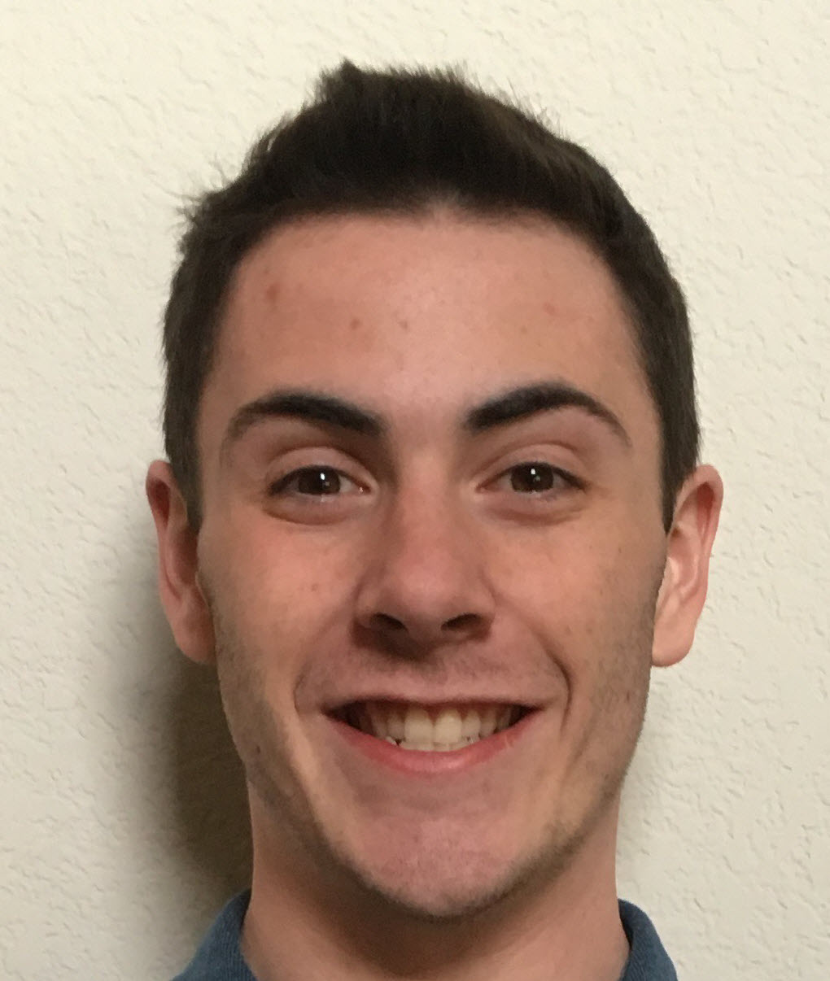
Finn P Cassidy
Isolation and Characterization of B1 subcluster phage Longacauda from the Univ. Nebraska-Lincoln campus
Finn P Cassidy, Ben Ahern, Rebecca A Hartz, Jacey M Kant, Kathryn M Muilenburg, Awa Youm, Catherine P Chia
Using the host Mycobacterium smegmatis mc²155, the subcluster B1 phage Longacauda (Latin for long tail) was obtained by enriched isolation from soil at the base of a pine tree on the UNL campus. The circularly permuted Longacada genome is 68,804 bp, with a GC content of 66.4%. Longacauda produces clear 1.5 mm diameter plaques with darker centers. As determined from TEM images, the average Longacauda capsid diameter was 62.5 nm and tail lengths averaged 249.4 nm. After sequencing by the Pittsburgh Bacteriophage Institute using Illumina Sequencing, students used BLASTn and DNA Master to identify a total of 105 genes that subsequently were annotated. Consistent with other B1 subcluster phages, no tRNA genes were found. With a combination of NCBI’s BLASTp, HHPred, PhagesDB, Phamerator, and Starterator, the start sites of open reading frames, and their likely functions were predicted. After completing annotation tasks, students selected six Longacauda genes and their predicted functions (Lysin A, Lysin B, tape measure protein, major tail subunit, RNase E, and phospholipase A) to compare to phage within and outside of subcluster B1.

