DO NOT CONSIDER FOR TALK
9th Annual SEA-PHAGES Symposium Abstract
Fayetteville State University
Fayetteville NC
Corresponding Faculty Member: Kristen Delaney-Nguyen (kdelaney@uncfsu.edu)
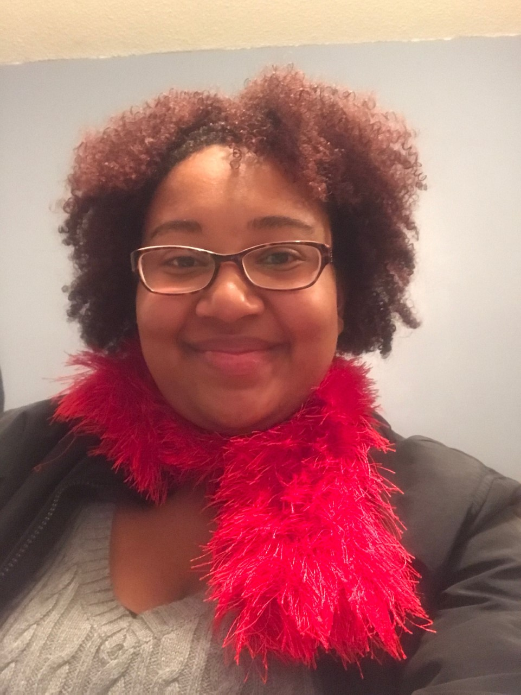
Lena Franklin
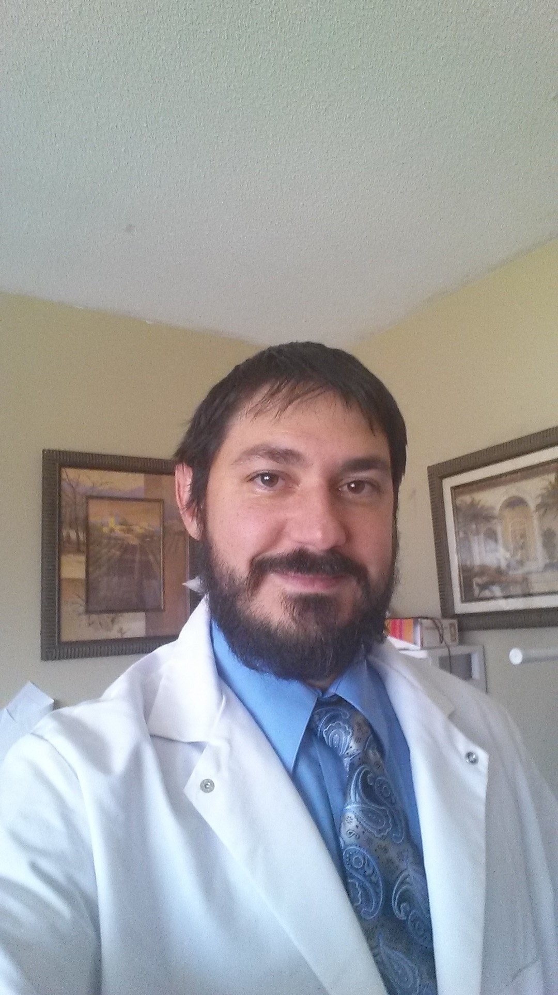
Ismael Hernandezvillasuso
Isolation and Characterization of Mycobacteriophage Cornie, the Lone Member of the New F5 Subcluster
Lena Franklin, Ismael Hernandezvillasuso, Alan Ardin, Rebecca Galloway, Justin Lugo, Samantha Selix, Ambria Thomason, Kristen Delaney Nguyen
Bacteriophages are the most numerous microbes in the biome and display massive genetic diversity. Thirteen phages capable of replication in Mycobacterium smegmatis mc2155 were isolated in the Sandhills region of North Carolina. Three phages (Cornie, FrayBell, and Leogania) were sequenced at the Pittsburgh Bacteriophage Institute. All three of the sequenced phages were novel. Fraybell demonstrated myoviridae morphology and the remainder were syphoviridae. Cornie is of particular interest as it is the lone member of the new subcluster F5. The plaques of Cornie have a slight comet tail appearance when grown in M. smegmatis mc2155. Many of the encoded proteins had higher homology to bacterial genes than the genes of other phages. Cornie appears to be a lysogenic phage due to its turbid plaques and the presence of lysogeny-associated genes such as an integrase, an immunity repressor, a CRO repressor, and antirepressor. Continuing work will involve seeking related phages from the same geographic region using a Cornie lysogen.

