CONSIDER FOR TALK
9th Annual SEA-PHAGES Symposium Abstract
Queens University of Charlotte
Charlotte NC
Corresponding Faculty Member: Scott Weir (weirs@queens.edu)
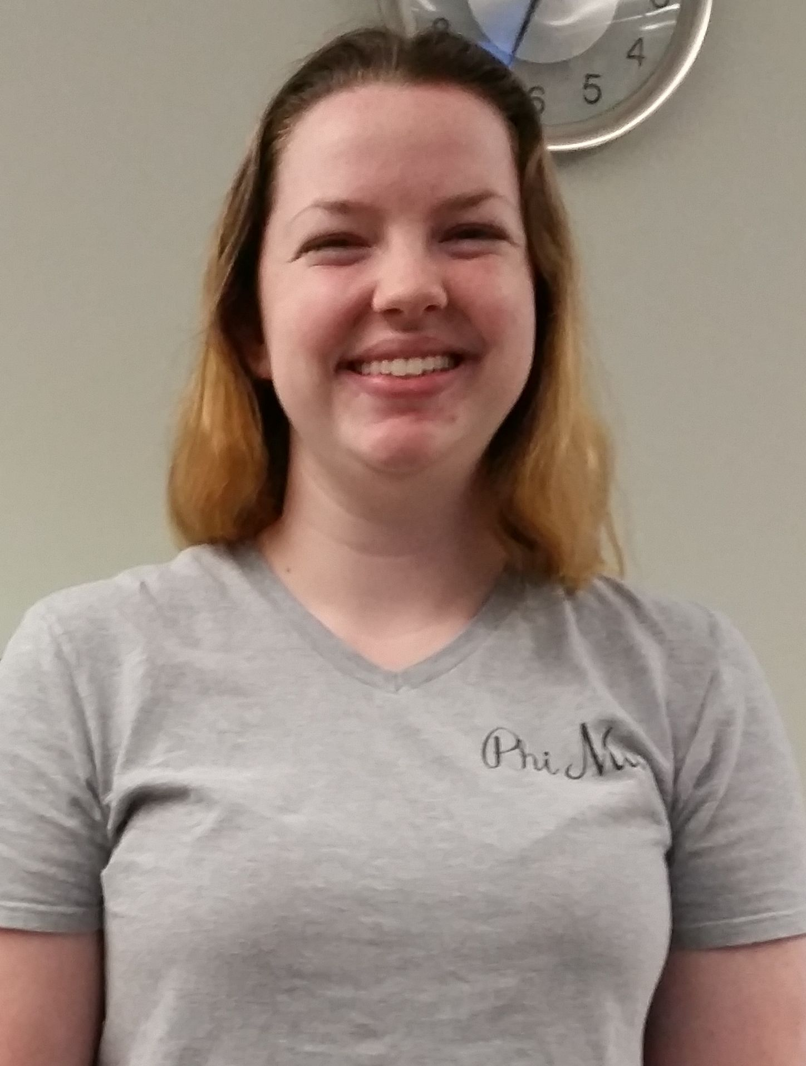
Hailey Gase
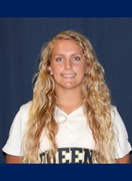
Alyssa Strickler
Queens University of Charlotte makes a “HoleInOne” discovery with “Ebony”, isolating and annotating two bacteriophages.
Hailey Gase, Alyssa Strickler, Caroleen Ellis, Orianna Jerez, Chioma Ngene, Jennifer Easterwood, April Sipprell, Scott Weir, Joanna Katsanos
During Queens’ first year in the SEA-PHAGES program students isolated and characterized two novel phages from local soil samples. These phages were grown in the bacterial host Mycobacterium smegmatis mc2155 and were extracted using enriched isolation. Bacteriophage “Ebony” was identified from soil north of Charlotte and “HoleinOne” was extracted from soil on the outskirts of a golf course. Both phages were isolated, purified, and amplified using protocols from the Phage Discovery Guide as a part of the SEA-PHAGES program. The plaque size for Ebony was approximately 4mm, whereas HoleInOne plaques were less than 1mm. Transmission Electron Microscopy revealed that both phages were of the siphoviridae morphotype. After discovery and DNA isolation, Ebony and HoleInOne were sequenced at the Pittsburgh Bacteriophage Institute. Ebony is in cluster A subcluster 11 with 52,152 base pairs and a 63.8% Guanine-Cytosine (GC) content. Following auto annotation using DNAMaster 99 genes were predicted. HoleInOne is in cluster B, subcluster 2 and is 67,044 base pairs in length with a 68.9% GC content and 91 predicted genes. As a result of our inclusion in this program, student and faculty research collaborations are examining the potential use of phage therapy in Caenorhabditis elegans.

