DO NOT CONSIDER FOR TALK
9th Annual SEA-PHAGES Symposium Abstract
University of Alabama at Birmingham
Birmingham AL
Corresponding Faculty Member: Denise Monti (denise.monti@unf.edu)
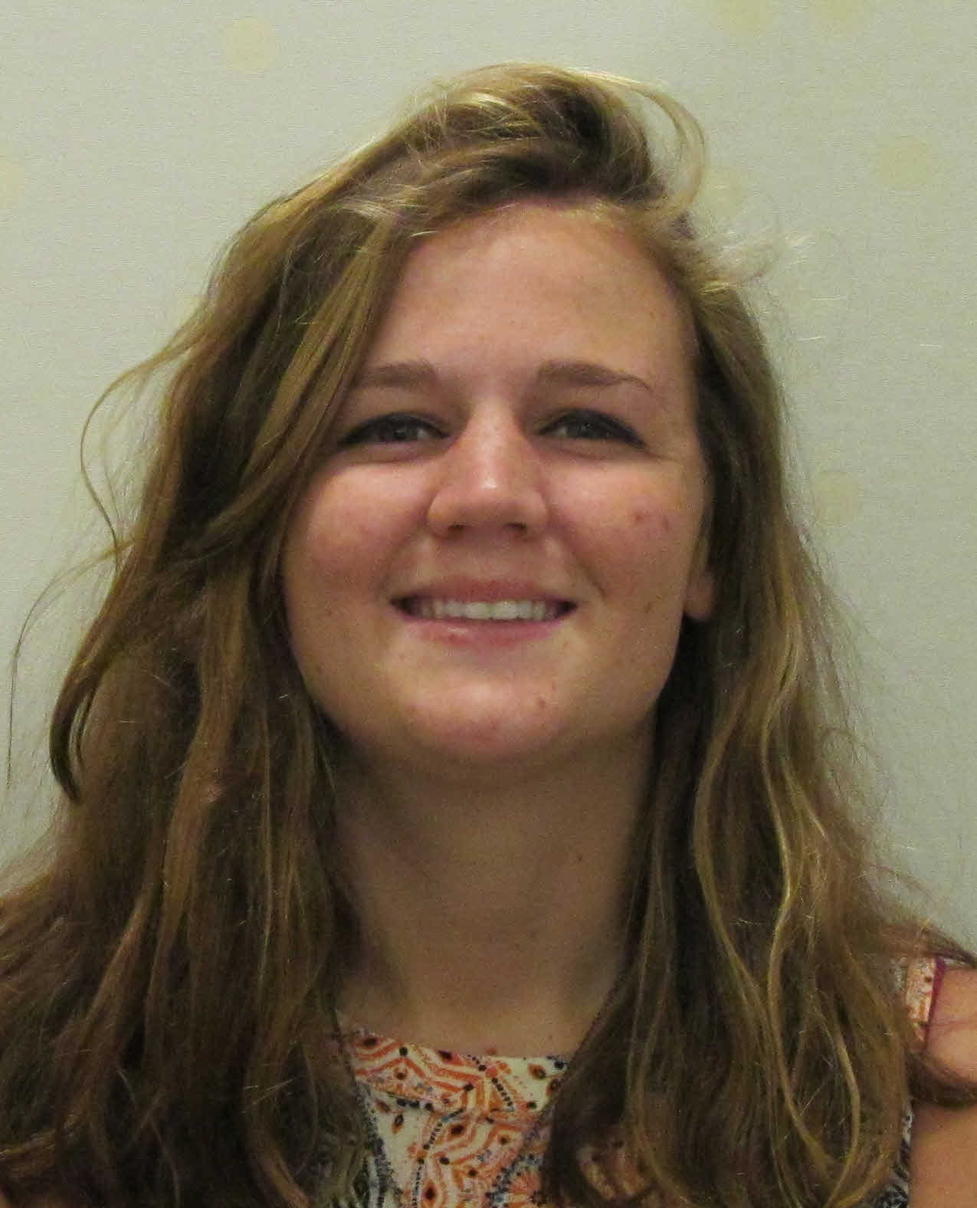
Karly N Casey
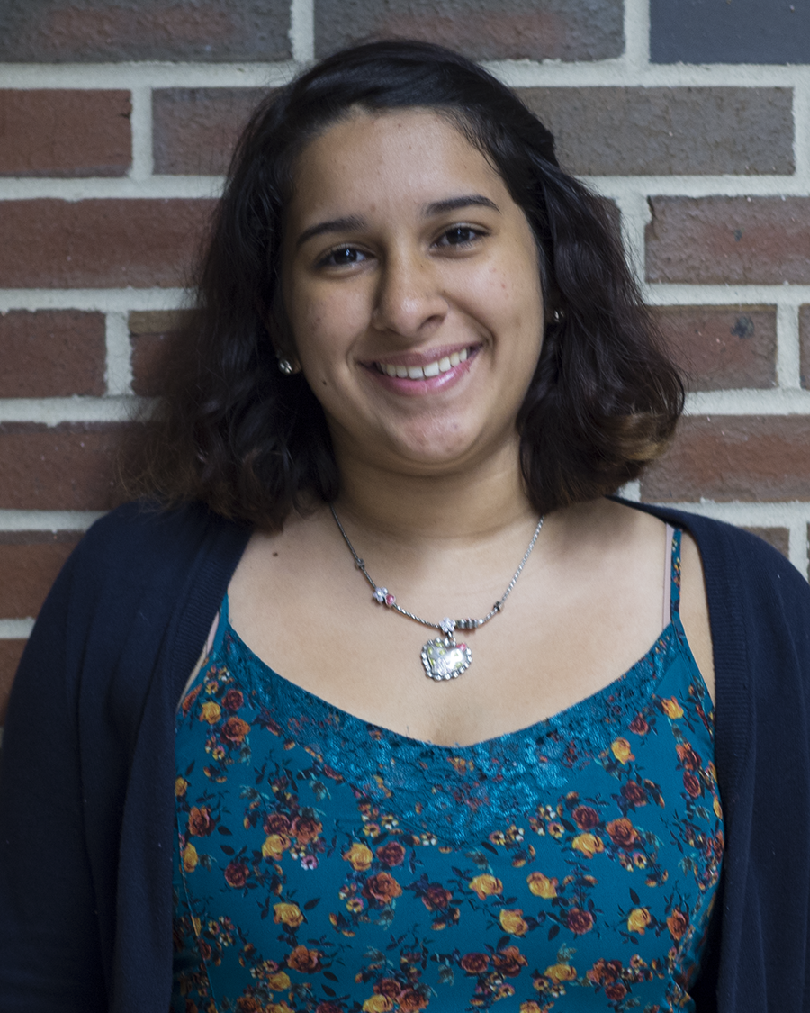
Karina Vale
Investigating Mechanisms of Infection in Newly Isolated Phage Infecting the Host, Corynebacterium
Karly N Casey, Karina Vale, Sameen Y Ali, Nellie N Baghaei, Sam Castillo, Aleksandra M Foksinska, Aakansha J Gosain, Nikki Mallepalli, Cameron W McPhail, Ashlyn C Murrell, Dan C Nguyen, Skye A Opsteen, Emily F Page, Madeline C Pratt, Natalie A Presado, Abby Thompson, David Saleeby, Katrina Sahawneh, Denise L Monti
Bacteriophages are the most abundant, yet least studied, entities on earth and contain a wealth of untapped genetic information for advancing biotechnology. Over 1500 full-genome phage sequences are entered in GenBank, yet only 2 corynebacteriophages had been sequenced as of August 2016. To expand the number of full-genome sequences for phages infecting the host Corynebacterium vitaeruminis, we isolated and characterized 12 novel corynebacteriophages from sewage influent samples. Full-genome sequencing and subsequent bioinformatics analysis of 4 phages (Darwin, PeteyPab, PotatoChip, Zion) revealed significant sequence similarity among the viruses in the EN cluster. Basic characterization experiments revealed these phages shared similar plaque and particle morphology and all were capable of calcium-independent host infection. Host-range experiments showed that 5/12 phages were capable of producing plaques on the host C. pseudodiptheriticum albeit at various degrees of infectivity despite sharing sequence similarity. Here we present data describing the 12 newly-isolated novel corynebacteriophages and discuss differences in putative gene products that may be responsible for differential host infection.

