CONSIDER FOR TALK
9th Annual SEA-PHAGES Symposium Abstract
Doane University
Crete NE
Corresponding Faculty Member: Erin Doyle (erin.doyle@doane.edu)
Nick Iwata
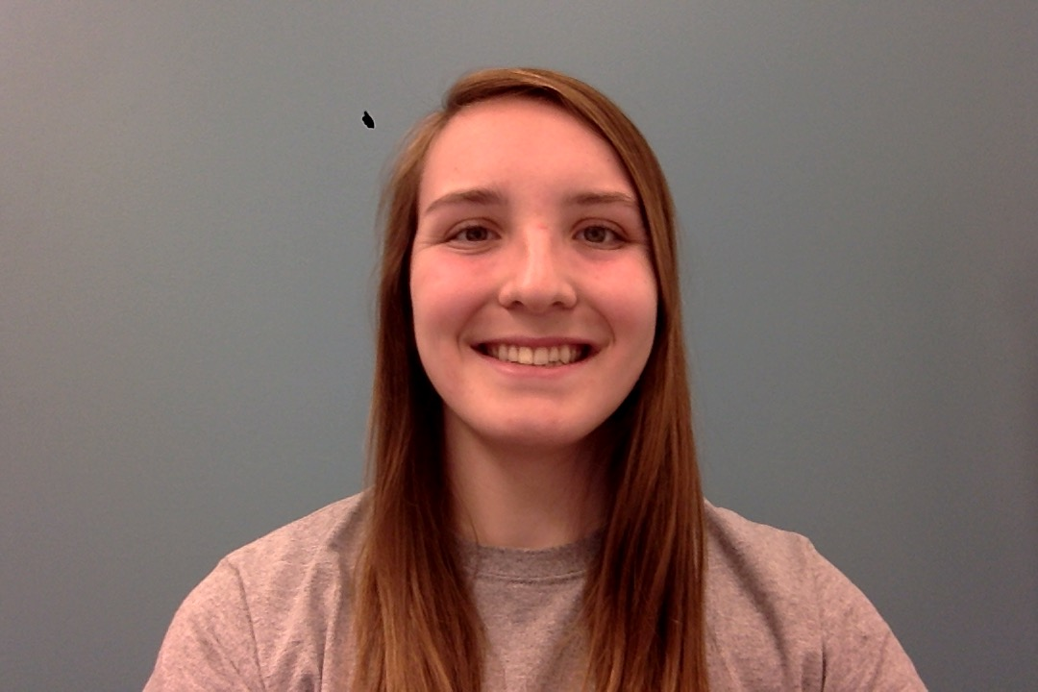
Jade Prochaska
ISOLATION, GENOME ANNOTATION, AND BIOFILM ANALYSIS OF KSQUARED, A NOVEL CLUSTER P MYCOBACTERIOPHAGE
Nick Iwata, Jade Prochaska, Ashlynn Baker, Hannah Carlstedt, Autumn Hurd, Cassidy Kepler, Jackie Lewis, Kelly Leukens, Cali McEntee, Kelsey Snyder, Kali Ulrich, Erin Doyle
The overuse of antibiotics and the resulting increase in antibiotic resistant bacteria has become a major concern in the medical community. One proposed solution is the use of bacteriophage (phage) that infect and kill specific bacteria. Phage have a unique benefit for possible treatment of infections because the phage can adapt to the mutations in the bacteria. To be able to research such possible uses for phage, science must first learn about their genomes to understand more about how they work. We isolated the phage Ksquared from soil on Doane University’s campus using the SEA-PHAGES protocol. Ksquared infects Mycobacterium smegmatis, a close relative to Mycobacterium tuberculosis. Ksquared is a lytic siphovidae. Mycobacteriophage Ksquared was selected for annotation due to it being a part of the rare P cluster and P1 subcluster. With the genome sequenced, we were able to annotate the genome of Ksquared. 41 of Ksquared’s annotated genes were assigned functions. Endodeoxyribonuclease was one of the unique functions found by HHPRED; however, further testing would be needed to assign such a specific function as endodeoxyribonuclease. Additionally, Ksquared shares a small region of similarity with the singleton phage Pine5. Overall most of the functions found and assigned when Ksquared was compared to these phages: Brusacoram, Fishburne, Phayonce, and Tortellini. In the future, we will also test Ksquared’s effectiveness against bacteria grown as biofilms, which can increase antibiotic resistance.

