CONSIDER FOR TALK
9th Annual SEA-PHAGES Symposium Abstract
Hampden-Sydney College
Hampden-Sydney VA
Corresponding Faculty Member: Mike Wolyniak (mwolyniak@hsc.edu)
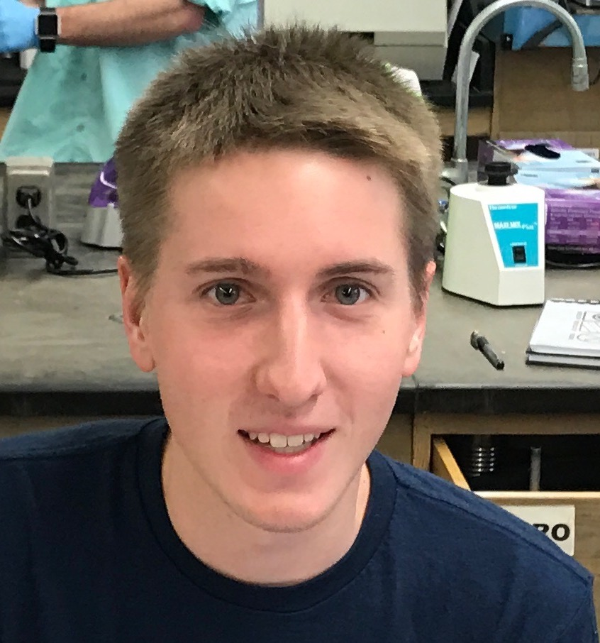
Dakota M Reinartz
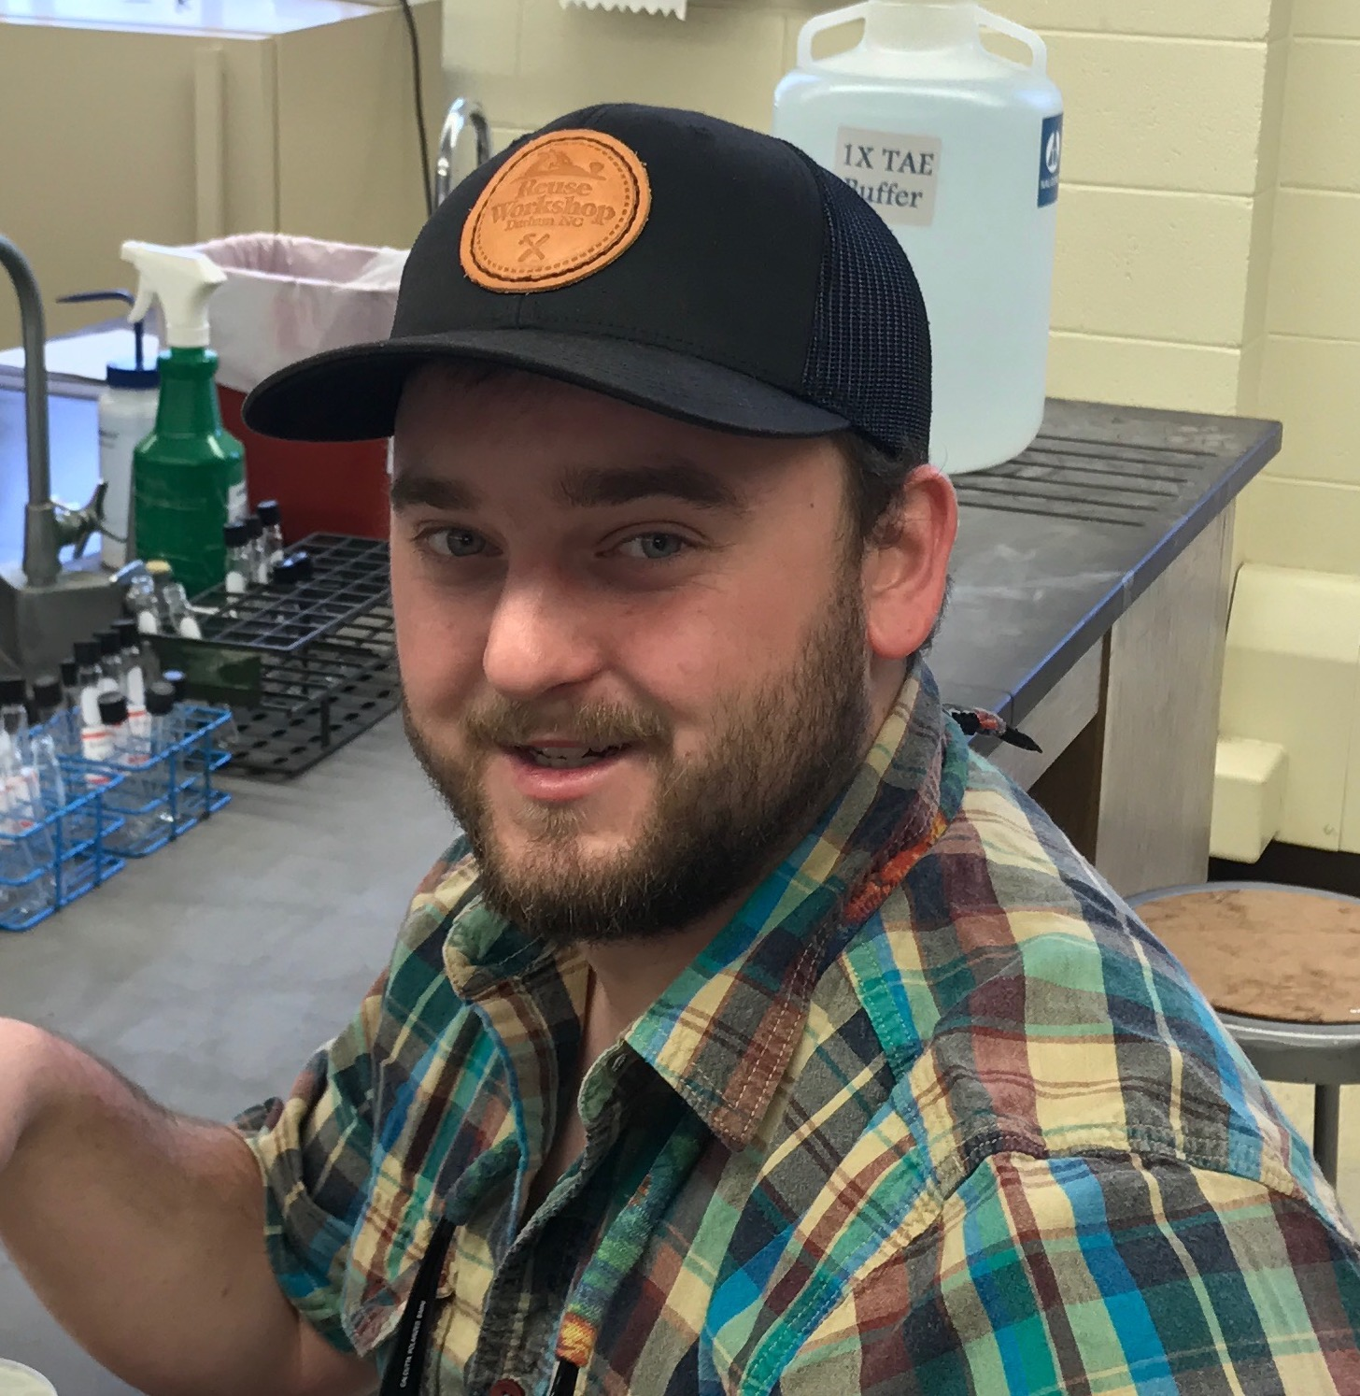
Richard W Morgan
Isolation and Genomic Characterization of Bacteriophage Thespis
Dakota M Reinartz, Richard W Morgan, Michael J Wolyniak
Thespis is a Mycobacterium smegmatis bacteriophage that was isolated from a soil sample taken from the campus of Hampden-Sydney College. After isolation and purification of the phage occurred, we sent the phage to have its genome sequenced. Upon receiving the sequence of the genome, it was annotated using the DNA master software. Annotation of the Thespis genome was done by multiple students in our fall Genomics and Bioinformatics course. We found that Thespis has a total of 47,619 basepairs that encode 78 genes. Also it was found that this bacteriophage was very similar to bacteriophage Brusacoram that was isolated and found at the College of St. Scholastica in Duluth, Minnesota. Genes that students found interesting were investigated through BLAST and through primary literature to learn what those genes might function to do in the bacteriophage. Gene 30 and 31 of the Thespis genome were two genes that were investigated further. Gene 30 was found to code for an integrase and 31 was found to code for an immunity repressor. Also towards the 3’ end of the Thespis genome many DNA methylase genes were identified. These methylases probably have a regulatory function during the bacteriophage infection. These could be useful genes to look into because of their function as possible regulators in the lifecycle of Thespis. Thespis was found to have lysogenic capabilities based on the genes found and to have regulatory genes present like the DNA methylases in its genome.

