DO NOT CONSIDER FOR TALK
9th Annual SEA-PHAGES Symposium Abstract
University of North Georgia
Dahlonega GA
Corresponding Faculty Member: Miriam Segura-Totten (mstotten@ung.edu)
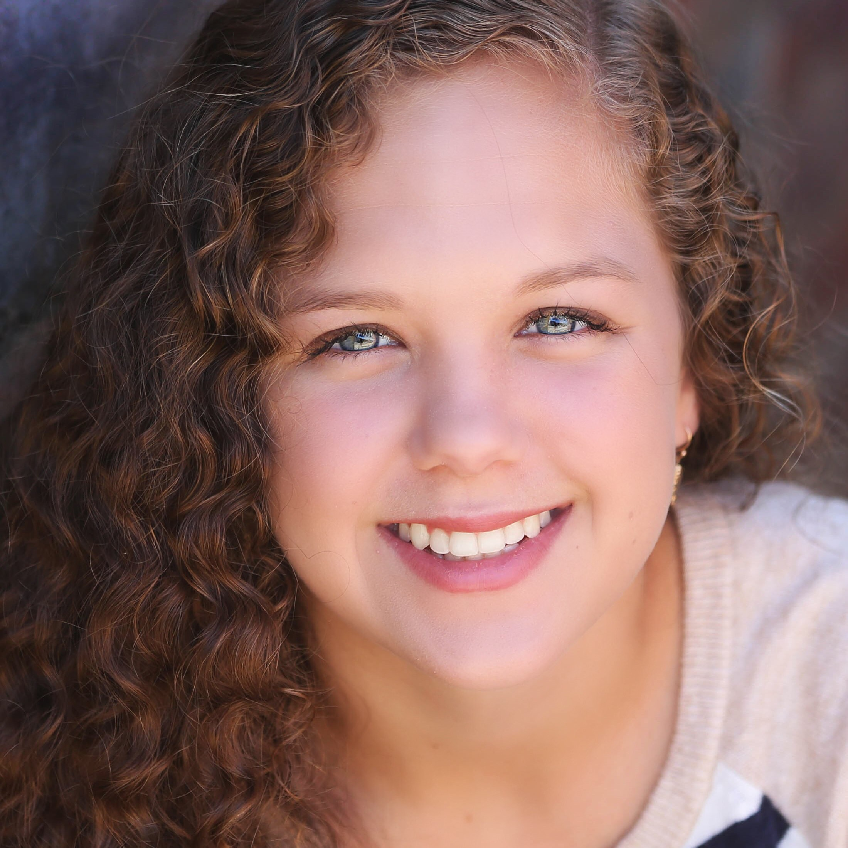
Lauren E Colston
Grant L Zacher
Isolation and genomic characterization of mycobacteriophages Donny and LilHazelnut
Lauren E Colston, Grant L Zacher, Ryan A Shanks, Miriam Segura-Totten
Bacteriophages make up a diverse and abundant population of viruses that replicate by hijacking the cellular machinery of a bacterial host. Only a minute fraction of the phage population is characterized phenotypically or genetically. To date, this small percentage of phages represents a large diversity categorized into 88 clusters and 73 subclusters. Phage contribute to our understanding of evolution, biological diversity, and have potential medical applications. We predict that by isolating and genetically characterizing novel bacteriophages we will be able to contribute to this growing scientific field. Using Mycobacterium smegmatis, a non-pathogenic bacterial host, we isolated two phages, Donny and LilHazelnut, from soil samples. Donny has round, smooth edged plaques with a diameter of approximately 0.1cm. LilHazelnut has clear plaques with a slight haziness around the edges and a diameter of 0.3cm. Transmission electron microscopy determined that both phages are Siphoviridae. The DNA of each phage was extracted, and its genome sequenced. Donny, which contains 96 predicted genes, was identified as a member of the B5 subcluster of mycobacteriophages. LilHazelnut was identified as a member of the highly conserved Q cluster and was initially predicted to encode for 87 genes. However, after annotating its genome, three genes were deleted leaving 84 putative genes. Through the annotation of these two genomes, we were able to assign functions to 27 genes in Donny and 24 genes in LilHazelnut. Of the genes with assigned functionality in Donny, 96% are conserved within the B5 subcluster, while 92% are conserved outside of the cluster. On the other hand, as a testament to high conservation of the Q cluster, 100% LilHazenut’s genes with assigned functionality are conserved within the cluster. Meanwhile, only 8.33% of these genes are conserved beyond the Q cluster. Some of the genes with assigned function include those that code for tail assembly proteins and the highly conserved hydrolytic enzymes Lysin A and B. Genetic variations in Donny and LilHazelnut are evidenced by their morphological differences. For example, the longer tail tape measure protein in Donny is partially responsible for a longer tail length for the phage. Interestingly, we found gene 70 in Donny to be truncated in relation to the corresponding genes in two of its fellow subcluster B5 phages, Acadian and Baee. Given the severe truncation of this gene, we predict that it is not essential for the phage. Subsequent research into Donny and LilHazelnut’ putative protein products will help to determine the extent of variance among their domains.

