DO NOT CONSIDER FOR TALK
9th Annual SEA-PHAGES Symposium Abstract
Virginia Tech
Blacksburg VA
Corresponding Faculty Member: Stephanie Voshell (svoshell@vt.edu)
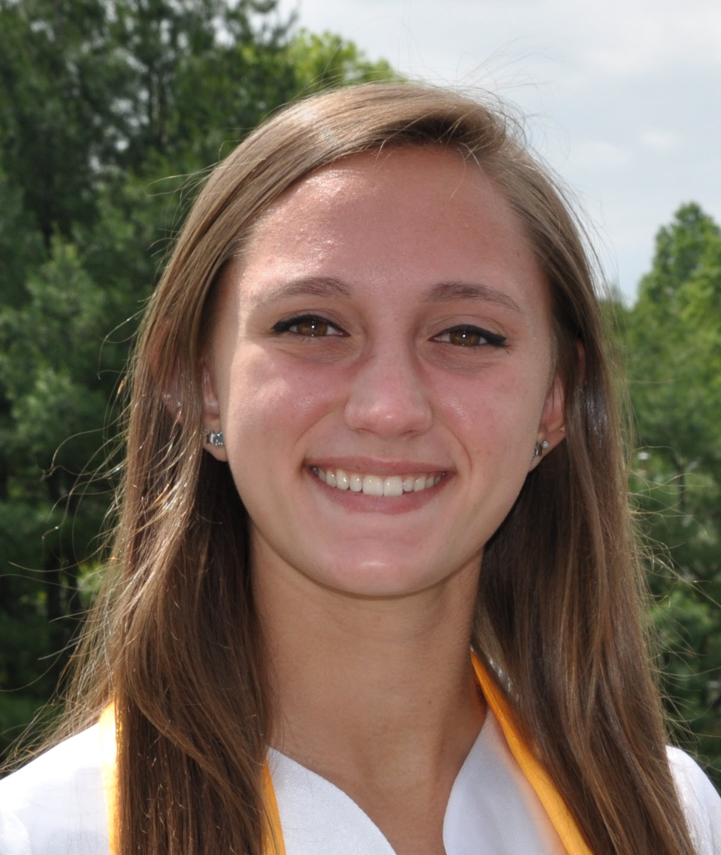
Brianna M Chop
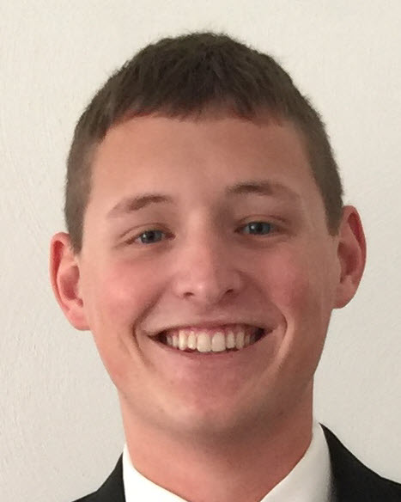
Cameron M Myers
The search for novel mycobacteriophages: Improved subcluster screening through PCR analysis of the tape measure protein gene
Brianna M Chop, Cameron M Myers, Gurvina J Atwal, John B Balyozian, Ashley E Black, Zachary A Cadieux, Adam G Coffin, Kristi R DeCourcy, Jake C Deslauriers, Vikrant S Dhindsa, Sarah G Freed, Sierra E Suarez Friend, Aaron D Gardner, Kennedy Gentry, Blair J Gilmer, Casey J Gringer, Alan H Huang, Victoria N Hudson, Tyler A Jones, Mitchell C Killar, Taylor N Klein, Christian B McBride, Alexander T Nguyen, Peggy Powars, Varsha Ravichandran, Corey S Rosenblatt, Paulene A Sapao, Virginia C Saux, Inderjeet Singh, Jack R Thornton, Lisa T To, Stephanie M Voshell, Madeleine L Walters, Haoyun Yang
It is increasingly unlikely to find truly novel phage within the A3 and A4 subclusters since so many have been sequenced and annotated already. During the 2016-2017 academic year, students at Virginia Tech focused on finding and sequencing mycobacteriophage of less commonly studied subclusters. After isolating phage, students carried out a PCR assay of the tape measure protein gene. Data from the PCR assay was considered alongside restriction digest and tail length data to select phage that likely belonged to unusual subclusters. Mycobacteriophages Chancellor and Shaobing yielded ambiguous PCR results; genomic sequencing revealed them to be novel K4 and K1 phages, respectively. Barbarian, a suspected E cluster phage, was confirmed through sequencing. Blackmoor, a suspected A4 phage, was sent for sequencing as a control to confirm that the screening methods were accurate.

